**LIFE’S LITTLE BLACK BOOK**

**(SOFTWARE DESIGN AND ARCHITECTURE)**



**SUBMITTED TO:**

MAM ALINA MUNIR

**SUBMITTED BY:**

KAUSAR FATIMA(2021-SE-25)

UME HABIBA(2021-SE-27)

LAIBA AMBER EJAZ(2021-SE-37)

**DEPARTMENT OF COMPUTER SCIENCE**

**UNIVERSITY OF ENGINEERING AND TECHNOLOGY LAHORE (KSK CAMPUS)**

**TABLE OF CONTENTS:**

* INTRODUCTION
* VISION
* SCOPE
* WORK BREAK-DOWN STRUCTURE
* GANTT CHART
* FUNCTIONAL REQUIREMENTS
* NON-FUNCTIONAL REQUIREMENTS
* BUSINESS REQUIREMENTS
* BUSINESS RULES
* USER REQUIREMENTS
* PHYSICAL PRODUCT REQUIREMENTS
* EXTERNAL INTERFACE
* DEVELOPMENT CONSTRAINTS
* WIREFRAMES
* STORY BOARDING TECHNIQUES
* UML DIAGRAMS
* TEST CASES

**(-----:INTRODUCTION:-----)**

We will be designing a Person’s Daily Management Diary. The system will allow users to make account and Sign-In to their accounts. Users can edit their daily notes, events, budget and contacts. They can add, update, delete and search contacts, budget and daily notes. They can Log-Out from their system at any time.

**VISION OF PRODUCT**

**For** a Venture Capitalist **who** wants to give a platform to users including students, teachers, doctor, professionals and non-professionals to manage their daily routines. **The** **LIFE’S LITTLE BLACK BOOK** is a desktop app **that** will provide you with more privacy, security, and innovative features on one platform . **Unlike** Full-Budget Tracker, Notepad, Microsoft Outlook Contact, **our** focus will have to facilitate users with notes, contact and budget management on one platform.

**SCOPE OF PRODUCT**

The scope of our project involves the development of an application that enables the management of daily notes, events, budget and contacts. The system should be designed to be user-friendly and scalable for users to manage their daily routine. The system should be secure and should be concerned with enhancing user privacy.

The system should be able to allow users to make an account, Sign-In to their account with authenticated credentials, edit their daily notes (including add, delete, update notes), edit events, edit contacts (including add, delete, update, search contacts), edit budget (including add, delete, update budget). The system should be able to allow users to make log-out activity at any time.

The project should be completed within a defined timeline and budget, and should meet all the requirements and specifications outlined in the project scope. It should be thoroughly tested to ensure its reliability, security, and performance. Finally, the system should be easy to maintain and support, with clear documentation provided for users.

**WORK BREAK-DOWN STRUCTURE:**

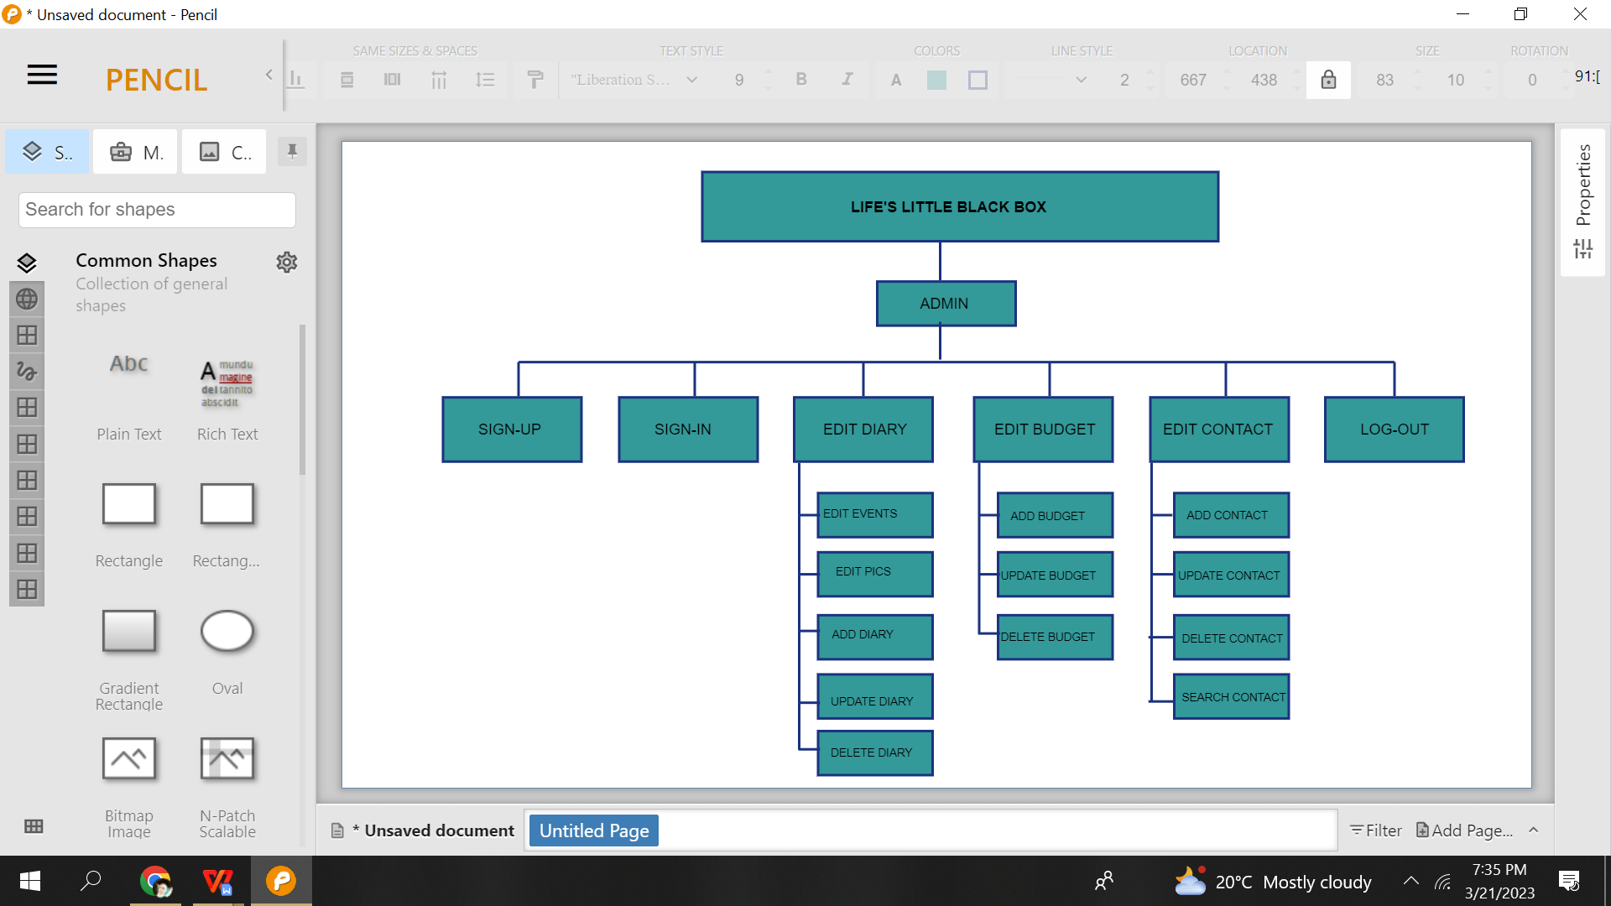

**GANTT-CHART:**

**TIME ESTIMATION:**

**(-----:FUNCTIONAL REQUIREMENTS:-----)**

**REGISTRATION:**

1. The system must be able to allow users to register for the application.
2. The system must be able to allow users to login through valid user_id and password.

**DIARY MANAGEMENT:**

1. The system must be able to allow users to add notes.
2. The system must be able to allow users to delete notes.
3. The system must be able to allow users to update notes.
4. The system must be able to allow users to add events.
5. The system must be able to allow users to delete events.
6. The system must be able to allow users to update events.

**CONTACT MANAGEMENT:**

1. The system must be able to allow users to add contacts.
2. The system must be able to allow users to delete contacts.
3. The system must be able to allow users to update contacts.
4. The system must be able to allow users to search contacts.

**BUDGET MANAGEMENT:**

1. The system must be able to allow users to add budget.
2. The system must be able to allow users to delete budget.
3. The system must be able to allow users to update budget.

**LOG-OUT:**

1. The system must be able to allow users to log-out.

**(-----:NON-FUNCTIONAL REQUIREMENTS:-----)**

**PERFORMANCE:**

1. The system shall be able to provide instant services to 5000 users at a time.
2. The system shall be lightweight and shall be able to respond instantly.

**SECURITY:**

1. The system shall be able provide password lock for opening the system.

**SAFETY:**

1. The system shall be able to tolerate user’s mistake.

**RELIABILITY:**

1. The system shall be to preserve user’s data.
2. The system shall be to available 24/7.

**MEMORY:**

1. The system shall be able to provide memory for storing 30 members in groups.

**DATA INTEGRITY:**

1. The system shall be able to integrate data of different types such as numbers, alphabets etc.

**MAINTAINANCE:**

1. The system shall be to be updated timely.

**USABILITY:**

1. The system should be easy to use and intuitive for users, with clear navigation and a

user-friendly interface.

**PORTABILITY:**

1. The system shall be working only on desktop.

**BACKUP & RESTORE:**

1. The system shall be able to store backup data of users until deletion of their account.

**(-----:BUSINESS REQUIREMENTS:-----)**

**Cost-effectiveness:**

1.The system should provide cost-effective solutions, resulting in cost savings for stakeholders.

**Compliance:**

1. The system should comply with all relevant regulations, as well as any industry

standards and best practices.

**Workflow optimization:**

1. The system should optimize workflows and reduce inefficiencies, resulting in increased productivity and improved user’s easiness.

**Integration:**

1. The system should integrate with existing technologies.

**Customization:**

1. The system should be customizable to meet the unique needs of the diary, budget, and contacts such as specific workflows, reports, and data analysis.

**(-----:BUSINESS RULES:-----)**

**Access control:**

1. The system should have access control mechanisms to ensure that only authorized personnel have access to sensitive user information.

**Data validation:**

1. The system should perform data validation checks to ensure that entered data is accurate and consistent.

**Workflow rules:**

1. The system should have predefined workflows for specific tasks, such as

Contacts, diary and budget.

**Compliance rules:**

1. The system should have predefined compliance rules to ensure that the

System complies with all relevant regulations and laws.

**(-----:USER REQUIREMENTS:-----)**

**USER-FRIENDLY INTERFACE:**

1. The system should have a user-friendly interface that is easy to navigate

for users.

**OTHER DEVICE ACCESS:**

1. The system should be accessible via any desktop devices.

**USER INFO MANAGEMENT:**

1. The system should be able to manage user information.

**EVENT SCHEDULING:**

1. The system should allow users to highlight/unhighlight events, and users should be able to view their schedules and manage events.

**BUDGET SCHEDULING:**

1. The system should allow users to schedule budget, and users should be able to view their schedules and manage budget.

**ELECTRONIC RECORDS (ER’S):**

1. The system should be able to store, retrieve, and share records securely.

**(-----:PHYSICAL PRODUCT REQUIREMENTS:-----)**

1. Backup and storage devices
2. Desktop devices
3. Computer hardware

**(-----:EXTERNAL INTERFACE:-----)**

**USER INTERFACES:**

1. Graphical User Interfaces (GUIs)

**APPLICATION PROGRAMMING INTERFACES (API’S):**

1. C#.NET Core

**DATABASE SERVER**:

1. SQL SERVER

**(-----:DEVELOPMENT CONTRAINTS:-----)**

**BUDGET CONSTRAINTS:**

The system has to be developed within a limited budget to avoid any overspend and should still deliver a quality product.

**TIME CONSTRAINTS:**

1. The system has to be developed within a limited deadline, and the system has to be ready for deployment by then. Therefore, it is to ensure that team should manage their time effectively to meet the deadline.

**RESOURCE CONSTRAINTS:**

1. The system has to be developed utilizing the limited resources at the disposal, which meant that team has to utilize them optimally to achieve the desired outcome.

**TECHNICAL CONSTRAINTS:**

1. The system has to be developed using C# and SQL Database due to technical constraints. This required team to have the necessary technical skills to develop the system effectively.

**REGULATORY CONSTRAINTS:**

1. The system has to comply with all necessary regulations and standards to ensure that it would be safe and secure for use.

**(-----:WIREFRAMES:-----)**

**Sign Up**

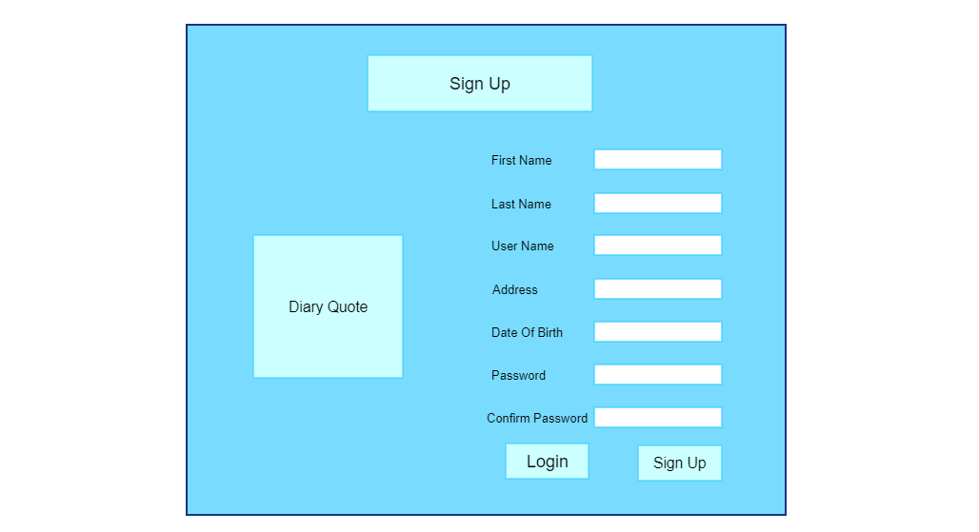

T1

T2

|  |  |  |  |
| --- | --- | --- | --- |
| **As a User:** | | **As an Admin:** | |
| T1 | **As a user, I shall enter credential to create to create account.** | T1 | **As an admin, I shall allow user to create his/her account.** |
| **T2** | **As a user, I shell login to account if already have Signed up.** | **T2** | **As an admin, I shall allow users to access login page.** |

**Login**

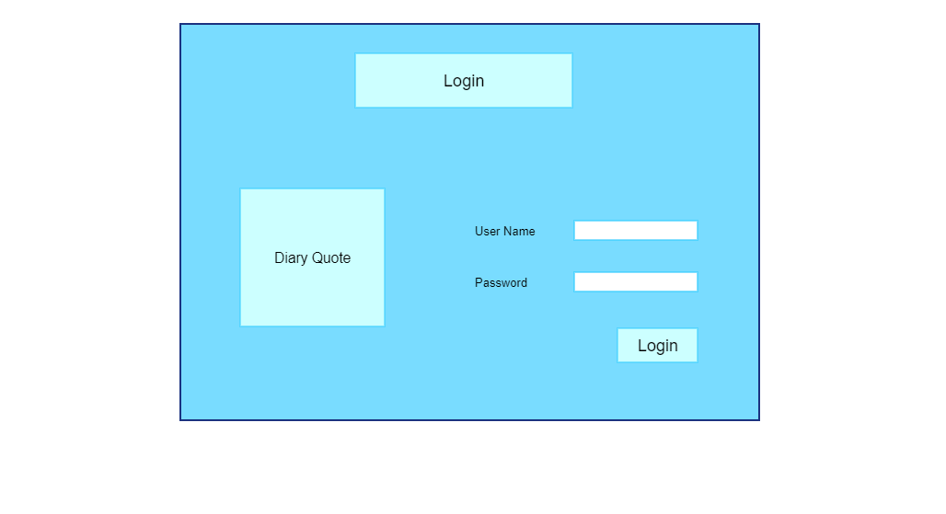

T1

|  |  |  |  |
| --- | --- | --- | --- |
| **As a User:** | | **As an Admin:** | |
| T1 | **As a user, I shall enter credential to login to account.** | T1 | **As an admin, I shall authenticate user to login to his/her account.** |

**Home**

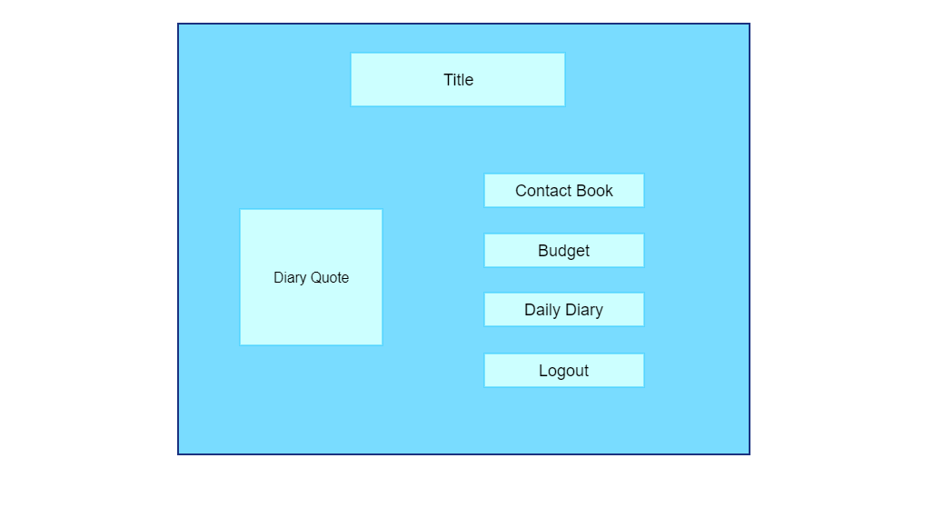

T1

|  |  |  |  |
| --- | --- | --- | --- |
| **As a User:** | | **As an Admin:** | |
| T1 | **As a user, I shall select the desire menu option to access services.** | T1 | **As an admin, I shall allow user to access the services of Life little Black Book.** |

**Contact Book**

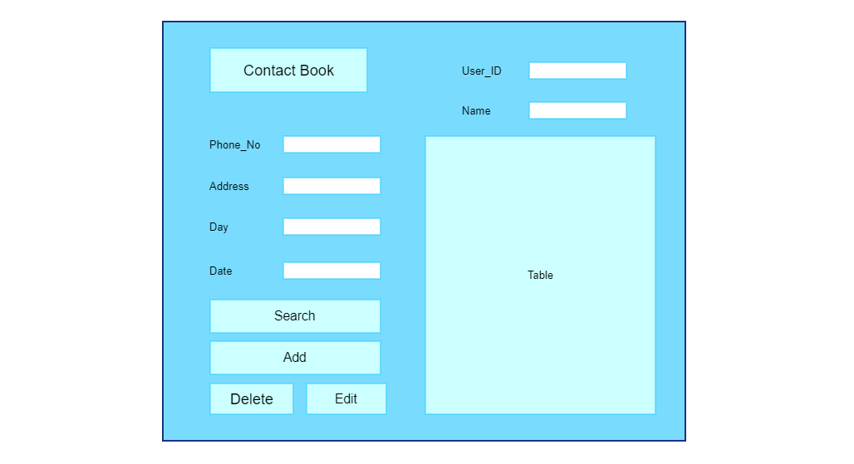

T1

|  |  |  |  |
| --- | --- | --- | --- |
| **As a User:** | | **As an Admin:** | |
| T1 | **As a user, I shall select the desire button to do updation in Contact Book.** | T1 | **As an admin, I shall allow user to do updation in Contact Book.** |

**Budget**

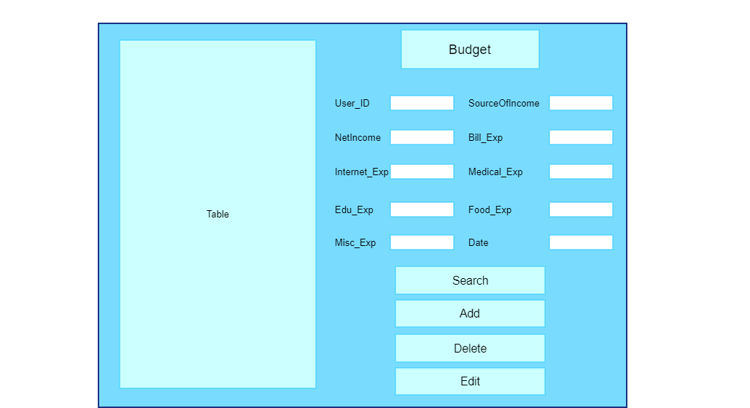

T1

|  |  |  |  |
| --- | --- | --- | --- |
| **As a User:** | | **As an Admin:** | |
| T1 | **As a user, I shall select the desire button to do updation in Budget to do budget management.** | T1 | **As an admin, I shall allow user to do updation in Budget.** |

**Daily Diary**

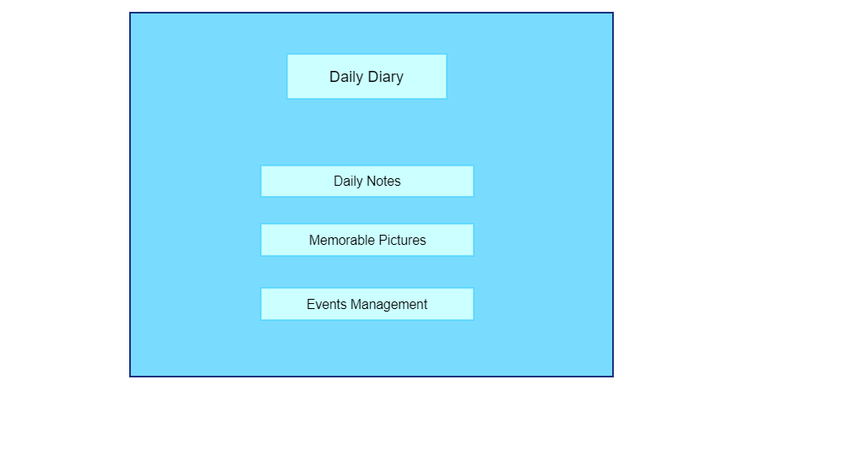

T1

|  |  |  |  |
| --- | --- | --- | --- |
| **As a User:** | | **As an Admin:** | |
| T1 | **As a user, I shall select the desire option to access the services of daily diary.** | T1 | **As an admin, I shall allow user to access the services of daily diary.** |

**Daily Notes**

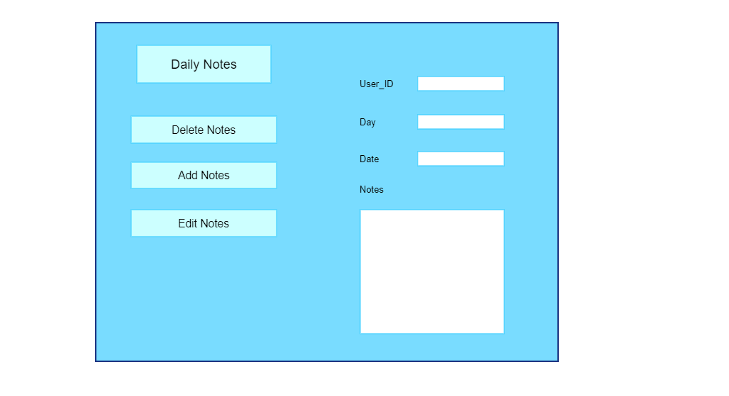

T1

|  |  |  |  |
| --- | --- | --- | --- |
| **As a User:** | | **As an Admin:** | |
| T1 | **As a user, I shall select the desire button to do updation in Daily Notes.** | T1 | **As an admin, I shall allow user to do updation in Daily Notes.** |

**Memorable Pictures**

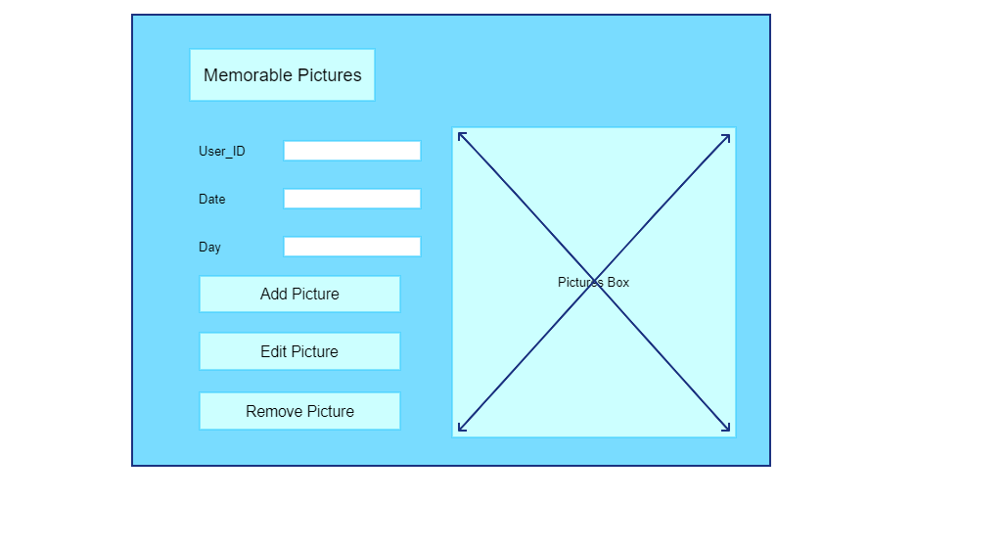

T1

|  |  |  |  |
| --- | --- | --- | --- |
| **As a User:** | | **As an Admin:** | |
| T1 | **As a user, I shall select the desire button to do updation in Memorable Pictures .** | T1 | **As an admin, I shall allow user to do updation in Memorable Pictures.** |

**Events Management**

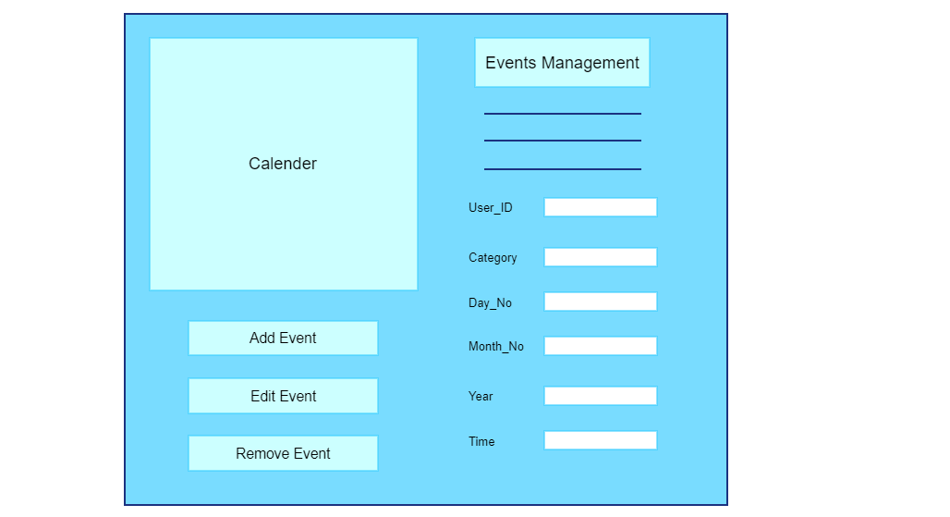

T1

|  |  |  |  |
| --- | --- | --- | --- |
| **As a User:** | | **As an Admin:** | |
| T1 | **As a user, I shall select the desire button to do updation in Events Management.** | T1 | **As an admin, I shall allow user to do updation in Events Management.** |

**(-----:STORY BOARDING TECHNIQUES:-----)**

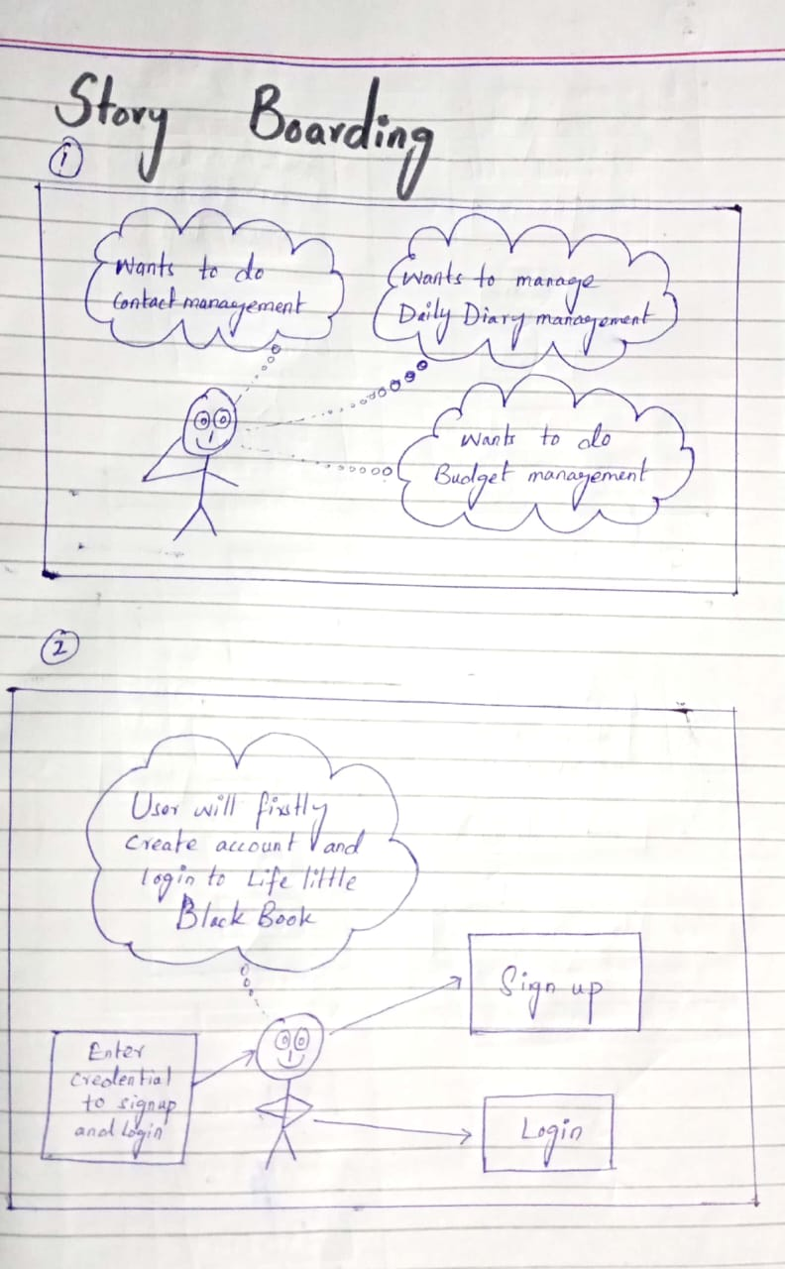

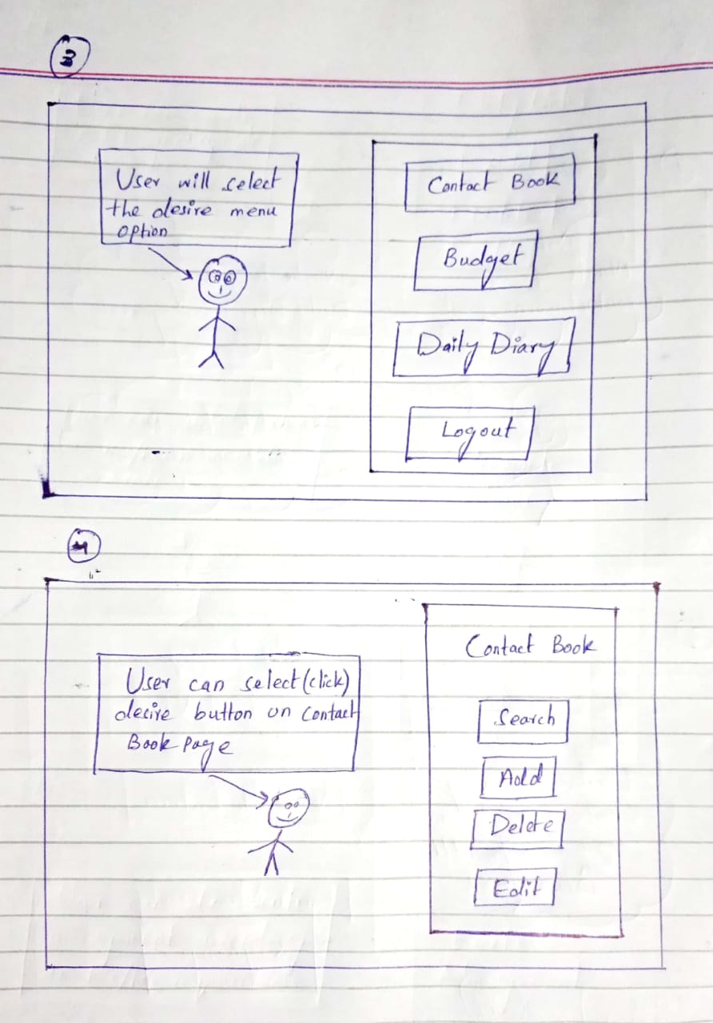

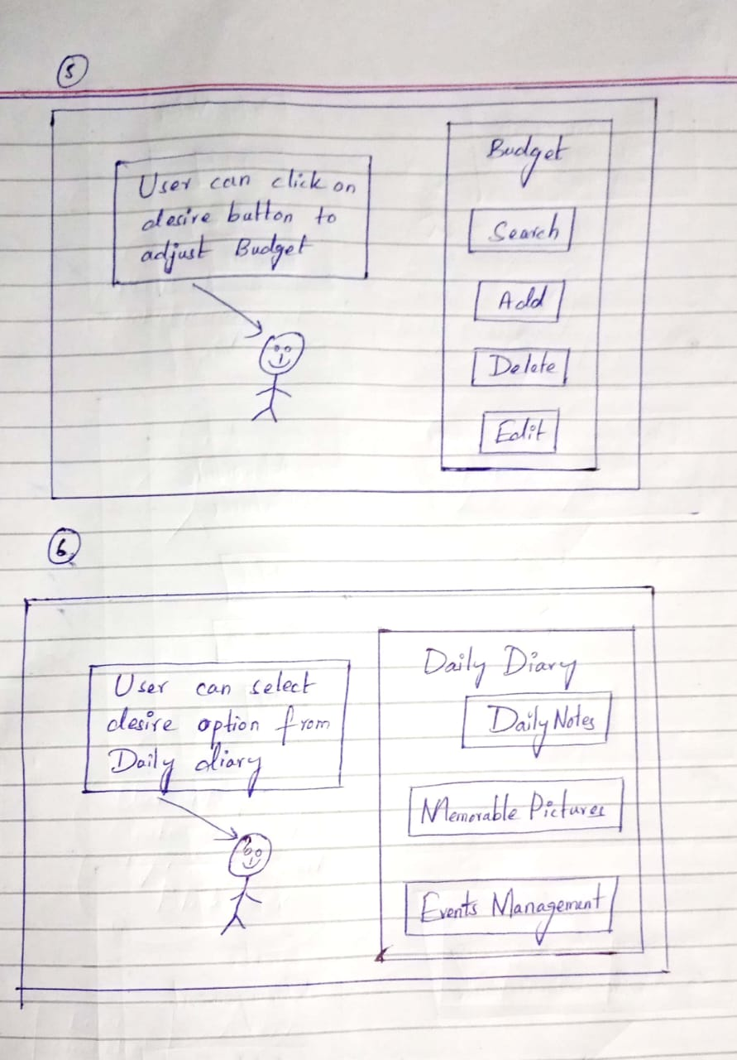

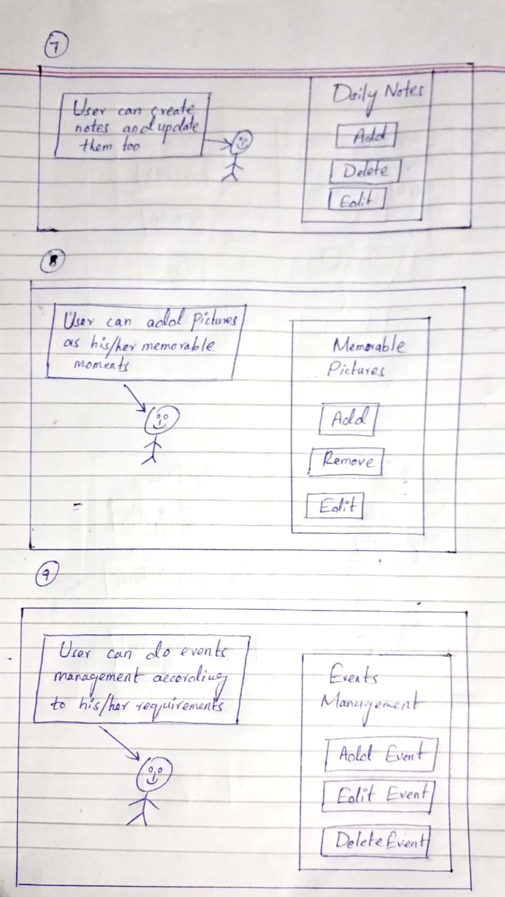

**(-----:UML DIAGRAMS:-----)**

**(-----:USE CASE:-----)**

**(-----:USE CASE DIAGRAM:-----)**

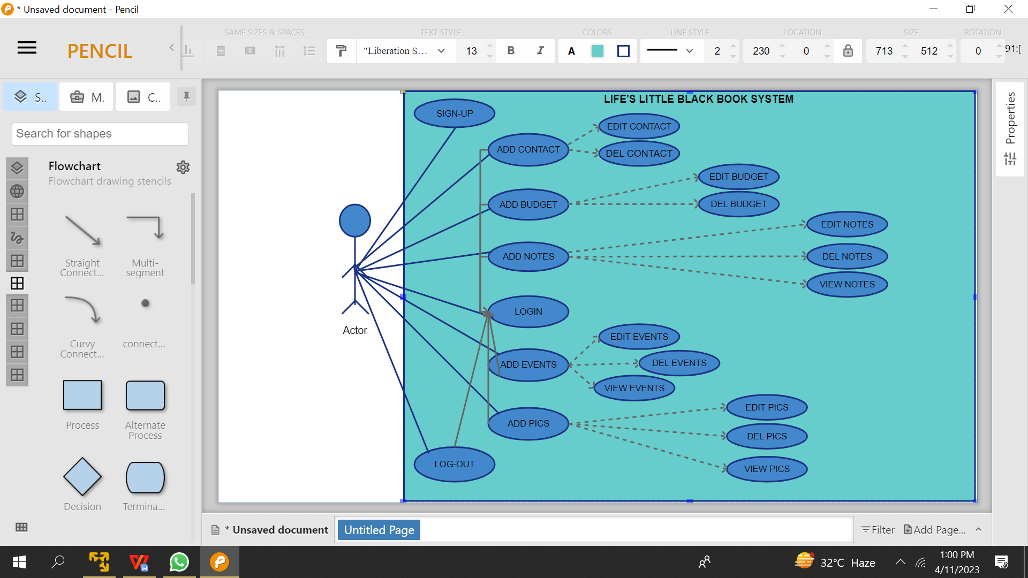

**(-----:USE CASE ATTRIBUTES:-----)**

1. **SIGN-UP:**

**Name:** Admin Account Creation

**Actor:** Admin

**Precondition:** The admin must have access to the system and the system must be functional.

**Goal:** The goal of this use case is to allow the admin to create an account on the system.

**Trigger:** The admin requests to create an account on the system.

**Post-condition:** The admin has an account on the system.

**Exception:** If the admin's credentials are incorrect or the system is not functional, the admin will not be able to create an account.

**Alternate flow:** If the admin already has an account, they can log in to the system instead of creating a new account.

**Main flow:**

The admin opens the system and clicks on the sign-up button.

The system presents a form to the admin to fill in their details such as name, email, password, and other necessary information.

The admin fills in the required details and submits the form.

The system validates the details and creates an account for the admin.

1. **LOGIN:**

**Name:** Admin Login

**Actor:** Admin

**Precondition:** The admin must have an account on the system and the system must be functional.

**Goal:** The goal of this use case is to allow the admin to log in to the system.

**Trigger:** The admin requests to log in to the system.

**Post-condition:** The admin has successfully logged in to the system.

**Exception:** If the admin's credentials are incorrect or the system is not functional, the admin will not be able to log in to the system.

**Alternate flow:** If the admin forgets their password, they can reset it by providing their registered email address.

**Main flow:**

The admin opens the system and clicks on the login button.

The system presents a form to the admin to fill in their credentials such as email and password.

The admin fills in their credentials and submits the form.

The system validates the credentials and grants the admin access to the system.

1. **ADD-BUDGET:**

**Name:** Add Budget

**Actor:** Admin

**Precondition:** The admin must be logged in to the system and the system must be functional.

**Goal:** The goal of this use case is to allow the admin to add a budget.

**Trigger:** The admin requests to add a budget.

**Post-condition:** The budget has been added to the system.

**Exception:** If the system is not functional, the admin will not be able to add a budget.

**Main flow:**

The admin clicks on the budget button.

The system presents a form to the admin to fill in the budget details such as name, amount, and description.

The admin fills in the required details and submits the form.

The system validates the details and adds the budget to the system.

1. **EDIT-BUDGET:**

**Name:** Edit Budget

**Actor:** Admin

**Precondition:** The admin must be logged in to the system and the system must be functional.

**Goal:** The goal of this use case is to allow the admin to edit a budget.

**Trigger:** The admin requests to edit a budget.

**Post-condition:** The budget has been edited in the system.

**Exception:** If the system is not functional, the admin will not be able to edit a budget.

**Main flow:**

The admin clicks on the budget button.

The system presents a list of budgets to the admin.

The admin selects the budget they want to edit.

The system presents the details of the selected budget to the admin.

The admin clicks on the edit button and makes the necessary changes.

The system validates the changes and updates the budget in the system.

1. **DELETE-BUDGET:**

**Name:** Delete Budget

**Actor:** Admin

**Precondition:** The admin must be logged in to the system and the system must be functional. There must also be at least one budget in the system.

**Goal:** The goal of this use case is to allow the admin to delete a budget.

**Trigger:** The admin requests to delete a budget.

**Post-condition:** The budget has been deleted from the system.

**Exception:** If the system is not functional or there are no budgets in the system, the admin will not be able to delete a budget.

**Main flow:**

The admin clicks on the budget button.

The system presents a list of budgets to the admin.

The admin selects the budget they want to delete.

The system prompts the admin to confirm the deletion.

The admin confirms the deletion.

The system deletes the budget from the system.

1. **ADD-CONTACTS:**

**Name:** Add Contacts

**Actor:** Admin

**Precondition:** The admin must be logged in to the system and the system must be functional.

**Goal:** The goal of this use case is to allow the admin to add a contact.

**Trigger:** The admin requests to add a contact.

**Post-condition:** The contact has been added to the system.

**Exception:** If the system is not functional, the admin will not be able to add a contact.

**Main flow:**

The admin clicks on the contacts button.

The system presents a form to the admin to fill in the contact details such as name, email, phone number, and description.

The admin fills in the required details and submits the form.

The system validates the details and adds the contact to the system.

1. **EDIT-CONTACTS:**

**Name:** Edit Contacts

**Actor:** Admin

**Precondition:** The admin must be logged in to the system and the system must be functional.

**Goal:** The goal of this use case is to allow the admin to edit a contact.

**Trigger:** The admin requests to edit a contact.

**Post-condition:** The contact has been edited in the system.

**Exception:** If the system is not functional, the admin will not be able to edit a contact.

**Main flow:**

The admin clicks on the contacts button.

The system presents a list of contacts to the admin.

The admin selects the contact they want to edit.

The system presents the details of the selected contact to the admin.

The admin clicks on the edit button and makes the necessary changes.

The system validates the changes and updates the contact in the system.

1. **DELETE-CONTACTS:**

**Name:** Delete Contacts

**Actor:** Admin

**Precondition:** The admin must be logged in to the system and the system must be functional. There must also be at least one contact in the system.

**Goal:** The goal of this use case is to allow the admin to delete a contact.

**Trigger:** The admin requests to delete a contact.

**Post-condition:** The contact has been deleted from the system.

**Exception:** If the system is not functional or there are no contacts in the system, the admin will not be able to delete a contact.

**Main flow:**

The admin clicks on the contacts button.

The system presents a list of contacts to the admin.

The admin selects the contact they want to delete.

The system prompts the admin to confirm the deletion.

The admin confirms the deletion.

The system deletes the contact from the system.

1. **ADD-EVENTS:**

**Name:** Add Events

**Actor:** Admin

**Precondition:** The admin must be logged in to the system and the system must be functional.

**Goal:** The goal of this use case is to allow the admin to add an event.

**Trigger:** The admin requests to add an event.

**Post-condition:** The event has been added to the system.

**Exception:** If the system is not functional, the admin will not be able to add an event.

**Main flow:**

The admin clicks on the events button.

The system presents a form to the admin to fill in the event details.

The admin fills in the required details and submits the form.

The system validates the details and adds the event to the system.

1. **EDIT-EVENTS:**

**Name:** Edit Events

**Actor:** Admin

**Precondition:** The admin must be logged in to the system and the system must be functional.

**Goal:** The goal of this use case is to allow the admin to edit an event.

**Trigger:** The admin requests to edit an event.

**Post-condition:** The event has been edited in the system.

**Exception:** If the system is not functional, the admin will not be able to edit an event.

**Main flow:**

The admin clicks on the events button.

The system presents a list of events to the admin.

The admin selects the event they want to edit.

The system presents the details of the selected event to the admin.

The admin clicks on the edit button and makes the necessary changes.

The system validates the changes and updates the event in the system.

1. **VIEW EVENTS:**

**Name:** View Events

**Actor:** Admin

**Precondition:** The admin must be logged in to the system and the system must be functional.

**Goal:** The goal of this use case is to allow the admin to view events.

**Trigger:** The admin requests to view events.

**Post-condition:** The system displays a list of events to the admin.

**Exception:** If the system is not functional, the admin will not be able to view events.

**Main flow:**

The admin clicks on the events button.

The system presents a list of events to the admin.

1. **DELETE EVENTS:**

**Name:** Delete Events

**Actor:** Admin

**Precondition:** The admin must be logged in to the system and the system must be functional. There must also be at least one event in the system.

**Goal:** The goal of this use case is to allow the admin to delete an event.

**Trigger:** The admin requests to delete an event.

Post-condition: The event has been deleted from the system.

**Exception:** If the system is not functional or there are no events in the system, the admin will not be able to delete an event.

**Main flow:**

The admin clicks on the events button.

The system presents a list of events to the admin.

The admin selects the event they want to delete.

The system prompts the admin to confirm the deletion.

The admin confirms the deletion.

The system deletes the event from the system.

1. **ADD DAILY NOTES:**

**Name:** Add Daily Notes

**Actor:** Admin

**Precondition:** The admin must be logged in to the system and the system must be functional.

**Goal:** The goal of this use case is to allow the admin to add a daily note.

**Trigger:** The admin requests to add a daily note.

**Post-condition:** The daily note has been added to the system.

**Exception:** If the system is not functional, the admin will not be able to add a daily note.

**Main flow:**

The admin clicks on the daily notes button.

The system presents a form to the admin to fill in the daily note details such as title and description.

The admin fills in the required details and submits the form.

The system validates the details and adds the daily note to the system.

1. **EDIT DAILY NOTES:**

**Name:** Edit Daily Notes

**Actor:** Admin

**Precondition:** The admin must be logged in to the system and the system must be functional.

**Goal:** The goal of this use case is to allow the admin to edit a daily note.

**Trigger:** The admin requests to edit a daily note.

**Post-condition:** The daily note has been edited in the system.

**Exception:** If the system is not functional, the admin will not be able to edit a daily note.

**Main flow:**

The admin clicks on the daily notes button.

The system presents a list of daily notes to the admin.

The admin selects the daily note they want to edit.

The system presents the details of the selected daily note to the admin.

The admin clicks on the edit button and makes the necessary changes.

The system validates the changes and updates the daily note in the system.

1. **VIEW DAILY NOTES:**

**Name:** View Daily Notes

**Actor:** Admin

**Precondition:** The admin must be logged in to the system and the system must be functional.

**Goal:** The goal of this use case is to allow the admin to view daily notes.

**Trigger:** The admin requests to view daily notes.

**Post-condition:** The system displays a list of daily notes to the admin.

**Exception:** If the system is not functional, the admin will not be able to view daily notes.

**Main flow:**

The admin clicks on the daily notes button.

The system presents a list of daily notes to the admin.

1. **DELETE DAILY NOTES:**

**Name:** Delete Daily Notes

**Actor:** Admin

**Precondition:** The admin must be logged in to the system and the system must be functional. There must also be at least one daily note in the system.

**Goal:** The goal of this use case is to allow the admin to delete a daily note.

**Trigger:** The admin requests to delete a daily note.

**Post-condition:** The daily note has been deleted from the system.

**Exception:** If the system is not functional or there are no daily notes in the system, the admin will not be able to delete a daily note.

**Main flow:**

The admin clicks on the daily notes button.

The system presents a list of daily notes to the admin.

The admin selects the daily note they want to delete.

The system prompts the admin to confirm the deletion.

The admin confirms the deletion.

The system deletes the daily note from the system.

1. **ADD PICTURES:**

**Name:** Add Pictures

**Actor:** Admin

**Precondition:** The admin must be logged in to the system and the system must be functional.

**Goal:** The goal of this use case is to allow the admin to add a picture.

**Trigger:** The admin requests to add a picture.

**Post-condition:** The picture has been added to the system.

**Exception:** If the system is not functional, the admin will not be able to add a picture.

**Main flow:**

The admin clicks on the pictures button.

The system presents a form to the admin to upload the picture and add a description.

The admin uploads the picture and adds the required details.

The system validates the details and adds the picture to the system.

1. **EDIT PICTURES:**

**Name:** Edit Pictures

**Actor:** Admin

**Precondition:** The admin must be logged in to the system and the system must be functional.

**Goal:** The goal of this use case is to allow the admin to edit a picture.

**Trigger:** The admin requests to edit a picture.

**Post-condition:** The picture has been edited in the system.

**Exception:** If the system is not functional, the admin will not be able to edit a picture.

**Main flow:**

The admin clicks on the pictures button.

The system presents a list of pictures to the admin.

The admin selects the picture they want to edit.

The system presents the details of the selected picture to the admin.

The admin clicks on the edit button and makes the necessary changes.

The system validates the changes and updates the picture in the system.

1. **VIEW PICTURES:**

**Name:** View Pictures

**Actor:** Admin

**Precondition:** The admin must be logged in to the system and the system must be functional.

**Goal:** The goal of this use case is to allow the admin to view pictures.

**Trigger:** The admin requests to view pictures.

**Post-condition:** The system displays a list of pictures to the admin.

**Exception:** If the system is not functional, the admin will not be able to view pictures.

**Main flow:**

The admin clicks on the pictures button.

The system presents a list of pictures to the admin.

1. **DELETE PICTURES:**

**Name:** Delete Pictures

**Actor:** Admin

**Precondition:** The admin must be logged in to the system and the system must be functional. There must also be at least one picture in the system.

**Goal:** The goal of this use case is to allow the admin to delete a picture.

**Trigger:** The admin requests to delete a picture.

**Post-condition:** The picture has been deleted from the system.

**Exception:** If the system is not functional or there are no pictures in the system, the admin will not be able to delete a picture.

**Main flow:**

The admin clicks on the pictures button.

The system presents a list of pictures to the admin.

The admin selects the picture they want to delete.

The system prompts the admin to confirm the deletion.

The admin confirms the deletion.

The system deletes the picture from the system.

1. **LOG-OUT:**

**Name:** Logout

**Actor:** Admin

**Precondition:** The admin must be logged in to the system.

**Goal:** The goal of this use case is to allow the admin to log out of the system.

**Trigger:** The admin requests to log out of the system.

**Post-condition:** The admin has been logged out of the system.

**Exception:** None.

**Main flow:**

The admin clicks on the logout button.

The system logs the admin out of the system.

**(-----:CLASS DIAGRAM:-----)**

The class diagram for the system includes classes such as Admin, Budget, Contact, Event, Daily-Notes, Picture, and System. These classes have attributes and methods specific to their functionality within the system. The relationships among classes are also specified.

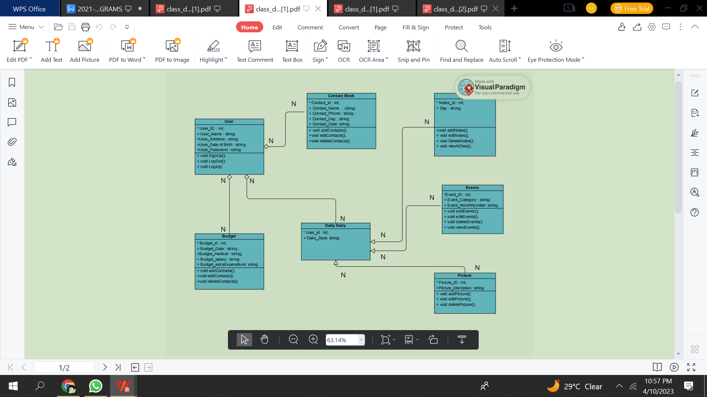

**(-----:OBJECT DIAGRAM:-----)**

The class diagram for the system includes objects of classes such as A1, B1, C1, E1, D1, P1, etc. These objects are connected to each other through association relation.

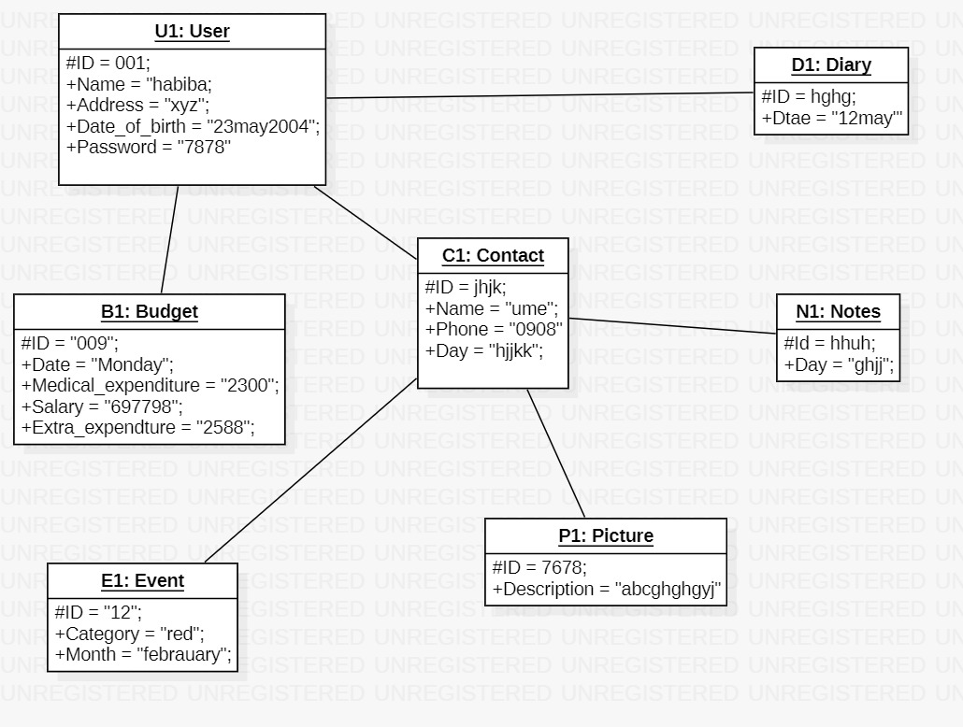

**(-----:SEQUENCE DIAGRAM:-----)**

This sequence diagram shows the flow of events when the Admin sign-up,login,adds a budget,edits a budget, delete a budget,adds a contact,edits a contact,deletes a contact,adds an event,edits an event,deletes an event,adds a note,deletes a note,edits a note,adds a picture ,views a note,edits a picture to the System and logout from the System, providing a visual representation of the interactions between the Admin and the System.

1. **LOGIN:**

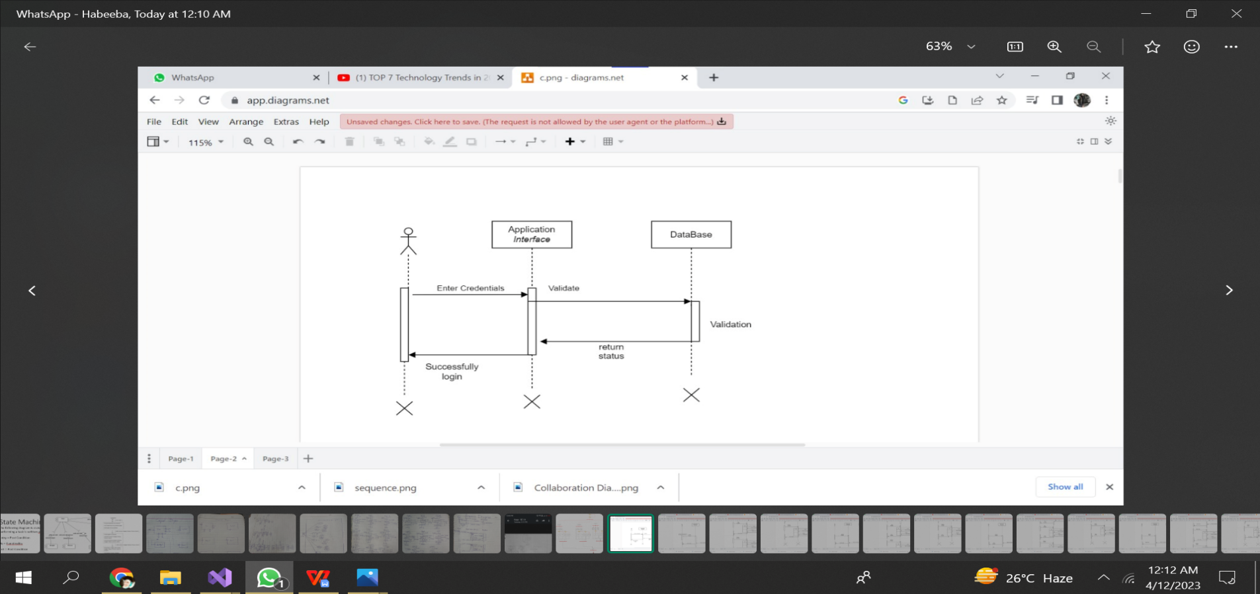

1. **CONTACTS:**

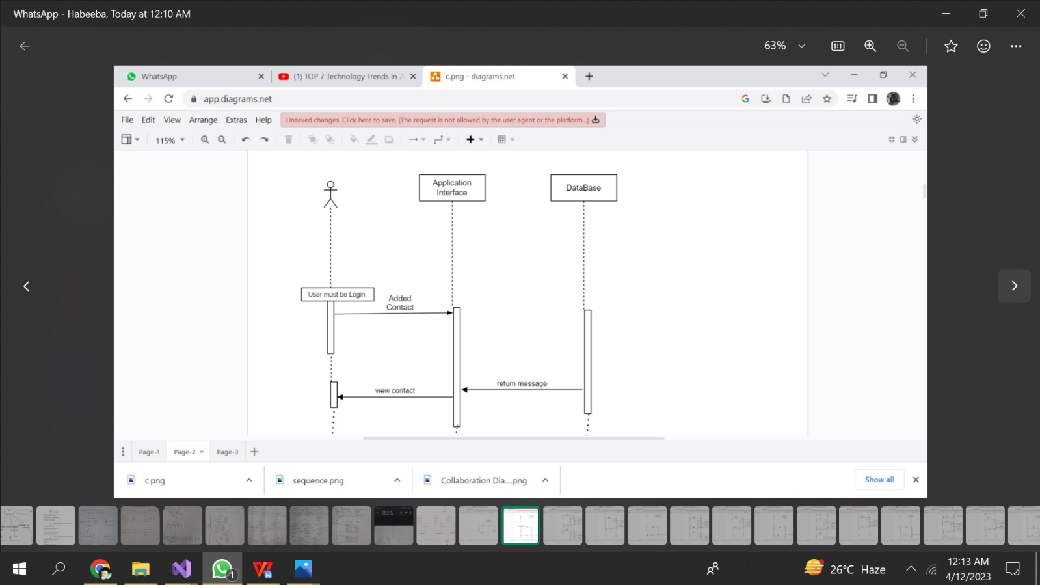

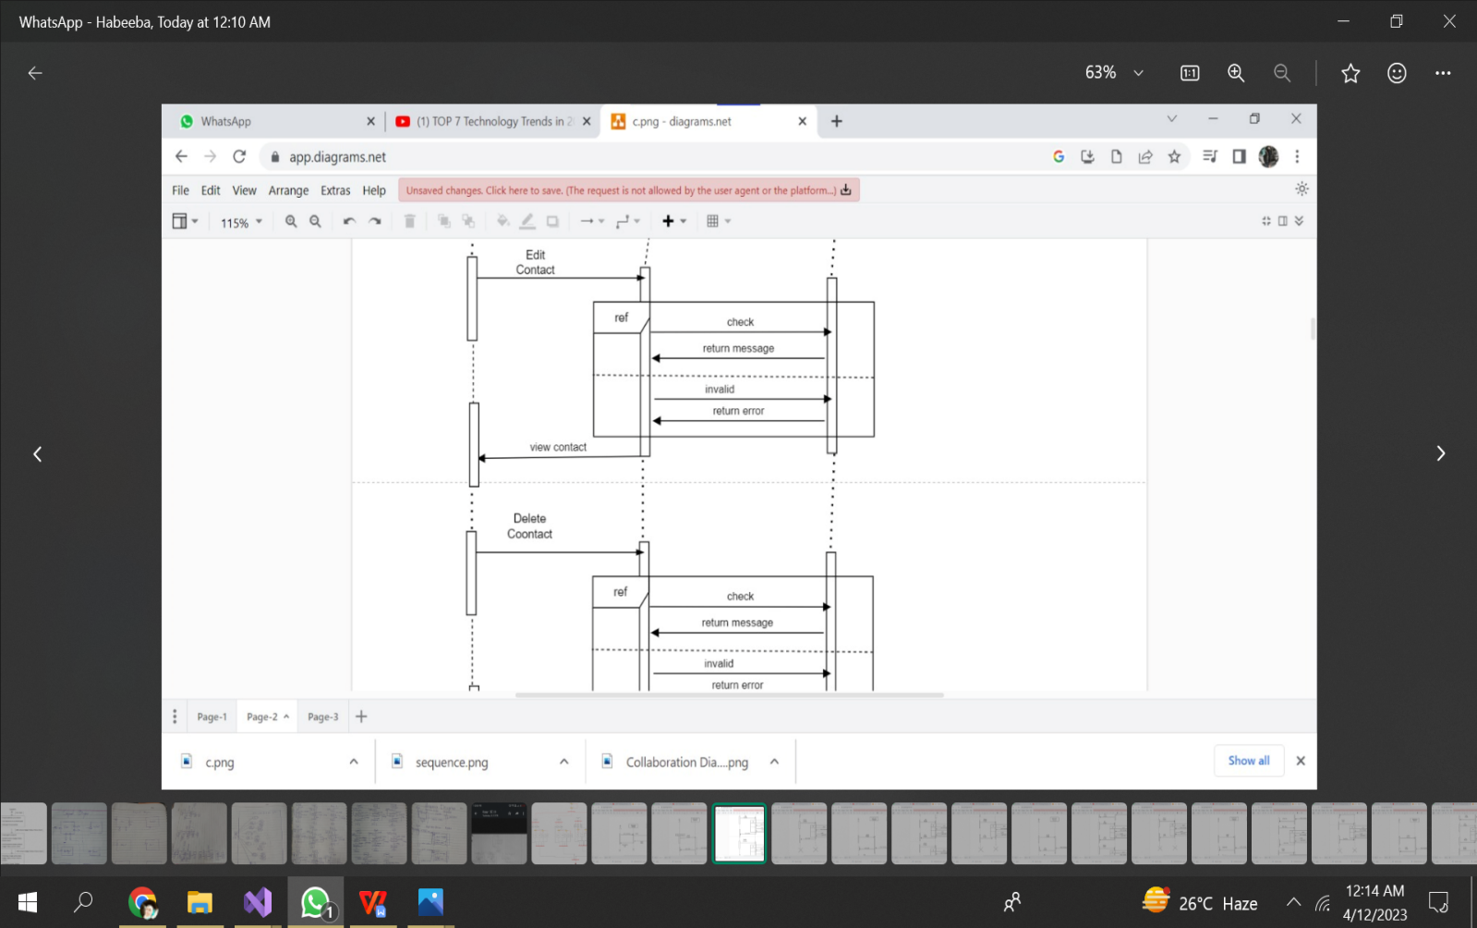

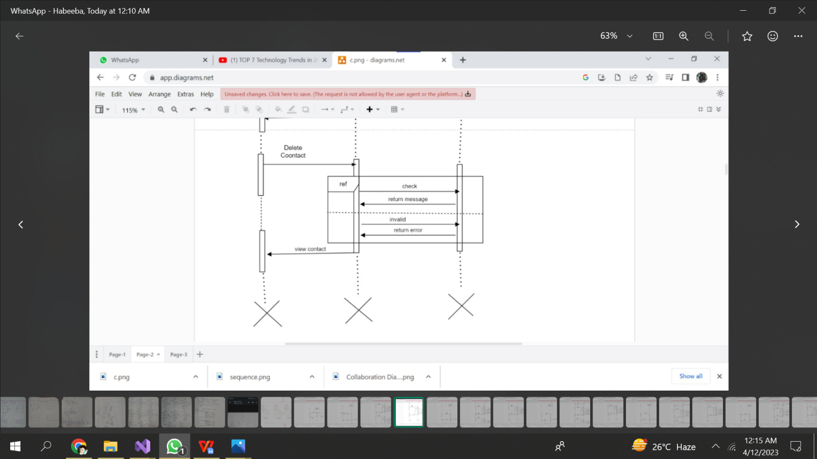

1. **BUDGET:**

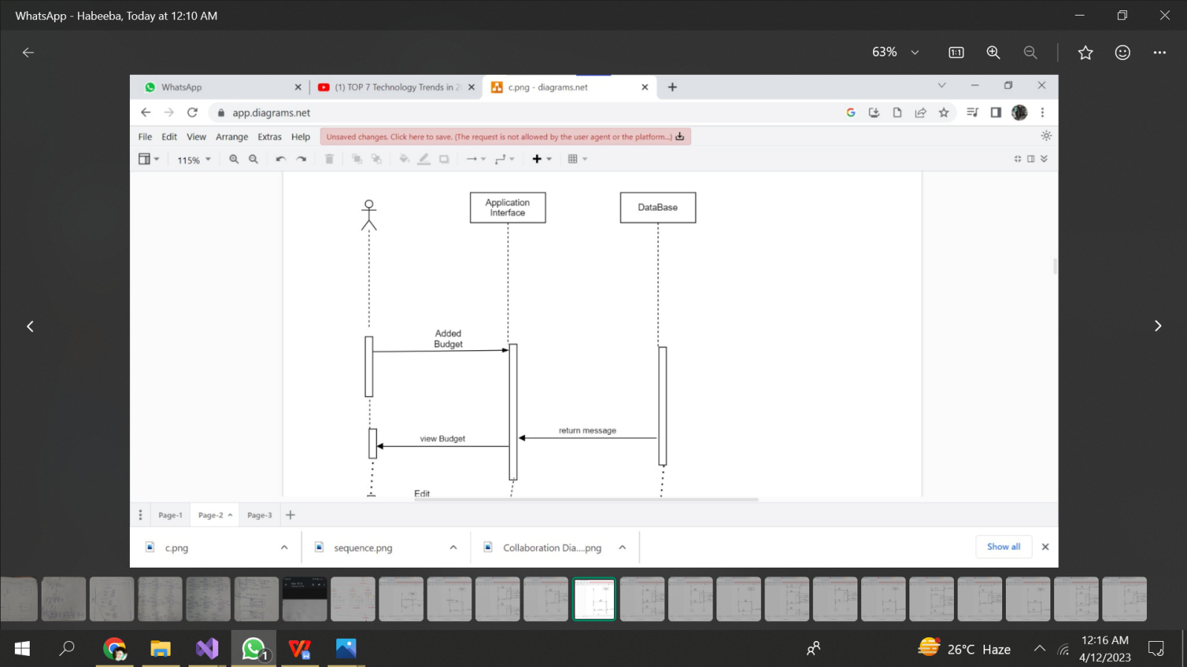

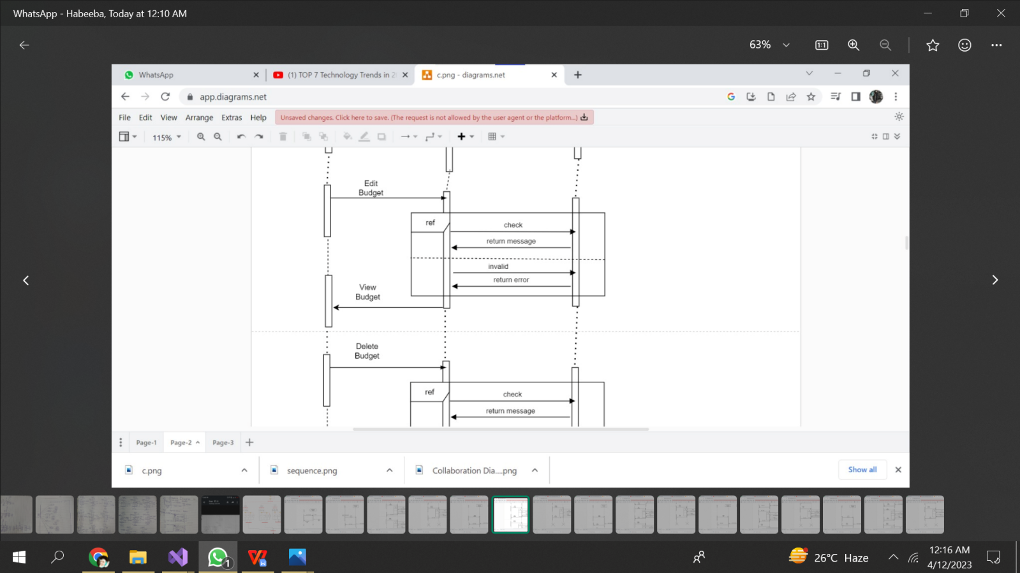

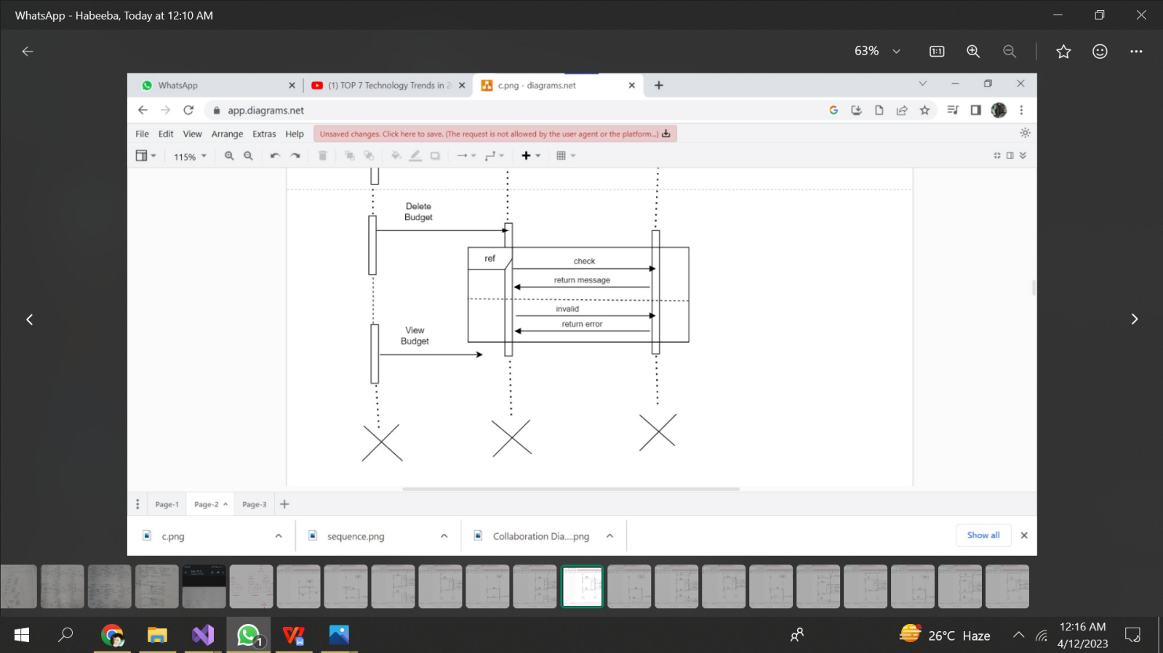

1. **PICTURES:**

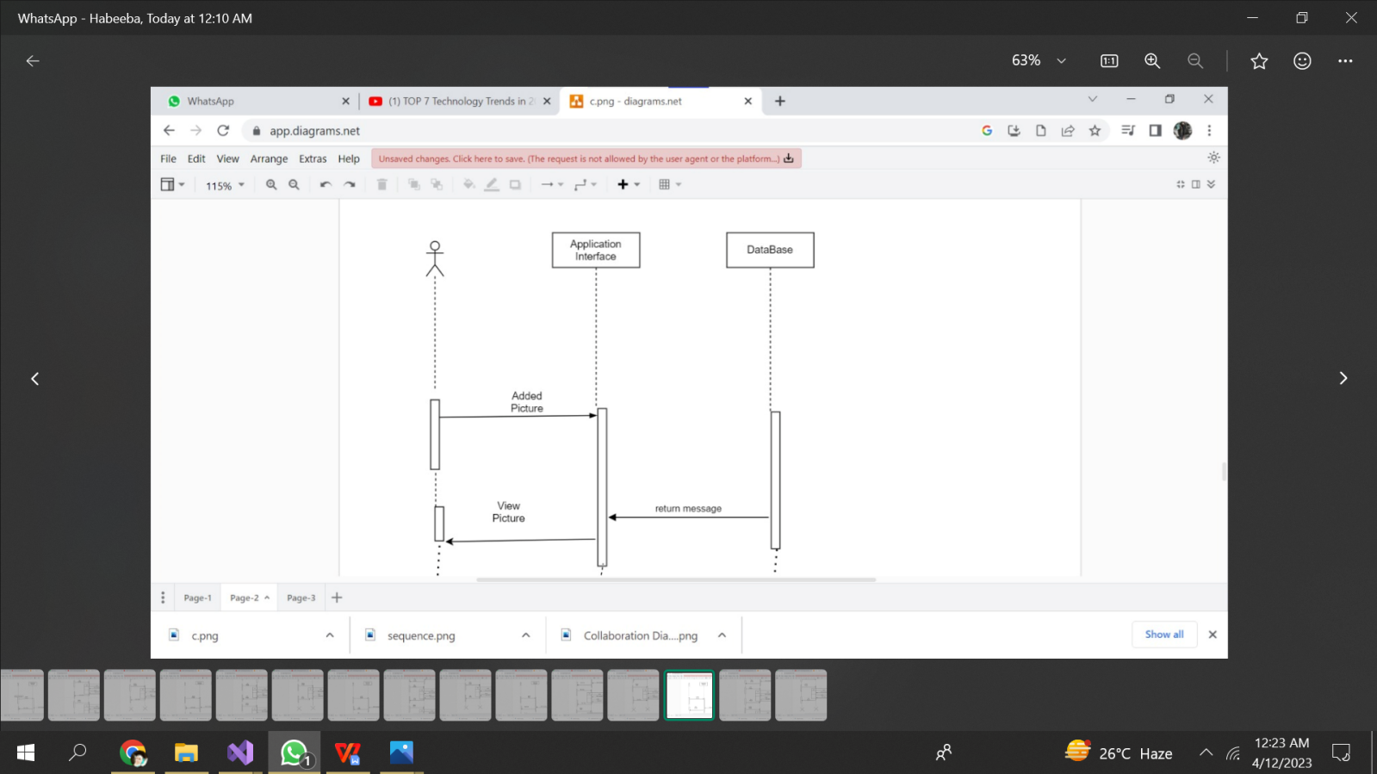

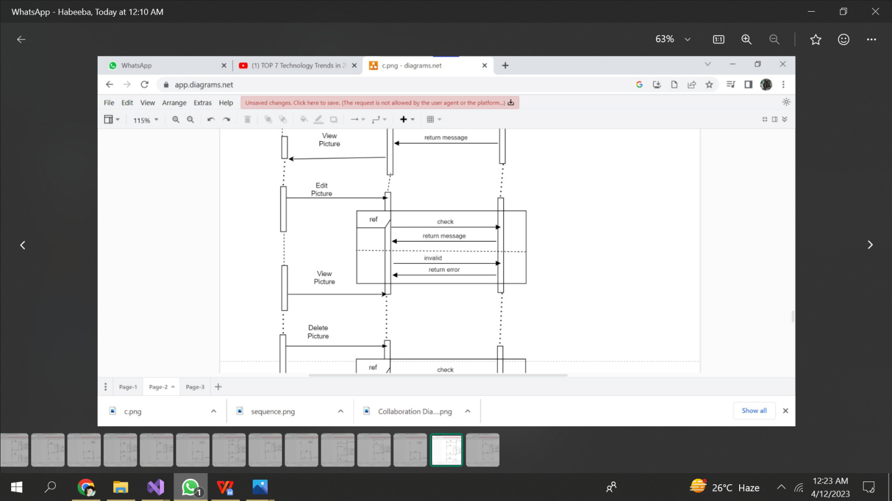

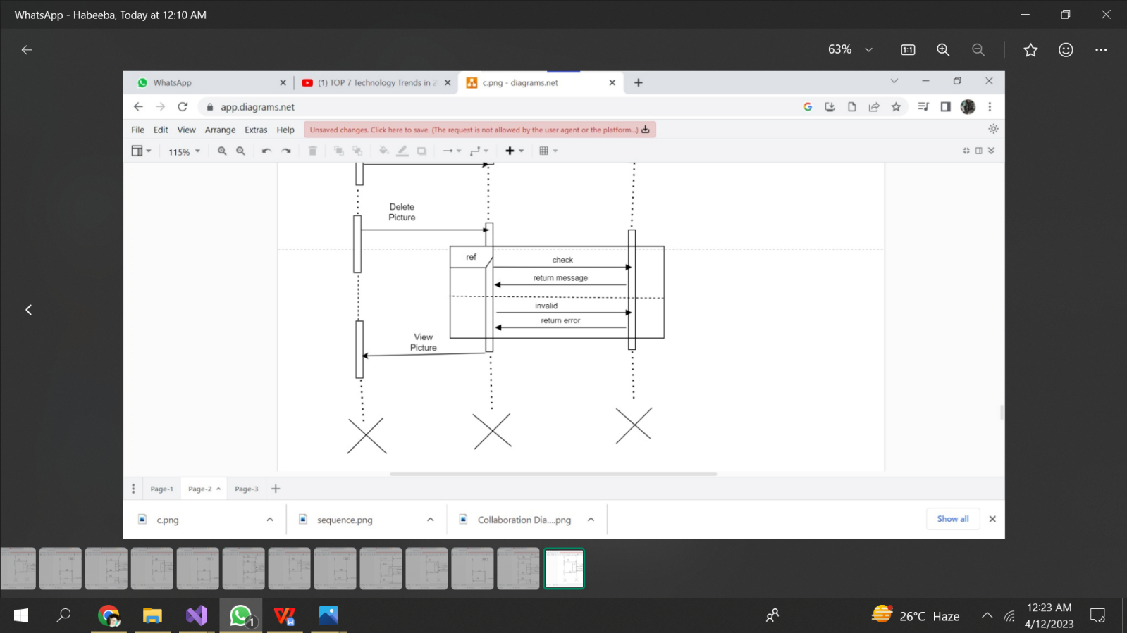

1. **EVENTS:**

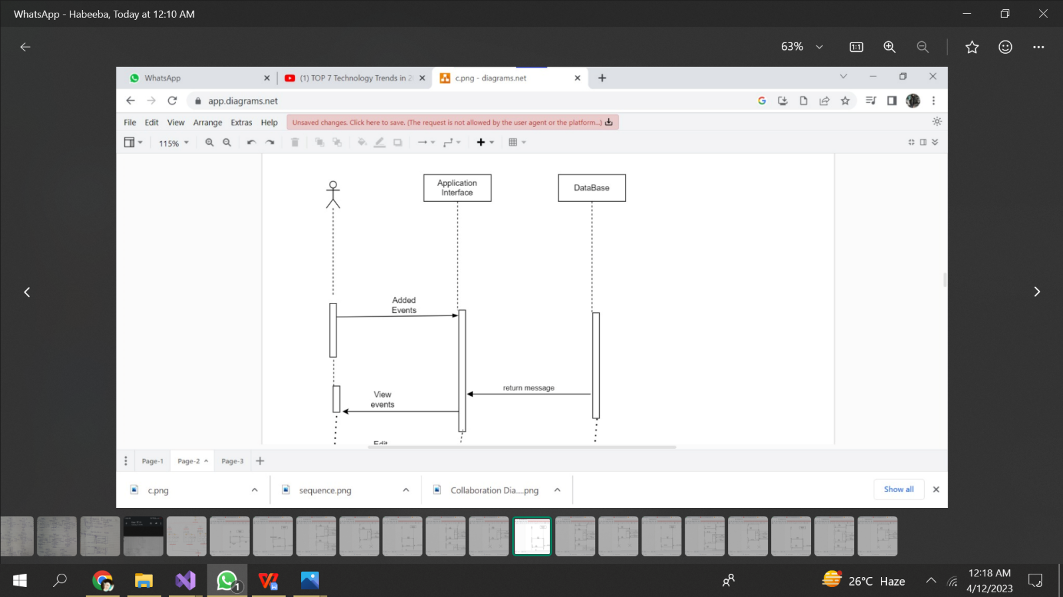

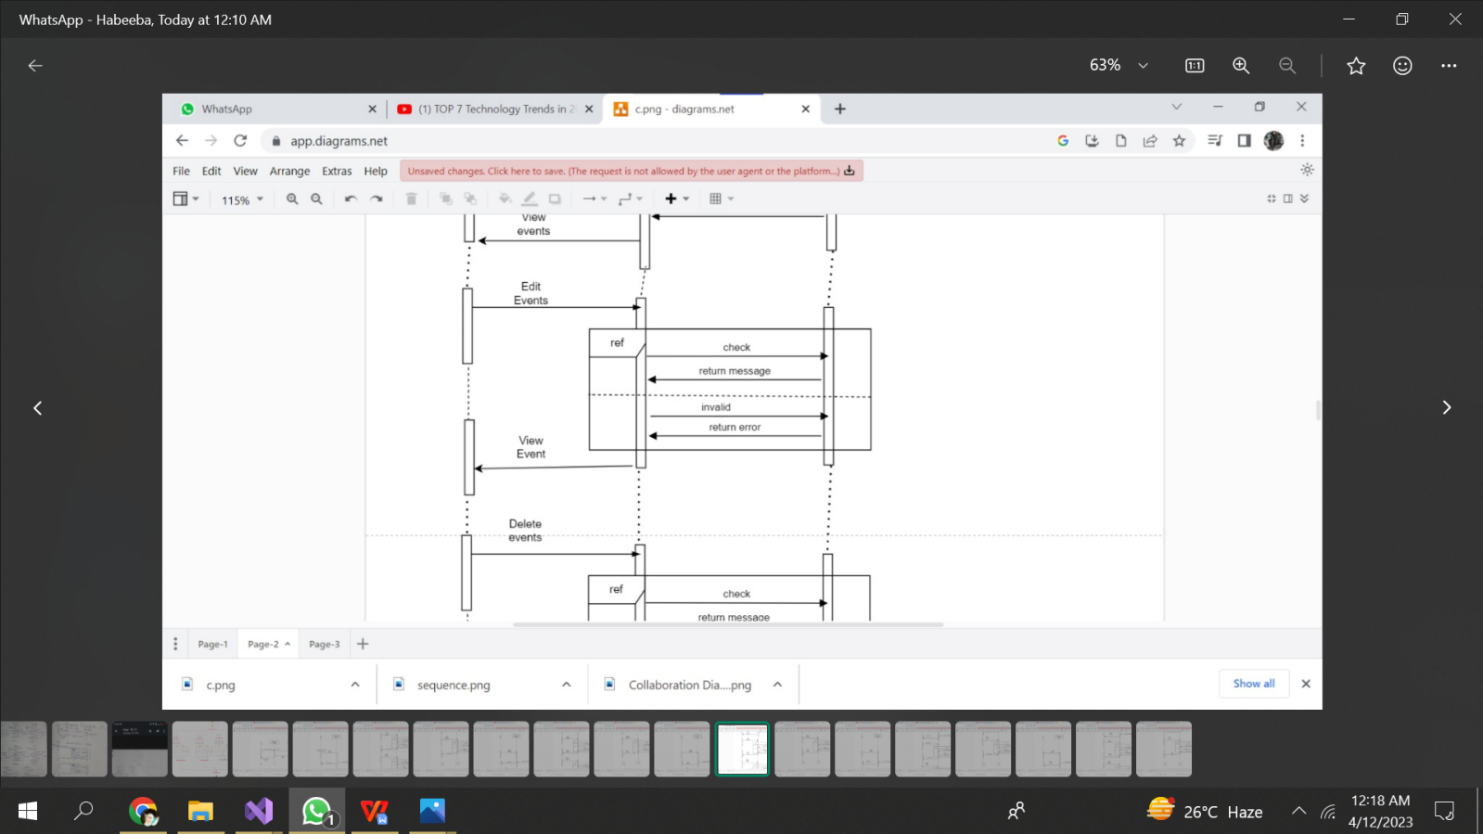

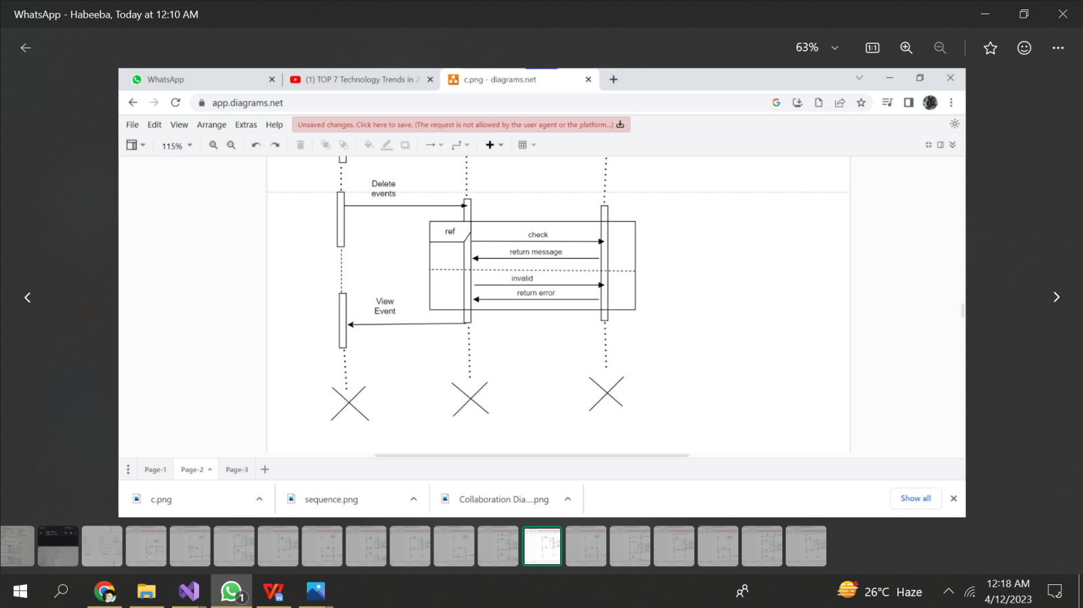

1. **NOTES:**

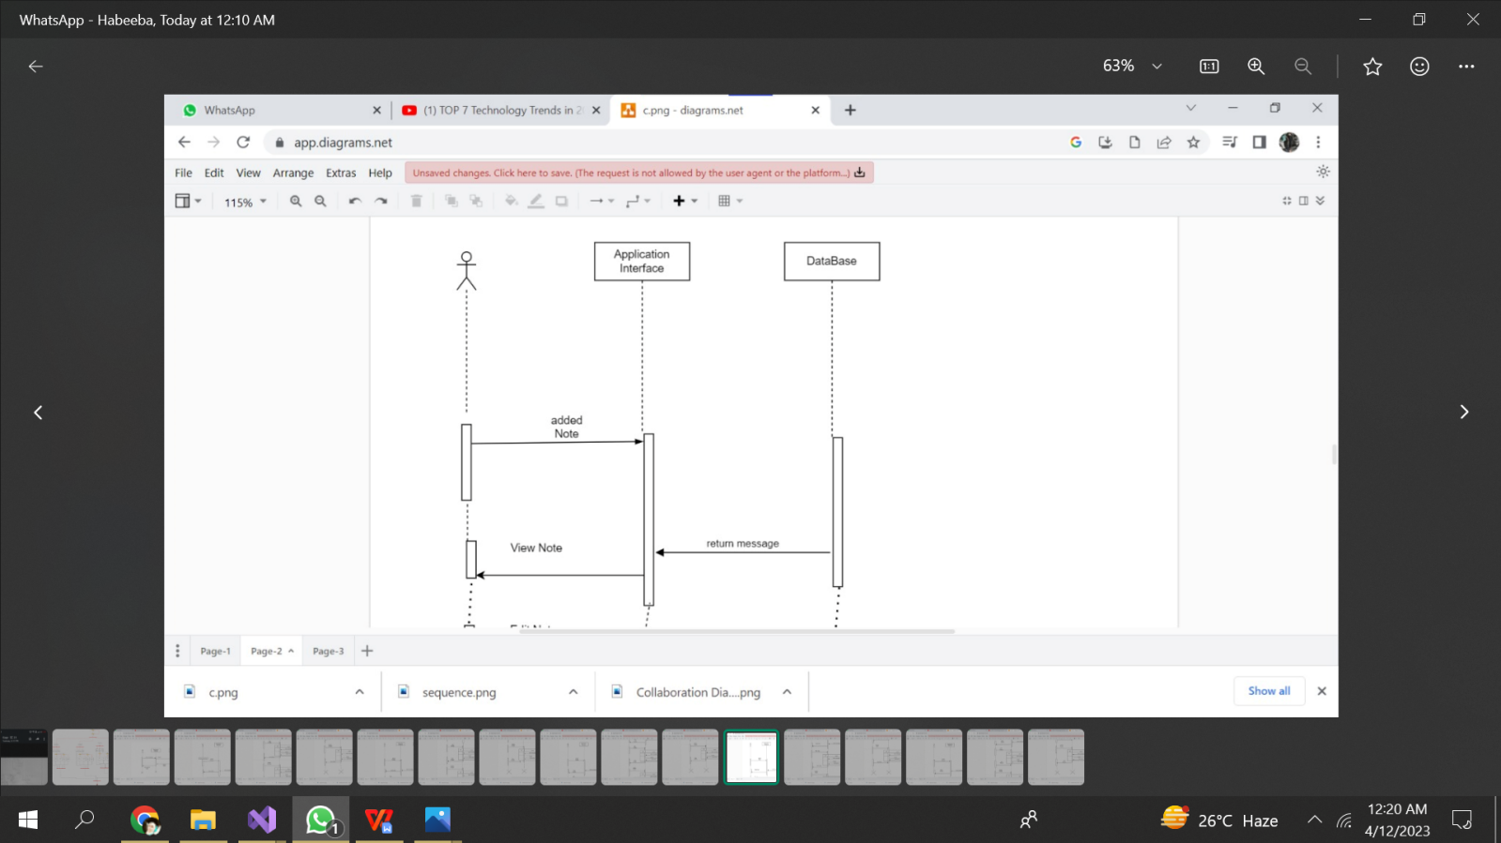

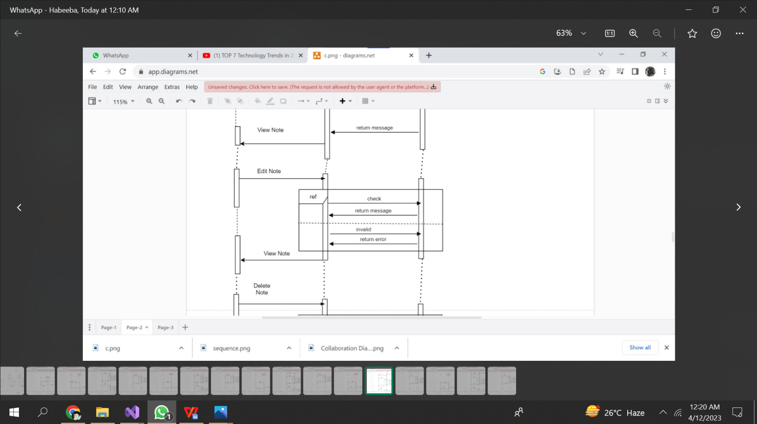

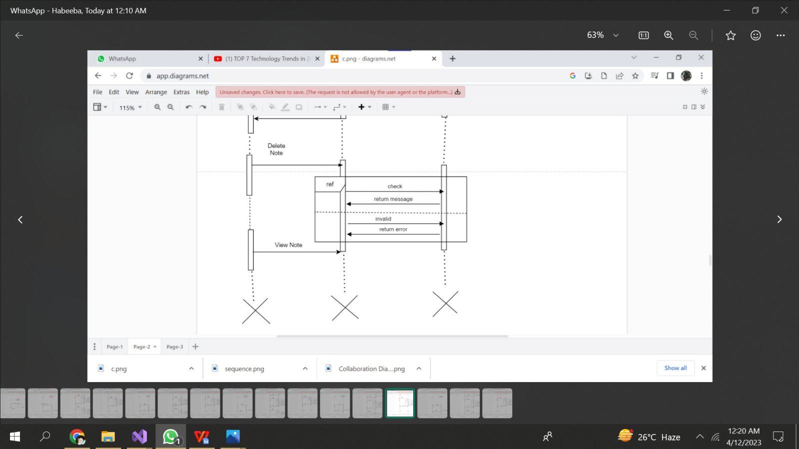

**(-----:COLLABORATION DIAGRAM:-----)**

This collaboration diagram shows the flow of events when the Admin sign-up,login,adds a budget,edits a budget, delete a budget,adds a contact,edits a contact,deletes a contact,adds an event,edits an event,deletes an event,adds a note,deletes a note,edits a note,adds a picture ,views a note,edits a picture and view all to the System and logout from the System, providing a visual representation of the interactions between the Admin and the System.

**LOGIN:**

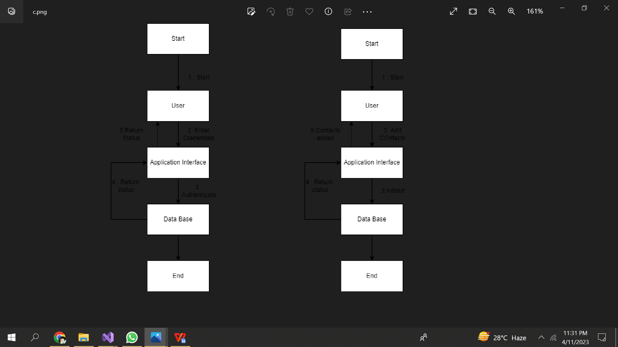

**ADD CONTACTS:**



**EDIT CONTACTS:**

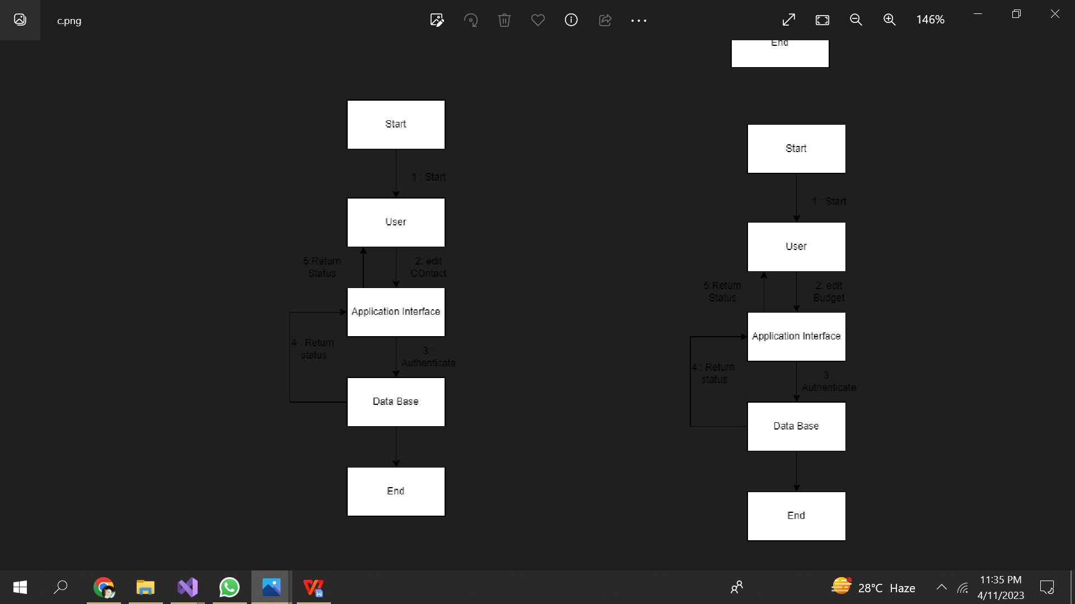

**ADD BUDGETS:**

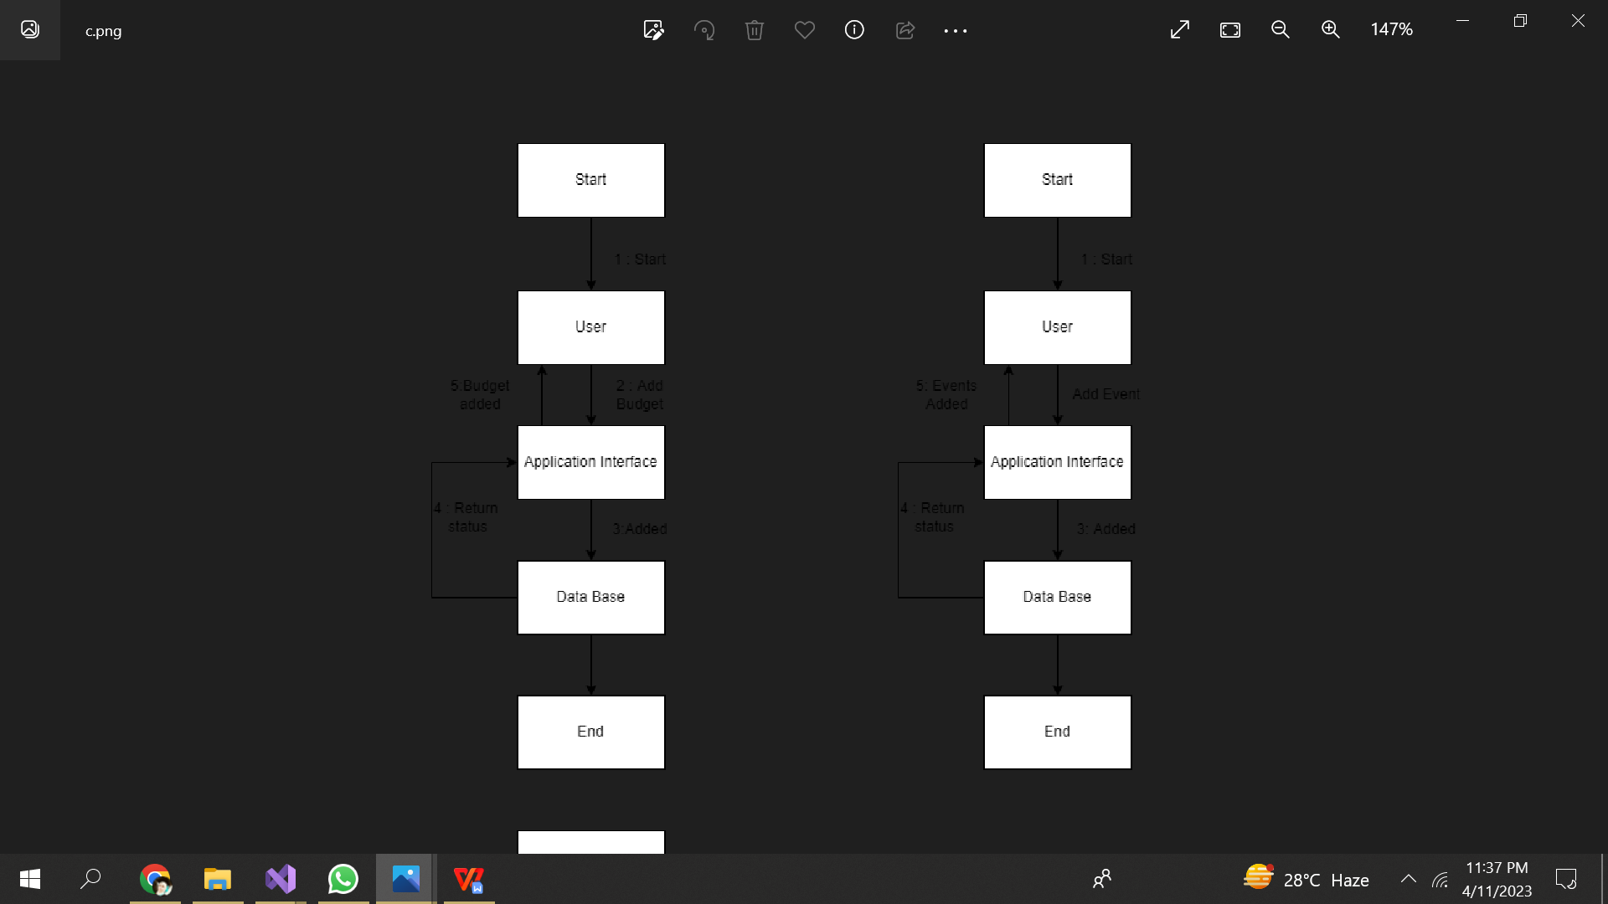

**EDIT BUDGET:**



**ADD EVENTS:**



**ADD PICTURES:**

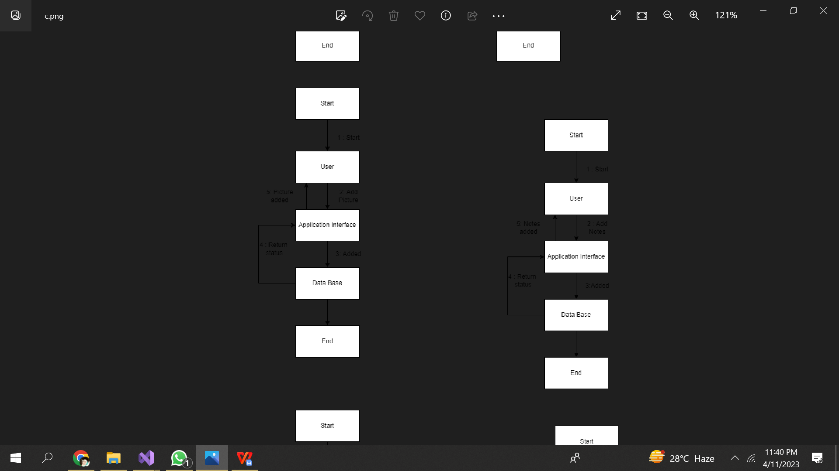

**ADD NOTES:**



**EDIT EVENTS:**

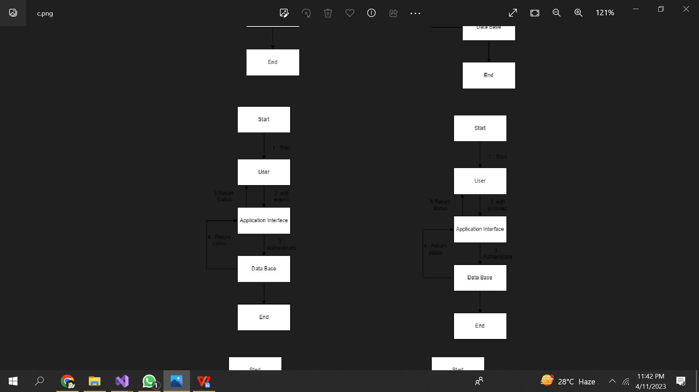

**EDIT PICTURES:**



**EDIT NOTES AND DELETE CONTACTS:**

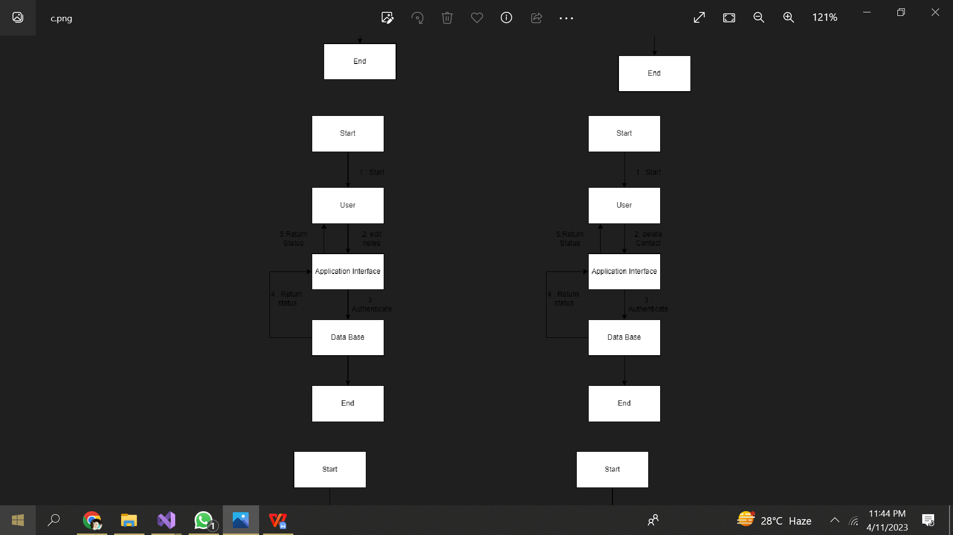

**EDIT BUDGET AND DELETE EVENTS:**

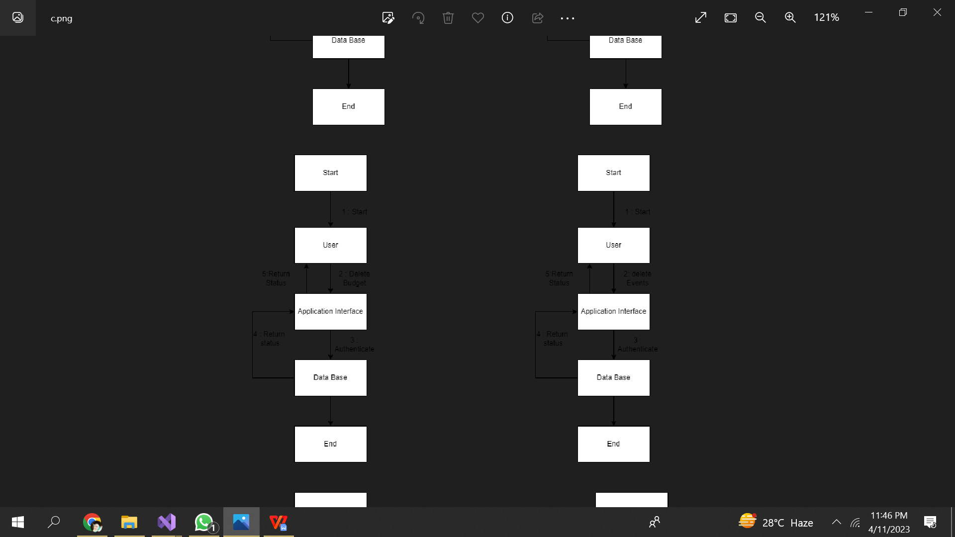

**EDIT PICTURES AND DELETE NOTES:**

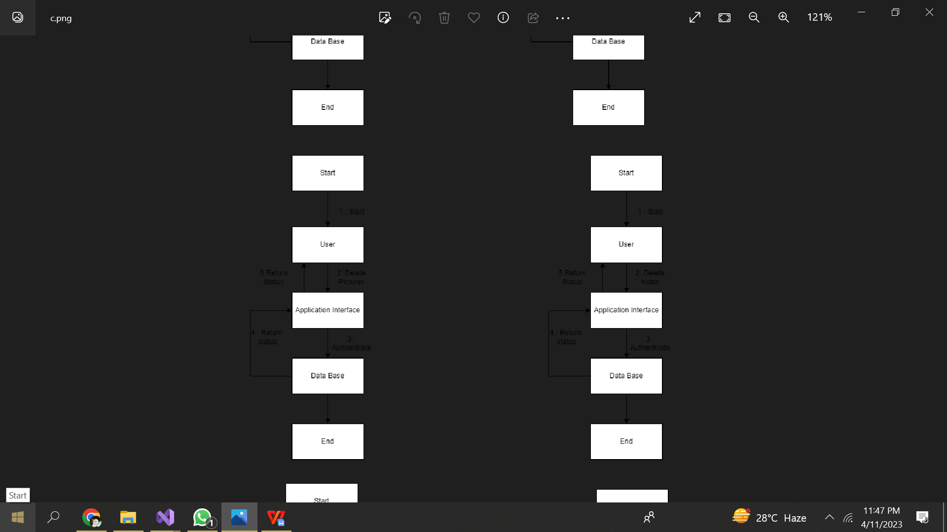

**VIEW PICTURES AND VIEW EVENTS:**

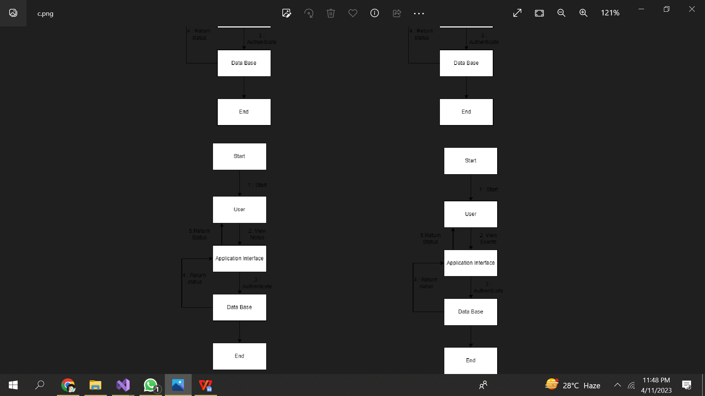

**(-----:ACTIVITY DIAGRAM:-----)**

This activity diagram shows the flow of events when the Admin sign-up,login,adds a budget,edits a budget, delete a budget,adds a contact,edits a contact,deletes a contact,adds an event,edits an event,deletes an event,adds a note,deletes a note,edits a note,adds a picture ,views a note,edits a picture to the System and logout from the System, providing a visual representation of the interactions between the Admin and the System.

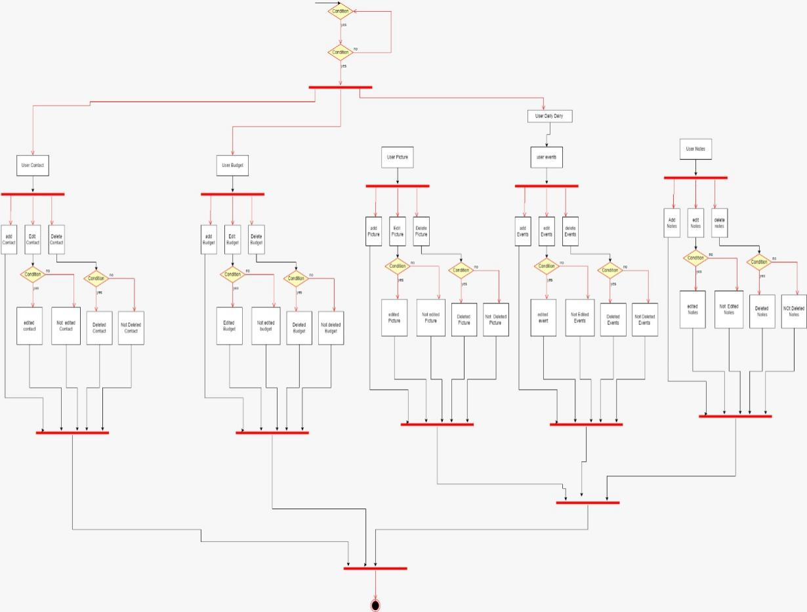

**(-----:STATE MACHINE DIAGRAM:-----)**

This state machine diagram shows the flow of events when the Admin sign-up,login,adds a budget,edits a budget, delete a budget,adds a contact,edits a contact,deletes a contact,adds an event,edits an event,deletes an event,adds a note,deletes a note,edits a note,adds a picture ,views a note,edits a picture to the System and logout from the System, providing a visual representation of the interactions between the Admin and the System.

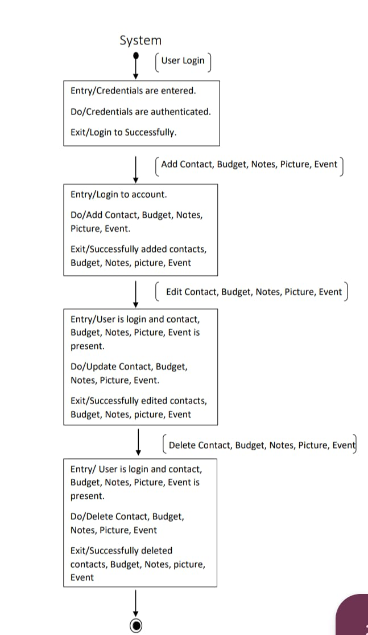

**(-----:PACKAGE DIAGRAM:-----)**

A package diagram provides a graphical representation of the dependencies between packages in our system.

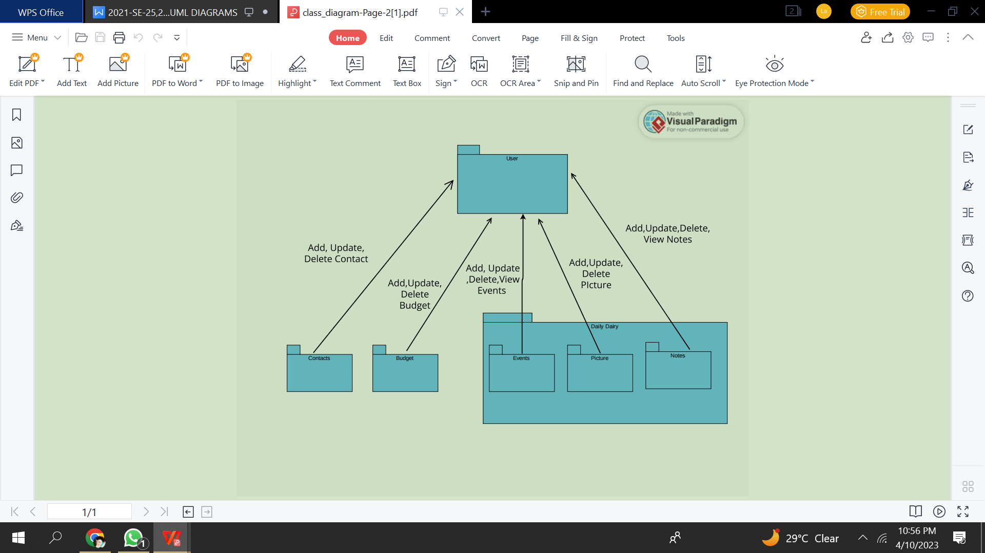

**(-----:COMPONENT DIAGRAM:-----)**

A component diagram represents the various components of the system, such as the Budget Manager, Contact Manager, Event Manager, and Note Manager, along with their interfaces and dependencies.

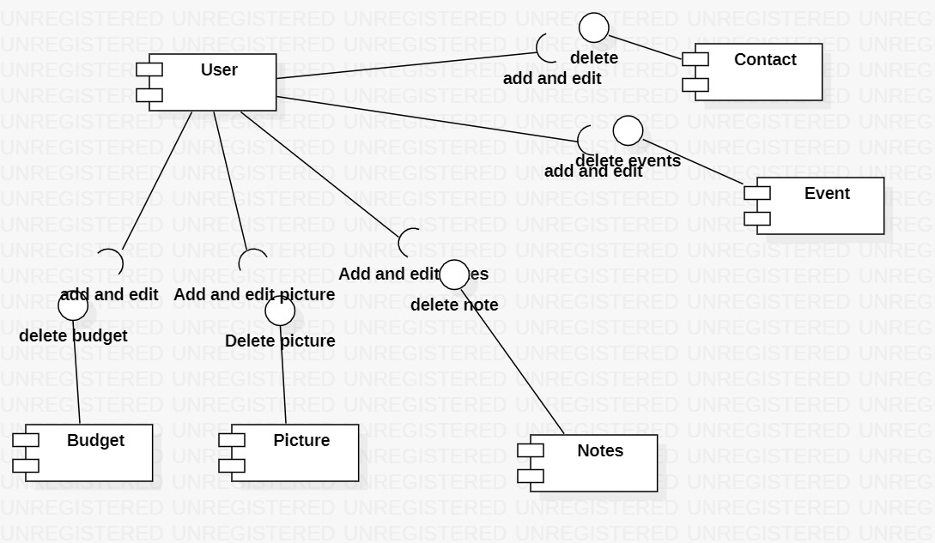

**(-----:DEPLOYMENT DIAGRAM:-----)**

A deployment diagram for the shows the physical deployment of the software system and hardware components, such as Database Servers and User PC.

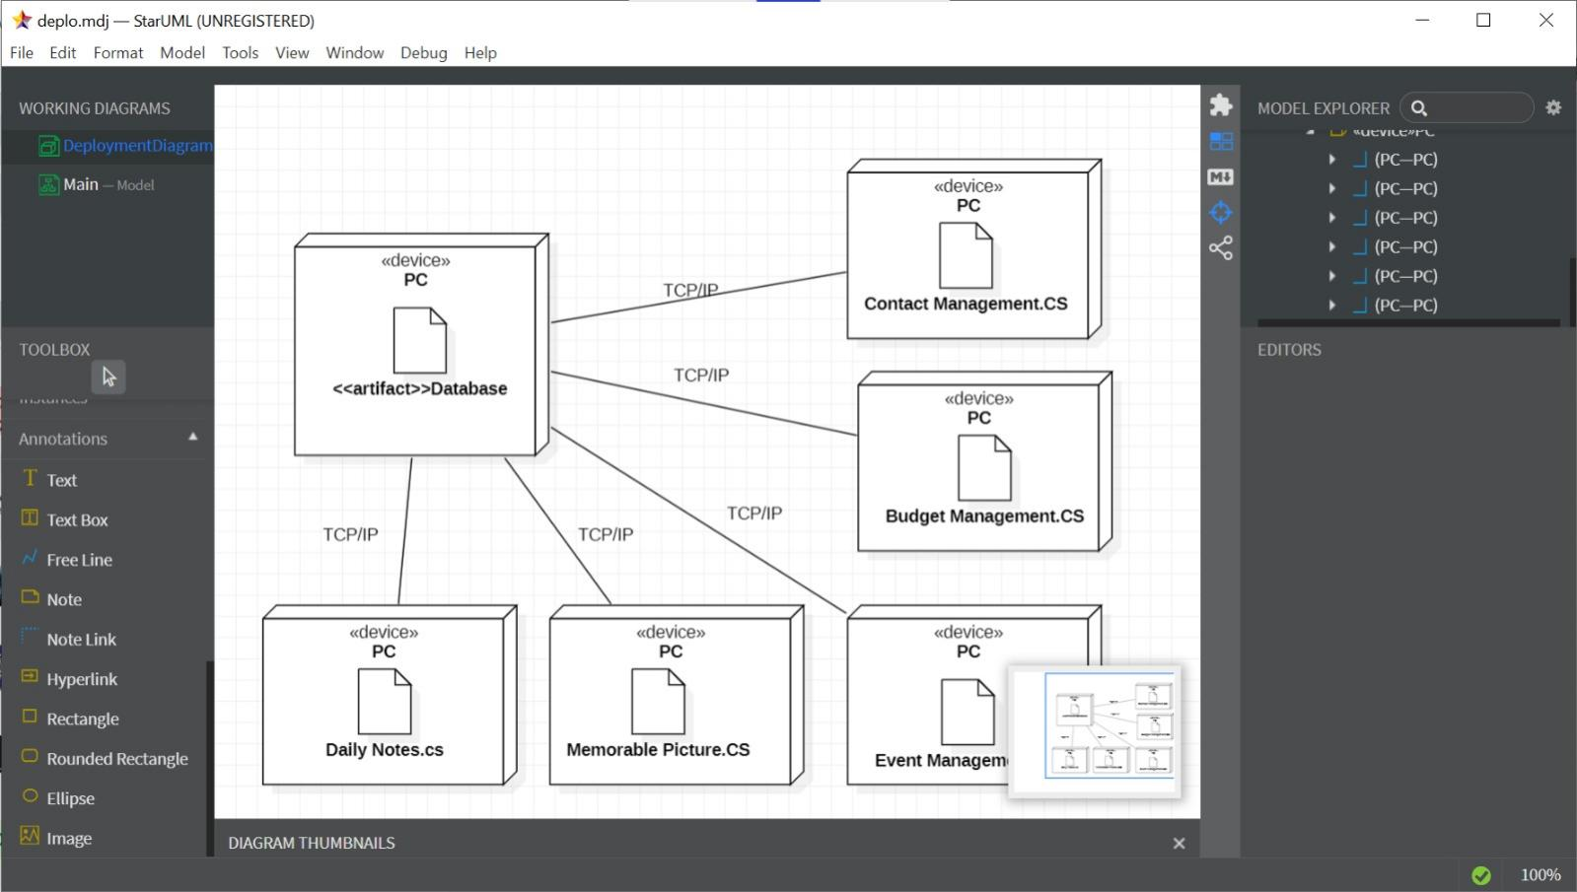

**(-----:TEST CASES:-----)**

**(-----:FUNCTIONAL TESTING-----)**

**Sign Up**

|  |  |  |  |  |  |  |  |  |  |  |
| --- | --- | --- | --- | --- | --- | --- | --- | --- | --- | --- |
| **Test Case ID** | | BU_001 | **Test Case Description** | | Test the Sign-Up Functionality in LLBB | | | | | |
| **Created By** | | Kausar, Habeeba, Laiba | **Reviewed By** | | Kausar, Habeeba, Laiba | | **Version** | | 1.0 | |
|  |  |  |  |  |  |  |  |  |  |  |
| **QA Tester’s Log** | | Review requirements incorporated in SRS | | | |  |  |  |  |  |
|  |  |  |  |  |  |  |  |  |  |  |
| **Tester's Name** | | Kausar, Habeeba, Laiba | **Date Tested** | | 23-April-2022 | | **Test Case (Pass/Fail/Not Executed)** | | Pass | |
|  |  |  |  |  |  |  |  |  |  |  |
| **S #** | **Prerequisites:** | | |  | **S #** | **Test Data** | | | | |
| 1 | Access to Visual Studio | | |  | 1 | Username=jameel02 | | | | |
|  |  | | |  | 2 | Password = Dg56hmL0 | | | | |
|  |  | | |  | 3 | Date-of-Birth=09-09-8-2004 | | | | |
|  |  | | |  | 4 | First Name=Ahmed | | | | |
|  |  | | |  | 5 | Last Name=Ali | | | | |
|  |  | | |  | 6 | Current Address=House#23, street#1 Lahore | | | | |
|  |  | | |  | 7 | Confirm Password= Dg56hmL0 | | | | |
|  |  | | |  | 8 | Sign-Up Button | | | | |
|  |  | | |  | 9 | Login Button | | | | |
|  |  | | |  | 10 | User_ID=1 | | | | |
|  |  |  |  |  |  |  |  |  |  |  |
| **Test Scenario** | Validate necessary details , so the user can create their account. | | | | | |  |  |  |  |

**TEST CASES**

|  |  |  |  |  |  |
| --- | --- | --- | --- | --- | --- |
| **Step #** | | **Step Details** | **Expected Results** | **Actual Results** | **Pass / Fail / Not executed / Suspended** |
|  |
| 1 | | Navigate to Sign-Up | App Sign-Page should open | As Expected | Pass |  |
| 2 | | Enter Username, Password, Confirm Password, First Name, Last Name, Current Address, Date-of-Birth,User_ID | Credential can be entered | As Expected | Pass |  |
| 3 | | Click Sign-Up button without entering Username, Password, Confirm Password, First Name, Last Name, Current Address, Date-of-Birth,User_ID | User should get registered and can login with valid credentials. | As Expected | Pass |  |
|  |
| 4 | | Click Sign-Up button with entering Username, Password, Confirm Password, First Name, Last Name, Current Address, Date-of-Birth,User_ID | Home page should be opened | As Expected | Pass |  |
| 5 | | Click Sign-Up button with entering Username, Password, First Name, Last Name, Current Address, Date-of-Birth without entering same Confirm Password as Password,User_ID | Next page should not be opened | As Expected | Pass |  |
| 6 | | Click Login button | Login page should be opened | As Expected | Pass |  |

**Login**

|  |  |  |  |  |  |  |  |  |  |  |
| --- | --- | --- | --- | --- | --- | --- | --- | --- | --- | --- |
| **Test Case ID** | | BU_002 | **Test Case Description** | | Test the Login Functionality in LLBB | | | | | |
| **Created By** | | Kausar, Habeeba, Laiba | **Reviewed By** | | Kausar, Habeeba, Laiba | | **Version** | | 1.0 | |
|  |  |  |  |  |  |  |  |  |  |  |
| **QA Tester’s Log** | | Review requirements incorporated in SRS | | | |  |  |  |  |  |
|  |  |  |  |  |  |  |  |  |  |  |
| **Tester's Name** | | Kausar, Habeeba, Laiba | **Date Tested** | | 23-April-2023 | | **Test Case (Pass/Fail/Not Executed)** | | Pass | |
|  |  |  |  |  |  |  |  |  |  |  |
| **S #** | **Prerequisites:** | | |  | **S #** | **Test Data** | | | | |
| 1 | Access to Visual Studio | | |  | 1 | Email1 = abc@gmail.com | | | | |
| 2 | Access to home page | | |  | 2 | Password = Dg56hmL0 | | | | |
| 3 | Access to Sign-Up Page | | |  | 3 | Email2=abc | | | | |
|  |  | | |  | 4 | Email3=abc @ | | | | |
|  |  | | |  | 5 | Email4=@gmail.com | | | | |
|  |  | | |  | 6 | Login button | | | | |
| **Test Scenario** | Verify on entering valid Email and password, the user can login | | | | | |  |  |  |  |

**TEST CASES**

|  |  |  |  |  |
| --- | --- | --- | --- | --- |
| **Step #** | **Step Details** | **Expected Results** | **Actual Results** | **Pass / Fail / Not executed / Suspended** |
|  |
| 1 | Navigate to Login | Page should be opened | As Expected | Pass |  |
| 2 | Enter Email1 & Password | Credential can be entered | As Expected | Pass |  |
| 3 | Enter Email2 & Password | Credential cannot be entered | As Expected | Pass |  |
| 4 | Enter Email3 & Password | Credential cannot be entered | As Expected | Pass |  |
| 5 | Enter Email4 & Password | Credential cannot be entered | As Expected | Pass |  |
| 6 | Enter Email only | Next page should not be opened | As Expected | Pass |  |
| 7 | Enter Password only | Next page should not be opened | As Expected | Pass |  |
| 8 | Click Login button without entering Email and Password | Next page should not be opened | As Expected | Pass |  |
| 9 | Enter correct Email and Password | Next pages can be opened | As Expected | Pass |  |
| 10 | Enter correct Email but incorrect password | Next page should not be opened | As Expected | Pass |  |
| 11 | Enter incorrect Email but correct password | Next page should not be opened | As Expected | Pass |  |
| 12 | Enter incorrect Email and password | Next page should not be opened | As Expected | Pass |  |
| 13 | Click Login | Product page should be opened | As Expected | Pass |  |
| 14 | Account doesn’t exist | Next page should not be opened | As Expected | Pass |  |

**Contact Management**

|  |  |  |  |  |  |  |  |  |  |  |
| --- | --- | --- | --- | --- | --- | --- | --- | --- | --- | --- |
| **Test Case ID** | | BU_003 | **Test Case Description** | | Test the Contact Functionality in LLBB | | | | | |
| **Created By** | | Kausar, Habeeba, Laiba | **Reviewed By** | | Kausar, Habeeba, Laiba | | **Version** | | 1.0 | |
|  |  |  |  |  |  |  |  |  |  |  |
| **QA Tester’s Log** | | Review requirements incorporated in SRS | | | |  |  |  |  |  |
|  |  |  |  |  |  |  |  |  |  |  |
| **Tester's Name** | | Kausar, Habeeba, Laiba | **Date Tested** | | 23-April-2023 | | **Test Case (Pass/Fail/Not Executed)** | | Pass | |
|  |  |  |  |  |  |  |  |  |  |  |
| **S #** | **Prerequisites:** | | |  | **S #** | **Test Data** | | | | |
| 1 | Access to Visual Studio | | |  | 1 | User_ID=1 | | | | |
| 2 | Access to home page | | |  | 2 | Phone Number=03017293034 | | | | |
|  |  | | |  | 3 | Date=09-08-2004 | | | | |
|  |  | | |  | 4 | Name=Asia | | | | |
|  |  | | |  | 5 | Address=ksk | | | | |
|  |  | | |  | 6 | Day=Monday | | | | |
|  |  | | |  | 4 | Add button | | | | |
|  |  | | |  | 5 | Delete button | | | | |
|  |  | | |  | 6 | Edit button | | | | |
|  |  | | |  |  |  | | | | |
| **Test Scenario** | Verify on entering valid user-id, the user can add,edit and delete contact | | | | | |  |  |  |  |

**TEST CASES**

|  |  |  |  |  |
| --- | --- | --- | --- | --- |
| **Step #** | **Step Details** | **Expected Results** | **Actual Results** | **Pass / Fail / Not executed / Suspended** |
|  |
| 1 | Navigate to Contact | Page should be opened | As Expected | Pass |  |
| 2 | Enter User_ID, PhoneNumber ,Date, Day, Name, Address | Credential can be entered | As Expected | Pass |  |
| 3 | Click add button by entering User_ID, PhoneNumber ,Date, Day, Name, Address | User should be added | As Expected | Pass |  |
| 4 | Click add button by entering PhoneNumber ,Date, Day, Name, Address without entering User_ID | User should not be added | As Expected | Pass |  |
| 5 | Click Edit button by already existing User_id | User data should be edited | As Expected | Pass |  |
| 6 | Click Edit button by un-existed User_id | User data should not be edited | As Expected | Pass |  |
| 7 | Click delete button by un-existed User_id | User data should not be deleted | As Expected | Pass |  |
| 8 | Click delete button by already existing User_id | User data should be deleted | As Expected | Pass |  |

**Budget Management**

|  |  |  |  |  |  |  |  |  |  |  |
| --- | --- | --- | --- | --- | --- | --- | --- | --- | --- | --- |
| **Test Case ID** | | BU_004 | **Test Case Description** | | Test the Budget Functionality in LLBB | | | | | |
| **Created By** | | Kausar, Habeeba, Laiba | **Reviewed By** | | Kausar, Habeeba, Laiba | | **Version** | | 1.0 | |
|  |  |  |  |  |  |  |  |  |  |  |
| **QA Tester’s Log** | | Review requirements incorporated in SRS | | | |  |  |  |  |  |
|  |  |  |  |  |  |  |  |  |  |  |
| **Tester's Name** | | Kausar, Habeeba, Laiba | **Date Tested** | | 23-April-2023 | | **Test Case (Pass/Fail/Not Executed)** | | Pass | |
|  |  |  |  |  |  |  |  |  |  |  |
| **S #** | **Prerequisites:** | | |  | **S #** | **Test Data** | | | | |
| 1 | Access to Visual Studio | | |  | 1 | User_ID=1 | | | | |
| 2 | Access to home page | | |  | 2 | Net income=1000000 | | | | |
|  |  | | |  | 3 | Source of Income= Chat gbt | | | | |
|  |  | | |  | 4 | Bill exp=3000 | | | | |
|  |  | | |  | 5 | Internet exp=4000 | | | | |
|  |  | | |  | 6 | Medical exp=2000 | | | | |
|  |  | | |  | 7 | Edu exp=5000 | | | | |
|  |  | | |  | 8 | Food exp=8000 | | | | |
|  |  | | |  | 9 | Misc exp=3000 | | | | |
|  |  | | |  | 10 | Date=09-08-2004 | | | | |
|  |  | | |  | 11 | Add button | | | | |
|  |  | | |  | 12 | Delete button | | | | |
|  |  | | |  | 13 | Edit button | | | | |
|  |  | | |  |  |  | | | | |
| **Test Scenario** | Verify on entering valid user-id, the user can add,edit and delete budget | | | | | |  |  |  |  |

**TEST CASES**

|  |  |  |  |  |
| --- | --- | --- | --- | --- |
| **Step #** | **Step Details** | **Expected Results** | **Actual Results** | **Pass / Fail / Not executed / Suspended** |
|  |
| 1 | Navigate to Budget | Page should be opened | As Expected | Pass |  |
| 2 | Enter User_ID, Date, Net income, Source of Income, Bill exp, Internet exp, Medical exp, Edu exp, Food exp, Misc exp | Credential can be entered | As Expected | Pass |  |
| 3 | Click add button by entering User_ID, Date, Net income, Source of Income, Bill exp, Internet exp, Medical exp, Edu exp, Food exp, Misc exp | User should be added | As Expected | Pass |  |
| 4 | Click add button by entering Date, Net income, Source of Income, Bill exp, Internet exp, Medical exp, Edu exp, Food exp, Misc exp without entering User_ID | User should not be added | As Expected | Pass |  |
| 5 | Click Edit button by already existing User_id | User data should be edited | As Expected | Pass |  |
| 6 | Click Edit button by un-existed User_id | User data should not be edited | As Expected | Pass |  |
| 7 | Click delete button by un-existed User_id | User data should not be deleted | As Expected | Pass |  |
| 8 | Click delete button by already existing User_id | User data should be deleted | As Expected | Pass |  |

**Notes Management**

|  |  |  |  |  |  |  |  |  |  |  |
| --- | --- | --- | --- | --- | --- | --- | --- | --- | --- | --- |
| **Test Case ID** | | BU_005 | **Test Case Description** | | Test the Notes Functionality in LLBB | | | | | |
| **Created By** | | Kausar, Habeeba, Laiba | **Reviewed By** | | Kausar, Habeeba, Laiba | | **Version** | | 1.0 | |
|  |  |  |  |  |  |  |  |  |  |  |
| **QA Tester’s Log** | | Review requirements incorporated in SRS | | | |  |  |  |  |  |
|  |  |  |  |  |  |  |  |  |  |  |
| **Tester's Name** | | Kausar, Habeeba, Laiba | **Date Tested** | | 23-April-2023 | | **Test Case (Pass/Fail/Not Executed)** | | Pass | |
|  |  |  |  |  |  |  |  |  |  |  |
| **S #** | **Prerequisites:** | | |  | **S #** | **Test Data** | | | | |
| 1 | Access to Visual Studio | | |  | 1 | User_ID=1 | | | | |
| 2 | Access to diary page | | |  | 2 | Notes=I have to complete my project | | | | |
|  |  | | |  | 3 | Day=Monday | | | | |
|  |  | | |  | 4 | Date=09-08-2004 | | | | |
|  |  | | |  | 5 | Add button | | | | |
|  |  | | |  | 6 | Delete button | | | | |
|  |  | | |  | 7 | Edit button | | | | |
|  |  | | |  |  |  | | | | |
| **Test Scenario** | Verify on entering valid user-id, the user can add,edit and delete notes | | | | | |  |  |  |  |

**TEST CASES**

|  |  |  |  |  |
| --- | --- | --- | --- | --- |
| **Step #** | **Step Details** | **Expected Results** | **Actual Results** | **Pass / Fail / Not executed / Suspended** |
|  |
| 1 | Navigate to Notes | Page should be opened | As Expected | Pass |  |
| 2 | Enter User_ID, Date, Notes, Day | Credential can be entered | As Expected | Pass |  |
| 3 | Click add button by entering User_ID, Date, Notes, Day | User should be added | As Expected | Pass |  |
| 4 | Click add button by entering User_ID, Date, Notes, Day without entering User_ID | User should not be added | As Expected | Pass |  |
| 5 | Click Edit button by already existing User_id | User data should be edited | As Expected | Pass |  |
| 6 | Click Edit button by un-existed User_id | User data should not be edited | As Expected | Pass |  |
| 7 | Click delete button by un-existed User_id | User data should not be deleted | As Expected | Pass |  |
| 8 | Click delete button by already existing User_id | User data should be deleted | As Expected | Pass |  |

**Event Management**

|  |  |  |  |  |  |  |  |  |  |  |
| --- | --- | --- | --- | --- | --- | --- | --- | --- | --- | --- |
| **Test Case ID** | | BU_006 | **Test Case Description** | | Test the Event Functionality in LLBB | | | | | |
| **Created By** | | Kausar, Habeeba, Laiba | **Reviewed By** | | Kausar, Habeeba, Laiba | | **Version** | | 1.0 | |
|  |  |  |  |  |  |  |  |  |  |  |
| **QA Tester’s Log** | | Review requirements incorporated in SRS | | | |  |  |  |  |  |
|  |  |  |  |  |  |  |  |  |  |  |
| **Tester's Name** | | Kausar, Habeeba, Laiba | **Date Tested** | | 23-April-2023 | | **Test Case (Pass/Fail/Not Executed)** | | Pass | |
|  |  |  |  |  |  |  |  |  |  |  |
| **S #** | **Prerequisites:** | | |  | **S #** | **Test Data** | | | | |
| 1 | Access to Visual Studio | | |  | 1 | User_ID=1 | | | | |
| 2 | Access to diary page | | |  | 2 | Category=Urgent | | | | |
|  |  | | |  | 3 | Day_No=3 | | | | |
|  |  | | |  | 4 | Month_No=9 | | | | |
|  |  | | |  | 5 | Year=2003 | | | | |
|  |  | | |  | 6 | Time=10AM | | | | |
|  |  | | |  | 7 | Add button | | | | |
|  |  | | |  | 8 | Delete button | | | | |
|  |  | | |  | 9 | Edit button | | | | |
| **Test Scenario** | Verify on entering valid user-id, the user can add,edit and delete events | | | | | |  |  |  |  |

**TEST CASES**

|  |  |  |  |  |
| --- | --- | --- | --- | --- |
| **Step #** | **Step Details** | **Expected Results** | **Actual Results** | **Pass / Fail / Not executed / Suspended** |
|  |
| 1 | Navigate to Events | Page should be opened | As Expected | Pass |  |
| 2 | Enter User_ID, Day_No, Month_No,Year,Time,Category | Credential can be entered | As Expected | Pass |  |
| 3 | Click add button by entering User_ID, Day_No, Month_No,Year,Time,Category | User should be added | As Expected | Pass |  |
| 4 | Click add button by entering User_ID, Day_No, Month_No,Year,Time,Category without entering User_ID | User should not be added | As Expected | Pass |  |
| 5 | Click Edit button by already existing User_id | User data should be edited | As Expected | Pass |  |
| 6 | Click Edit button by un-existed User_id | User data should not be edited | As Expected | Pass |  |
| 7 | Click delete button by un-existed User_id | User data should not be deleted | As Expected | Pass |  |
| 8 | Click delete button by already existing User_id | User data should be deleted | As Expected | Pass |  |

**(-----:USER INTERFACE TESTING-----)**

**SIGN-UP**

|  |  |  |  |  |  |  |  |  |  |  |
| --- | --- | --- | --- | --- | --- | --- | --- | --- | --- | --- |
| **Test Case ID** | | U_001 | **Test Case Description** | | Test the Sign-Up Interface in LLBB | | | | | |
| **Created By** | | Kausar, Habeeba, Laiba | **Reviewed By** | | Kausar, Habeeba, Laiba | | **Version** | | 1.0 | |
|  |  |  |  |  |  |  |  |  |  |  |
| **QA Tester’s Log** | | Review wireframes incorporated in SRS | | | |  |  |  |  |  |
|  |  |  |  |  |  |  |  |  |  |  |
| **Tester's Name** | | Kausar, Habeeba, Laiba | **Date Tested** | | 23-April-2022 | | **Test Case (Pass/Fail/Not Executed)** | | Pass | |
|  |  |  |  |  |  |  |  |  |  |  |
| **S #** | **Prerequisites:** | | |  | **S #** | **Test Data** | | | | |
| 1 | Wireframes are already designed | | |  | 1 | TextBoxes | | | | |
| 2 | Have access to different types of devices such as mobile, laptop, tablet | | |  | 2 | Sign-Up Button | | | | |
|  |  | | |  | 3 | Login Button | | | | |
|  |  | | |  | 4 | labels | | | | |
|  |  | | |  | 5 | Username=jameel02 | | | | |
|  |  | | |  | 6 | Password = Dg56hmL0 | | | | |
|  |  | | |  | 7 | Date-of-Birth=09-09-8-2004 | | | | |
|  |  | | |  | 8 | First Name=Ahmed | | | | |
|  |  | | |  | 9 | Last Name=Ali | | | | |
|  |  | | |  | 10 | Current Address=House#23, street#1 Lahore | | | | |
|  |  | | |  | 11 | Confirm Password= Dg56hmL0 | | | | |
| **Test Scenario** | Validate responsiveness,links,textboxes,labels according to wireframes, so the user can create their account easily . | | | | | |  |  |  |  |

**TEST CASES**

|  |  |  |  |  |  |
| --- | --- | --- | --- | --- | --- |
| **Step #** | | **Step Details** | **Expected Results** | **Actual Results** | **Pass / Fail / Not executed / Suspended** |
|  |
| 1 | | Navigate to Sign-Up | App Sign-Page should open | As Expected | Pass |  |
| 2 | | Run application on Laptop | Pages should be re-sized automatically | As Expected | Pass |  |
| 3 | | Run application on mobile | Pages should be re-sized automatically | As Expected | Pass |  |
|  |
| 4 | | Click Sign-Up button with entering Username, Password, Confirm Password, First Name, Last Name, Current Address, Date-of-Birth,User_ID | User should get registered and can login with valid credentials. | As Expected | Pass |  |
| 5 | | Run application on tablet | Pages should be re-sized automatically | As Expected | Pass |  |
| 6 | | Click Login button | Login page should be opened | As Expected | Pass |  |
| 7 | | See No. of textboxes | No. of textboxes in app should be equal to No. of textboxes in wireframes | As Expected | Pass |  |
| 8 | | See text of labels | Text of labels should be same as written in wireframes | As Expected | Pass |  |

**Login**

|  |  |  |  |  |  |  |  |  |  |  |  |
| --- | --- | --- | --- | --- | --- | --- | --- | --- | --- | --- | --- |
| **Test Case ID** | | U_002 | **Test Case Description** | | Test the Login Interface in LLBB | | | | | | |
| **Created By** | | Kausar, Habeeba, Laiba | **Reviewed By** | | Kausar, Habeeba, Laiba | | **Version** | | 1.0 | | |
|  |  |  |  |  |  |  |  |  | |  |  | |
| **QA Tester’s Log** | | Review wireframes incorporated in SRS | | | |  |  |  | |  |  | |
|  |  |  |  |  |  |  |  |  | |  |  | |
| **Tester's Name** | | Kausar, Habeeba, Laiba | **Date Tested** | | 23-April-2023 | | **Test Case (Pass/Fail/Not Executed)** | | Pass | | |
|  |  |  |  |  |  |  |  |  | |  |  | |
| **S #** | **Prerequisites:** | | |  | **S #** | **Test Data** | | | | | |
| 1 | Wireframes are already designed | | |  | 1 | TextBoxes | | | | | |
| 2 | Have access to different types of devices such as mobile, laptop, tablet | | |  | 2 | labels | | | | | |
|  |  | | |  | 3 | Login Button | | | | | |
|  |  | | |  | 4 | Email1 = abc@gmail.com | | | | | |
|  |  | | |  | 5 | Password = Dg56hmL0 | | | | | |
| **Test Scenario** | Verify responsiveness, labels, textboxes, working of buttons and their links on entering valid Email and password, so the user can login on different devices | | | | | |  |  | |  |  | |

**TEST CASES**

|  |  |  |  |  |
| --- | --- | --- | --- | --- |
| **Step #** | **Step Details** | **Expected Results** | **Actual Results** | **Pass / Fail / Not executed / Suspended** |
|  |
| 1 | Navigate to Login | Page should be opened | As Expected | Pass |  |
| 2 | Run application on Laptop | Pages should be re-sized automatically | As Expected | Pass |  |
| 3 | Run application on mobile | Pages should be re-sized automatically | As Expected | Pass |  |
| 5 | Run application on tablet | Pages should be re-sized automatically | As Expected | Pass |  |
| 6 | Click Login button with entering valid Email and password | Home page should be opened | As Expected | Pass |  |
| 7 | See No. of textboxes | No. of textboxes in app should be equal to No. of textboxes in wireframes | As Expected | Pass |  |
| 8 | See text of labels | Text of labels should be same as written in wireframes | As Expected | Pass |  |

**Home**

|  |  |  |  |  |  |  |  |  |  |  |
| --- | --- | --- | --- | --- | --- | --- | --- | --- | --- | --- |
| **Test Case ID** | | U_003 | **Test Case Description** | | Test the Home Interface in LLBB | | | | | |
| **Created By** | | Kausar, Habeeba, Laiba | **Reviewed By** | | Kausar, Habeeba, Laiba | | **Version** | | 1.0 | |
|  |  |  |  |  |  |  |  |  |  |  |
| **QA Tester’s Log** | | Review wireframes incorporated in SRS | | | |  |  |  |  |  |
|  |  |  |  |  |  |  |  |  |  |  |
| **Tester's Name** | | Kausar, Habeeba, Laiba | **Date Tested** | | 23-April-2023 | | **Test Case (Pass/Fail/Not Executed)** | | Pass | |
|  |  |  |  |  |  |  |  |  |  |  |
| **S #** | **Prerequisites:** | | |  | **S #** | **Test Data** | | | | |
| 1 | Wireframes are already designed | | |  | 1 | labels | | | | |
| 2 | Have access to different types of devices such as mobile, laptop, tablet | | |  | 2 | Contact Book button | | | | |
|  |  | | |  | 3 | Budget button | | | | |
|  |  | | |  | 4 | Daily Diary button | | | | |
|  |  | | |  | 5 | Log-out button | | | | |
| **Test Scenario** | Verify responsiveness, working of buttons and their links on clicking them, so the user go to Contact Book, Daily Diary,Budget page, also can log-out from system. | | | | | |  |  |  |  |

**TEST CASES**

|  |  |  |  |  |
| --- | --- | --- | --- | --- |
| **Step #** | **Step Details** | **Expected Results** | **Actual Results** | **Pass / Fail / Not executed / Suspended** |
|  |
| 1 | Navigate to Home | Page should be opened | As Expected | Pass |  |
| 2 | Run application on Laptop | Pages should be re-sized automatically | As Expected | Pass |  |
| 3 | Click Contact Book button | Contact Book Page should be opened | As Expected | Pass |  |
| 4 | Run application on Laptop | Pages should be re-sized automatically | As Expected | Pass |  |
| 5 | Click Budget button | Budget Page should be opened | As Expected | Pass |  |
| 6 | Run application on mobile | Pages should be re-sized automatically | As Expected | Pass |  |
| 7 | Run application on tablet | Pages should be re-sized automatically | As Expected | Pass |  |
| 8 | Click Daily Diary button | Daily Diary Page should be opened | As Expected | Pass |  |
| 9 | Click Log-out button | User should be logged-out from the system | As Expected | Pass |  |

**Daily Diary**

|  |  |  |  |  |  |  |  |  |  |  |
| --- | --- | --- | --- | --- | --- | --- | --- | --- | --- | --- |
| **Test Case ID** | | U_004 | **Test Case Description** | | Test the Home Interface in LLBB | | | | | |
| **Created By** | | Kausar, Habeeba, Laiba | **Reviewed By** | | Kausar, Habeeba, Laiba | | **Version** | | 1.0 | |
|  |  |  |  |  |  |  |  |  |  |  |
| **QA Tester’s Log** | | Review wireframes incorporated in SRS | | | |  |  |  |  |  |
|  |  |  |  |  |  |  |  |  |  |  |
| **Tester's Name** | | Kausar, Habeeba, Laiba | **Date Tested** | | 23-April-2023 | | **Test Case (Pass/Fail/Not Executed)** | | Pass | |
|  |  |  |  |  |  |  |  |  |  |  |
| **S #** | **Prerequisites:** | | |  | **S #** | **Test Data** | | | | |
| 1 | Wireframes are already designed | | |  | 1 | labels | | | | |
| 2 | Have access to different types of devices such as mobile, laptop, tablet | | |  | 2 | Notes button | | | | |
|  |  | | |  | 3 | Event button | | | | |
| **Test Scenario** | Verify responsiveness, working of buttons and their links on clicking them, so the user go to Event, Notes page. | | | | | |  |  |  |  |

**TEST CASES**

|  |  |  |  |  |
| --- | --- | --- | --- | --- |
| **Step #** | **Step Details** | **Expected Results** | **Actual Results** | **Pass / Fail / Not executed / Suspended** |
|  |
| 1 | Navigate to Daily Diary | Page should be opened | As Expected | Pass |  |
| 2 | Run application on Laptop | Pages should be re-sized automatically | As Expected | Pass |  |
| 3 | Click Notes button | Notes Page should be opened | As Expected | Pass |  |
| 4 | Run application on Laptop | Pages should be re-sized automatically | As Expected | Pass |  |
| 5 | Click Events button | Event page should be opened | As Expected | Pass |  |
| 6 | Run application on mobile | Pages should be re-sized automatically | As Expected | Pass |  |
| 7 | Run application on tablet | Pages should be re-sized automatically | As Expected | Pass |  |

**Contact Management**

|  |  |  |  |  |  |  |  |  |  |  |
| --- | --- | --- | --- | --- | --- | --- | --- | --- | --- | --- |
| **Test Case ID** | | U_005 | **Test Case Description** | | Test the Contact Interface in LLBB | | | | | |
| **Created By** | | Kausar, Habeeba, Laiba | **Reviewed By** | | Kausar, Habeeba, Laiba | | **Version** | | 1.0 | |
|  |  |  |  |  |  |  |  |  |  |  |
| **QA Tester’s Log** | | Review wireframes incorporated in SRS | | | |  |  |  |  |  |
|  |  |  |  |  |  |  |  |  |  |  |
| **Tester's Name** | | Kausar, Habeeba, Laiba | **Date Tested** | | 23-April-2023 | | **Test Case (Pass/Fail/Not Executed)** | | Pass | |
|  |  |  |  |  |  |  |  |  |  |  |
| **S #** | **Prerequisites:** | | |  | **S #** | **Test Data** | | | | |
| 1 | Wireframes are already designed | | |  | 1 | TextBoxes | | | | |
| 2 | Have access to different types of devices such as mobile, laptop, tablet | | |  | 2 | labels | | | | |
|  |  | | |  | 3 | Add button | | | | |
|  |  | | |  | 4 | Delete button | | | | |
|  |  | | |  | 5 | Edit button | | | | |
|  |  | | |  | 6 | User_ID=1 | | | | |
|  |  | | |  | 7 | Phone Number=03017293034 | | | | |
|  |  | | |  | 8 | Date=09-08-2004 | | | | |
|  |  | | |  | 9 | Name=Asia | | | | |
|  |  | | |  | 10 | Address=ksk | | | | |
| **Test Scenario** | Verify responsiveness, labels, textboxes, working of buttons and their links on entering data in textboxes, so the user can add,delete and edit contact | | | | | |  |  |  |  |

**TEST CASES**

|  |  |  |  |  |
| --- | --- | --- | --- | --- |
| **Step #** | **Step Details** | **Expected Results** | **Actual Results** | **Pass / Fail / Not executed / Suspended** |
|  |
| 1 | Navigate to Contact | Page should be opened | As Expected | Pass |  |
| 2 | Run application on Laptop | Pages should be re-sized automatically | As Expected | Pass |  |
| 3 | Click add button by entering User_ID, PhoneNumber ,Date, Day, Name, Address | User data should be added | As Expected | Pass |  |
| 4 | Run application on Laptop | Pages should be re-sized automatically | As Expected | Pass |  |
| 5 | Click Edit button by already existing User_id | User data should be edited | As Expected | Pass |  |
| 6 | Run application on mobile | Pages should be re-sized automatically | As Expected | Pass |  |
| 7 | Run application on tablet | Pages should be re-sized automatically | As Expected | Pass |  |
| 8 | Click delete button by already existing User_id | User data should be deleted | As Expected | Pass |  |
| 9 | See No. of textboxes | No. of textboxes in app should be equal to No. of textboxes in wireframes | As Expected | Pass |  |
| 10 | See text of labels | Text of labels should be same as written in wireframes | As Expected | Pass |  |

**Budget Management**

|  |  |  |  |  |  |  |  |  |  |  |
| --- | --- | --- | --- | --- | --- | --- | --- | --- | --- | --- |
| **Test Case ID** | | U_006 | **Test Case Description** | | Test the Budget Interface in LLBB | | | | | |
| **Created By** | | Kausar, Habeeba, Laiba | **Reviewed By** | | Kausar, Habeeba, Laiba | | **Version** | | 1.0 | |
|  |  |  |  |  |  |  |  |  |  |  |
| **QA Tester’s Log** | | Review wireframes incorporated in SRS | | | |  |  |  |  |  |
|  |  |  |  |  |  |  |  |  |  |  |
| **Tester's Name** | | Kausar, Habeeba, Laiba | **Date Tested** | | 23-April-2023 | | **Test Case (Pass/Fail/Not Executed)** | | Pass | |
|  |  |  |  |  |  |  |  |  |  |  |
| **S #** | **Prerequisites:** | | |  | **S #** | **Test Data** | | | | |
| 1 | Wireframes are already designed | | |  | 1 | TextBoxes | | | | |
| 2 | Have access to different types of devices such as mobile, laptop, tablet | | |  | 2 | labels | | | | |
|  |  | | |  | 3 | Add button | | | | |
|  |  | | |  | 4 | Delete button | | | | |
|  |  | | |  | 5 | Edit button | | | | |
|  |  | | |  | 6 | User_ID=1 | | | | |
|  |  | | |  | 7 | Net income=1000000 | | | | |
|  |  | | |  | 8 | Source of Income= Chat gbt | | | | |
|  |  | | |  | 9 | Bill exp=3000 | | | | |
|  |  | | |  | 10 | Internet exp=4000 | | | | |
|  |  | | |  | 11 | Medical exp=2000 | | | | |
|  |  | | |  | 12 | Edu exp=5000 | | | | |
|  |  | | |  | 13 | Food exp=8000 | | | | |
|  |  | | |  | 14 | Misc exp=3000 | | | | |
|  |  | | |  | 15 | Date=09-08-2004 | | | | |
| **Test Scenario** | Verify responsiveness, labels, textboxes, working of buttons and their links on entering data in textboxes, so the user can add,delete and edit budget | | | | | |  |  |  |  |

**TEST CASES**

|  |  |  |  |  |
| --- | --- | --- | --- | --- |
| **Step #** | **Step Details** | **Expected Results** | **Actual Results** | **Pass / Fail / Not executed / Suspended** |
|  |
| 1 | Navigate to Budget | Page should be opened | As Expected | Pass |  |
| 2 | Run application on Laptop | Pages should be re-sized automatically | As Expected | Pass |  |
| 3 | Click add button by entering User_ID, Date, Net income, Source of Income, Bill exp, Internet exp, Medical exp, Edu exp, Food exp, Misc exp | User data should be added | As Expected | Pass |  |
| 4 | Run application on Laptop | Pages should be re-sized automatically | As Expected | Pass |  |
| 5 | Click Edit button by already existing User_id | User data should be edited | As Expected | Pass |  |
| 6 | Run application on mobile | Pages should be re-sized automatically | As Expected | Pass |  |
| 7 | Run application on tablet | Pages should be re-sized automatically | As Expected | Pass |  |
| 8 | Click delete button by already existing User_id | User data should be deleted | As Expected | Pass |  |
| 9 | See No. of textboxes | No. of textboxes in app should be equal to No. of textboxes in wireframes | As Expected | Pass |  |
| 10 | See text of labels | Text of labels should be same as written in wireframes | As Expected | Pass |  |

**Notes Management**

|  |  |  |  |  |  |  |  |  |  |  |
| --- | --- | --- | --- | --- | --- | --- | --- | --- | --- | --- |
| **Test Case ID** | | U_007 | **Test Case Description** | | Test the Notes Interface in LLBB | | | | | |
| **Created By** | | Kausar, Habeeba, Laiba | **Reviewed By** | | Kausar, Habeeba, Laiba | | **Version** | | 1.0 | |
|  |  |  |  |  |  |  |  |  |  |  |
| **QA Tester’s Log** | | Review wireframes incorporated in SRS | | | |  |  |  |  |  |
|  |  |  |  |  |  |  |  |  |  |  |
| **Tester's Name** | | Kausar, Habeeba, Laiba | **Date Tested** | | 23-April-2023 | | **Test Case (Pass/Fail/Not Executed)** | | Pass | |
|  |  |  |  |  |  |  |  |  |  |  |
| **S #** | **Prerequisites:** | | |  | **S #** | **Test Data** | | | | |
| 1 | Wireframes are already designed | | |  | 1 | TextBoxes | | | | |
| 2 | Have access to different types of devices such as mobile, laptop, tablet | | |  | 2 | labels | | | | |
|  |  | | |  | 3 | Add button | | | | |
|  |  | | |  | 4 | Delete button | | | | |
|  |  | | |  | 5 | Edit button | | | | |
|  |  | | |  | 6 | User_ID=1 | | | | |
|  |  | | |  | 7 | Notes=I have to complete my project | | | | |
|  |  | | |  | 8 | Day=Monday | | | | |
|  |  | | |  | 9 | Date=09-08-2004 | | | | |
| **Test Scenario** | Verify responsiveness, labels, textboxes, working of buttons and their links on entering data in textboxes, so the user can add,delete and edit notes | | | | | |  |  |  |  |

**TEST CASES**

|  |  |  |  |  |
| --- | --- | --- | --- | --- |
| **Step #** | **Step Details** | **Expected Results** | **Actual Results** | **Pass / Fail / Not executed / Suspended** |
|  |
| 1 | Navigate to notes | Page should be opened | As Expected | Pass |  |
| 2 | Run application on Laptop | Pages should be re-sized automatically | As Expected | Pass |  |
| 3 | Click add button by entering User_ID, Date, Notes, Day | User data should be added | As Expected | Pass |  |
| 4 | Run application on Laptop | Pages should be re-sized automatically | As Expected | Pass |  |
| 5 | Click Edit button by already existing User_id | User data should be edited | As Expected | Pass |  |
| 6 | Run application on mobile | Pages should be re-sized automatically | As Expected | Pass |  |
| 7 | Run application on tablet | Pages should be re-sized automatically | As Expected | Pass |  |
| 8 | Click delete button by already existing User_id | User data should be deleted | As Expected | Pass |  |
| 9 | See No. of textboxes | No. of textboxes in app should be equal to No. of textboxes in wireframes | As Expected | Pass |  |
| 10 | See text of labels | Text of labels should be same as written in wireframes | As Expected | Pass |  |

**Event Management**

|  |  |  |  |  |  |  |  |  |  |  |
| --- | --- | --- | --- | --- | --- | --- | --- | --- | --- | --- |
| **Test Case ID** | | U_008 | **Test Case Description** | | Test the Event Interface in LLBB | | | | | |
| **Created By** | | Kausar, Habeeba, Laiba | **Reviewed By** | | Kausar, Habeeba, Laiba | | **Version** | | 1.0 | |
|  |  |  |  |  |  |  |  |  |  |  |
| **QA Tester’s Log** | | Review wireframes incorporated in SRS | | | |  |  |  |  |  |
|  |  |  |  |  |  |  |  |  |  |  |
| **Tester's Name** | | Kausar, Habeeba, Laiba | **Date Tested** | | 23-April-2023 | | **Test Case (Pass/Fail/Not Executed)** | | Pass | |
|  |  |  |  |  |  |  |  |  |  |  |
| **S #** | **Prerequisites:** | | |  | **S #** | **Test Data** | | | | |
| 1 | Wireframes are already designed | | |  | 1 | TextBoxes | | | | |
| 2 | Have access to different types of devices such as mobile, laptop, tablet | | |  | 2 | labels | | | | |
|  |  | | |  | 3 | Add button | | | | |
|  |  | | |  | 4 | Delete button | | | | |
|  |  | | |  | 5 | Edit button | | | | |
|  |  | | |  | 6 | User_ID=1 | | | | |
|  |  | | |  | 7 | Category=Urgent | | | | |
|  |  | | |  | 8 | Day_No=3 | | | | |
|  |  | | |  | 9 | Month_No=9 | | | | |
|  |  | | |  | 10 | Year=2003 | | | | |
|  |  | | |  | 11 | Time=10AM | | | | |
| **Test Scenario** | Verify responsiveness, labels, textboxes, working of buttons and their links on entering data in textboxes, so the user can add,delete and edit event | | | | | |  |  |  |  |

**TEST CASES**

|  |  |  |  |  |
| --- | --- | --- | --- | --- |
| **Step #** | **Step Details** | **Expected Results** | **Actual Results** | **Pass / Fail / Not executed / Suspended** |
|  |
| 1 | Navigate to Event | Page should be opened | As Expected | Pass |  |
| 2 | Run application on Laptop | Pages should be re-sized automatically | As Expected | Pass |  |
| 3 | Click add button by entering User_ID, Day_No, Month_No,Year,Time,Category | User should be added | As Expected | Pass |  |
| 4 | Run application on Laptop | Pages should be re-sized automatically | As Expected | Pass |  |
| 5 | Click Edit button by already existing User_id | User data should be edited | As Expected | Pass |  |
| 6 | Run application on mobile | Pages should be re-sized automatically | As Expected | Pass |  |
| 7 | Run application on tablet | Pages should be re-sized automatically | As Expected | Pass |  |
| 8 | Click delete button by already existing User_id | User data should be deleted | As Expected | Pass |  |
| 9 | See No. of textboxes | No. of textboxes in app should be equal to No. of textboxes in wireframes | As Expected | Pass |  |
| 10 | See text of labels | Text of labels should be same as written in wireframes | As Expected | Pass |  |

**(-----:PERFORMANCE TESTING-----)**

**SIGN-UP**

|  |  |  |  |  |  |  |  |  |  |  |
| --- | --- | --- | --- | --- | --- | --- | --- | --- | --- | --- |
| **Test Case ID** | | P_001 | **Test Case Description** | | Test the Sign-Up Performance in LLBB | | | | | |
| **Created By** | | Kausar, Habeeba, Laiba | **Reviewed By** | | Kausar, Habeeba, Laiba | | **Version** | | 1.0 | |
|  |  |  |  |  |  |  |  |  |  |  |
| **QA Tester’s Log** | | Review performance time incorporated in SRS | | | |  |  |  |  |  |
|  |  |  |  |  |  |  |  |  |  |  |
| **Tester's Name** | | Kausar, Habeeba, Laiba | **Date Tested** | | 23-April-2022 | | **Test Case (Pass/Fail/Not Executed)** | | Pass | |
|  |  |  |  |  |  |  |  |  |  |  |
| **S #** | **Prerequisites:** | | |  | **S #** | **Test Data** | | | | |
| 1 | Application is in proper working condition | | |  | 1 | Sign-Up Button | | | | |
| 2 | Stopwatch | | |  | 2 | Login Button | | | | |
|  |  | | |  |  |  | | | | |
|  |  | | |  | 4 | Username=jameel02 | | | | |
|  |  | | |  | 5 | Password = Dg56hmL0 | | | | |
|  |  | | |  | 6 | Date-of-Birth=09-09-8-2004 | | | | |
|  |  | | |  | 7 | First Name=Ahmed | | | | |
|  |  | | |  | 8 | Last Name=Ali | | | | |
|  |  | | |  | 9 | Current Address=House#23, street#1 Lahore | | | | |
|  |  | | |  | 10 | User_ID=1 | | | | |
| **Test Scenario** | Validate responsive time taken to register user, and loading time of linked pages according to requirements. | | | | | |  |  |  |  |

**TEST CASES**

|  |  |  |  |  |
| --- | --- | --- | --- | --- |
| **Step #** | **Step Details** | **Expected Results** | **Actual Results** | **Pass / Fail / Not executed / Suspended** |
|
| 1 | Navigate to Sign-Up | App Sign-Page should open | As Expected | Pass |
| 2 | Click Sign-Up button with entering Username, Password, Confirm Password, First Name, Last Name, Current Address, Date-of-Birth, User_ID | User should get registered within 3s and can login with valid credentials. | As Expected | Pass |
| 3 | Click Login button | Login page should be opened within 2s | As Expected | Pass |

**Login**

|  |  |  |  |  |  |  |  |  |  |  |  |
| --- | --- | --- | --- | --- | --- | --- | --- | --- | --- | --- | --- |
| **Test Case ID** | | P_002 | **Test Case Description** | | Test the Login Performance in LLBB | | | | | | |
| **Created By** | | Kausar, Habeeba, Laiba | **Reviewed By** | | Kausar, Habeeba, Laiba | | **Version** | | 1.0 | | |
|  |  |  |  |  |  |  |  |  | |  |  | |
| **QA Tester’s Log** | | Review performance time incorporated in SRS | | | |  |  |  | |  |  | |
|  |  |  |  |  |  |  |  |  | |  |  | |
| **Tester's Name** | | Kausar, Habeeba, Laiba | **Date Tested** | | 23-April-2023 | | **Test Case (Pass/Fail/Not Executed)** | | Pass | | |
|  |  |  |  |  |  |  |  |  | |  |  | |
| **S #** | **Prerequisites:** | | |  | **S #** | **Test Data** | | | | | |
| 1 | Application is in proper working condition | | |  | 1 | Login Button | | | | | |
| 2 | Stopwatch | | |  | 2 | Email1 = abc@gmail.com | | | | | |
|  |  | | |  | 3 | Password = Dg56hmL0 | | | | | |
|  |  | | |  | 4 |  | | | | | |
|  |  | | |  | 5 |  | | | | | |
| **Test Scenario** | Validate responsive time taken to authenticate user, and loading time of linked pages according to requirements. | | | | | |  |  | |  |  | |

**TEST CASES**

|  |  |  |  |  |
| --- | --- | --- | --- | --- |
| **Step #** | **Step Details** | **Expected Results** | **Actual Results** | **Pass / Fail / Not executed / Suspended** |
|  |
| 1 | Navigate to Login | Page should be opened | As Expected | Pass |  |
| 2 | Click Login button with entering valid Email and password | User should be authenticated within 2s | As Expected | Pass |  |

**Home**

|  |  |  |  |  |  |  |  |  |  |  |
| --- | --- | --- | --- | --- | --- | --- | --- | --- | --- | --- |
| **Test Case ID** | | P_003 | **Test Case Description** | | Test the Home Performance in LLBB | | | | | |
| **Created By** | | Kausar, Habeeba, Laiba | **Reviewed By** | | Kausar, Habeeba, Laiba | | **Version** | | 1.0 | |
|  |  |  |  |  |  |  |  |  |  |  |
| **QA Tester’s Log** | | Review performance time incorporated in SRS | | | |  |  |  |  |  |
|  |  |  |  |  |  |  |  |  |  |  |
| **Tester's Name** | | Kausar, Habeeba, Laiba | **Date Tested** | | 23-April-2023 | | **Test Case (Pass/Fail/Not Executed)** | | Pass | |
|  |  |  |  |  |  |  |  |  |  |  |
| **S #** | **Prerequisites:** | | |  | **S #** | **Test Data** | | | | |
| 1 | Application is in proper working condition | | |  | 1 | Contact Book button | | | | |
| 2 | Stopwatch | | |  | 2 | Budget button | | | | |
|  |  | | |  | 3 | Daily Diary button | | | | |
|  |  | | |  | 4 | Log-out button | | | | |
| **Test Scenario** | Verify responsive time of loading to linked pages when clicked on buttons | | | | | |  |  |  |  |

**TEST CASES**

|  |  |  |  |  |
| --- | --- | --- | --- | --- |
| **Step #** | **Step Details** | **Expected Results** | **Actual Results** | **Pass / Fail / Not executed / Suspended** |
|  |
| 1 | Navigate to Home | Page should be opened | As Expected | Pass |  |
| 2 | Click Contact Book button | Contact Book page should be opened within 2s | As Expected | Pass |  |
| 3 | Click Daily Diary button | Daily Diary page should be opened within 2s | As Expected | Pass |  |
| 4 | Click Budget button | Budget page should be opened within 2s | As Expected | Pass |  |
| 5 | Click Log-out button | User should be logged-out within 2s | As Expected | Pass |  |

**Daily Diary**

|  |  |  |  |  |  |  |  |  |  |  |
| --- | --- | --- | --- | --- | --- | --- | --- | --- | --- | --- |
| **Test Case ID** | | P_004 | **Test Case Description** | | Test the Home Performance in LLBB | | | | | |
| **Created By** | | Kausar, Habeeba, Laiba | **Reviewed By** | | Kausar, Habeeba, Laiba | | **Version** | | 1.0 | |
|  |  |  |  |  |  |  |  |  |  |  |
| **QA Tester’s Log** | | Review performance time incorporated in SRS | | | |  |  |  |  |  |
|  |  |  |  |  |  |  |  |  |  |  |
| **Tester's Name** | | Kausar, Habeeba, Laiba | **Date Tested** | | 23-April-2023 | | **Test Case (Pass/Fail/Not Executed)** | | Pass | |
|  |  |  |  |  |  |  |  |  |  |  |
| **S #** | **Prerequisites:** | | |  | **S #** | **Test Data** | | | | |
| 1 | Application is in proper working condition | | |  | 1 | Notes button | | | | |
| 2 | Stopwatch | | |  | 2 | Event button | | | | |
| **Test Scenario** | Verify responsive time of loading to linked pages when clicked on buttons. | | | | | |  |  |  |  |

**TEST CASES**

|  |  |  |  |  |
| --- | --- | --- | --- | --- |
| **Step #** | **Step Details** | **Expected Results** | **Actual Results** | **Pass / Fail / Not executed / Suspended** |
|  |
| 1 | Navigate to Daily Diary | Page should be opened | As Expected | Pass |  |
| 2 | Click Notes button | Notes page should be opened within 2s | As Expected | Pass |  |
| 3 | Click Event button | Event page should be opened within 2s | As Expected | Pass |  |

**Contact Management**

|  |  |  |  |  |  |  |  |  |  |  |
| --- | --- | --- | --- | --- | --- | --- | --- | --- | --- | --- |
| **Test Case ID** | | P_005 | **Test Case Description** | | Test the Contact Performance in LLBB | | | | | |
| **Created By** | | Kausar, Habeeba, Laiba | **Reviewed By** | | Kausar, Habeeba, Laiba | | **Version** | | 1.0 | |
|  |  |  |  |  |  |  |  |  |  |  |
| **QA Tester’s Log** | | Review performance time incorporated in SRS | | | |  |  |  |  |  |
|  |  |  |  |  |  |  |  |  |  |  |
| **Tester's Name** | | Kausar, Habeeba, Laiba | **Date Tested** | | 23-April-2023 | | **Test Case (Pass/Fail/Not Executed)** | | Pass | |
|  |  |  |  |  |  |  |  |  |  |  |
| **S #** | **Prerequisites:** | | |  | **S #** | **Test Data** | | | | |
| 1 | Application is in proper working condition | | |  | 1 | Add button | | | | |
| 2 | Stopwatch | | |  | 2 | Delete button | | | | |
|  |  | | |  | 3 | Edit button | | | | |
|  |  | | |  | 4 | User_ID=1 | | | | |
|  |  | | |  | 5 | Phone Number=03017293034 | | | | |
|  |  | | |  | 6 | Date=09-08-2004 | | | | |
|  |  | | |  | 7 | Name=Asia | | | | |
|  |  | | |  | 8 | Address=ksk | | | | |
| **Test Scenario** | Verify responsive time, so the user can add,delete and edit contact within minimum time | | | | | |  |  |  |  |

**TEST CASES**

|  |  |  |  |  |
| --- | --- | --- | --- | --- |
| **Step #** | **Step Details** | **Expected Results** | **Actual Results** | **Pass / Fail / Not executed / Suspended** |
|  |
| 1 | Navigate to Contact | Page should be opened | As Expected | Pass |  |
| 2 | Click Add button by entering User_ID, PhoneNumber ,Date, Day, Name, Address | User data should be added within 2s | As Expected | Pass |  |
| 3 | Click Edit button by entering already existing User_ID | User data should be edited within 2s | As Expected | Pass |  |
| 4 | Click Delete button by entering already existing User_ID | User data should be deleted within 2s | As Expected | Pass |  |

**Budget Management**

|  |  |  |  |  |  |  |  |  |  |  |
| --- | --- | --- | --- | --- | --- | --- | --- | --- | --- | --- |
| **Test Case ID** | | P_006 | **Test Case Description** | | Test the Budget Performance in LLBB | | | | | |
| **Created By** | | Kausar, Habeeba, Laiba | **Reviewed By** | | Kausar, Habeeba, Laiba | | **Version** | | 1.0 | |
|  |  |  |  |  |  |  |  |  |  |  |
| **QA Tester’s Log** | | Review performance time incorporated in SRS | | | |  |  |  |  |  |
|  |  |  |  |  |  |  |  |  |  |  |
| **Tester's Name** | | Kausar, Habeeba, Laiba | **Date Tested** | | 23-April-2023 | | **Test Case (Pass/Fail/Not Executed)** | | Pass | |
|  |  |  |  |  |  |  |  |  |  |  |
| **S #** | **Prerequisites:** | | |  | **S #** | **Test Data** | | | | |
| 1 | Application is in proper working condition | | |  | 1 | Add button | | | | |
| 2 | Stopwatch | | |  | 2 | Delete button | | | | |
|  |  | | |  | 3 | Edit button | | | | |
|  |  | | |  | 4 | User_ID=1 | | | | |
|  |  | | |  | 5 | Net income=1000000 | | | | |
|  |  | | |  | 6 | Source of Income= Chat gbt | | | | |
|  |  | | |  | 7 | Bill exp=3000 | | | | |
|  |  | | |  | 8 | Internet exp=4000 | | | | |
|  |  | | |  | 9 | Medical exp=2000 | | | | |
|  |  | | |  | 10 | Edu exp=5000 | | | | |
|  |  | | |  | 11 | Food exp=8000 | | | | |
|  |  | | |  | 12 | Misc exp=3000 | | | | |
|  |  | | |  | 13 | Date=09-08-2004 | | | | |
| **Test Scenario** | Verify responsive time, so the user can add,delete and edit budget within minimum time | | | | | |  |  |  |  |

**TEST CASES**

|  |  |  |  |  |
| --- | --- | --- | --- | --- |
| **Step #** | **Step Details** | **Expected Results** | **Actual Results** | **Pass / Fail / Not executed / Suspended** |
|  |
| 1 | Navigate to Budget | Page should be opened | As Expected | Pass |  |
| 2 | Click Add button by entering User_ID, Date, Net income, Source of Income, Bill exp, Internet exp, Medical exp, Edu exp, Food exp, Misc exp | User data should be added within 2s | As Expected | Pass |  |
| 3 | Click Edit button by entering already existing User_ID | User data should be edited within 2s | As Expected | Pass |  |
| 4 | Click Delete button by entering already existing User_ID | User data should be deleted within 2s | As Expected | Pass |  |

**Notes Management**

|  |  |  |  |  |  |  |  |  |  |  |
| --- | --- | --- | --- | --- | --- | --- | --- | --- | --- | --- |
| **Test Case ID** | | P_007 | **Test Case Description** | | Test the Notes Performance in LLBB | | | | | |
| **Created By** | | Kausar, Habeeba, Laiba | **Reviewed By** | | Kausar, Habeeba, Laiba | | **Version** | | 1.0 | |
|  |  |  |  |  |  |  |  |  |  |  |
| **QA Tester’s Log** | | Review performance time incorporated in SRS | | | |  |  |  |  |  |
|  |  |  |  |  |  |  |  |  |  |  |
| **Tester's Name** | | Kausar, Habeeba, Laiba | **Date Tested** | | 23-April-2023 | | **Test Case (Pass/Fail/Not Executed)** | | Pass | |
|  |  |  |  |  |  |  |  |  |  |  |
| **S #** | **Prerequisites:** | | |  | **S #** | **Test Data** | | | | |
| 1 | Application is in proper working condition | | |  | 1 | Add button | | | | |
| 2 | Stopwatch | | |  | 2 | Delete button | | | | |
|  |  | | |  | 3 | Edit button | | | | |
|  |  | | |  | 4 | User_ID=1 | | | | |
|  |  | | |  | 5 | Notes=I have to complete my project | | | | |
|  |  | | |  | 6 | Day=Monday | | | | |
|  |  | | |  | 7 | Date=09-08-2004 | | | | |
| **Test Scenario** | Verify responsive time, so the user can add,delete and edit notes within minimum time. | | | | | |  |  |  |  |

**TEST CASES**

|  |  |  |  |  |
| --- | --- | --- | --- | --- |
| **Step #** | **Step Details** | **Expected Results** | **Actual Results** | **Pass / Fail / Not executed / Suspended** |
|  |
| 1 | Navigate to Notes | Page should be opened | As Expected | Pass |  |
| 2 | Click Add button by entering User_ID, Date, Notes, Day | User data should be added within 2s | As Expected | Pass |  |
| 3 | Click Edit button by entering already existing User_ID | User data should be edited within 2s | As Expected | Pass |  |
| 4 | Click Delete button by entering already existing User_ID | User data should be deleted within 2s | As Expected | Pass |  |

**Event Management**

|  |  |  |  |  |  |  |  |  |  |  |
| --- | --- | --- | --- | --- | --- | --- | --- | --- | --- | --- |
| **Test Case ID** | | P_008 | **Test Case Description** | | Test the Event Performance in LLBB | | | | | |
| **Created By** | | Kausar, Habeeba, Laiba | **Reviewed By** | | Kausar, Habeeba, Laiba | | **Version** | | 1.0 | |
|  |  |  |  |  |  |  |  |  |  |  |
| **QA Tester’s Log** | | Review performance time incorporated in SRS | | | |  |  |  |  |  |
|  |  |  |  |  |  |  |  |  |  |  |
| **Tester's Name** | | Kausar, Habeeba, Laiba | **Date Tested** | | 23-April-2023 | | **Test Case (Pass/Fail/Not Executed)** | | Pass | |
|  |  |  |  |  |  |  |  |  |  |  |
| **S #** | **Prerequisites:** | | |  | **S #** | **Test Data** | | | | |
| 1 | Application is in proper working condition | | |  | 1 | Add button | | | | |
| 2 | Stopwatch | | |  | 2 | Delete button | | | | |
|  |  | | |  | 3 | Edit button | | | | |
|  |  | | |  | 4 | User_ID=1 | | | | |
|  |  | | |  | 5 | Category=Urgent | | | | |
|  |  | | |  | 6 | Day_No=3 | | | | |
|  |  | | |  | 7 | Month_No=9 | | | | |
|  |  | | |  | 8 | Year=2003 | | | | |
|  |  | | |  | 9 | Time=10AM | | | | |
| **Test Scenario** | Verify responsive time, so the user can add,delete and edit events within minimum time. | | | | | |  |  |  |  |

**TEST CASES**

|  |  |  |  |  |
| --- | --- | --- | --- | --- |
| **Step #** | **Step Details** | **Expected Results** | **Actual Results** | **Pass / Fail / Not executed / Suspended** |
|  |
| 1 | Navigate to Events | Page should be opened | As Expected | Pass |  |
| 2 | Click Add button by entering User_ID, Day_No, Month_No,Year,Time,Category | User data should be added within 2s | As Expected | Pass |  |
| 3 | Click Edit button by entering already existing User_ID | User data should be edited within 2s | As Expected | Pass |  |
| 4 | Click Delete button by entering already existing User_ID | User data should be edited within 2s | As Expected | Pass |  |

**(-----:INTEGRATION TESTING-----)**

**SIGN-UP**

|  |  |  |  |  |  |  |  |  |  |  |
| --- | --- | --- | --- | --- | --- | --- | --- | --- | --- | --- |
| **Test Case ID** | | I_001 | **Test Case Description** | | Test the Sign-Up Integration in LLBB | | | | | |
| **Created By** | | Kausar, Habeeba, Laiba | **Reviewed By** | | Kausar, Habeeba, Laiba | | **Version** | | 1.0 | |
|  |  |  |  |  |  |  |  |  |  |  |
| **QA Tester’s Log** | | Review Integration Criteria incorporated in SRS | | | |  |  |  |  |  |
|  |  |  |  |  |  |  |  |  |  |  |
| **Tester's Name** | | Kausar, Habeeba, Laiba | **Date Tested** | | 23-April-2022 | | **Test Case (Pass/Fail/Not Executed)** | | Pass | |
|  |  |  |  |  |  |  |  |  |  |  |
| **S #** | **Prerequisites:** | | |  | **S #** | **Test Data** | | | | |
| 1 | Access to see users in system’s database | | |  | 1 | Sign-Up Button | | | | |
| 2 |  | | |  | 2 | Login Button | | | | |
|  |  | | |  |  |  | | | | |
|  |  | | |  | 4 | Username=jameel02 | | | | |
|  |  | | |  | 5 | Password = Dg56hmL0 | | | | |
|  |  | | |  | 6 | Date-of-Birth=09-09-8-2004 | | | | |
|  |  | | |  | 7 | First Name=Ahmed | | | | |
|  |  | | |  | 8 | Last Name=Ali | | | | |
|  |  | | |  | 9 | Current Address=House#23, street#1 Lahore | | | | |
|  |  | | |  | 10 | User_ID=1 | | | | |
| **Test Scenario** | Validate that user account should get registered after clicking Sign-Up. | | | | | |  |  |  |  |

**TEST CASES**

|  |  |  |  |  |
| --- | --- | --- | --- | --- |
| **Step #** | **Step Details** | **Expected Results** | **Actual Results** | **Pass / Fail / Not executed / Suspended** |
|
| 1 | Navigate to Sign-Up | App Sign-Page should open | As Expected | Pass |
| 2 | Click Sign-Up button with entering Username, Password, Confirm Password, First Name, Last Name, Current Address, Date-of-Birth | User Account should get registered to database. | As Expected | Pass |

**Contact Management**

|  |  |  |  |  |  |  |  |  |  |  |
| --- | --- | --- | --- | --- | --- | --- | --- | --- | --- | --- |
| **Test Case ID** | | I_002 | **Test Case Description** | | Test the Contact Integration in LLBB | | | | | |
| **Created By** | | Kausar, Habeeba, Laiba | **Reviewed By** | | Kausar, Habeeba, Laiba | | **Version** | | 1.0 | |
|  |  |  |  |  |  |  |  |  |  |  |
| **QA Tester’s Log** | | Review Integration Criteria incorporated in SRS | | | |  |  |  |  |  |
|  |  |  |  |  |  |  |  |  |  |  |
| **Tester's Name** | | Kausar, Habeeba, Laiba | **Date Tested** | | 23-April-2023 | | **Test Case (Pass/Fail/Not Executed)** | | Pass | |
|  |  |  |  |  |  |  |  |  |  |  |
| **S #** | **Prerequisites:** | | |  | **S #** | **Test Data** | | | | |
| 1 | Can see data | | |  | 1 | Add button | | | | |
| 2 |  | | |  | 2 | Delete button | | | | |
|  |  | | |  | 3 | Edit button | | | | |
|  |  | | |  | 4 | User_ID=1 | | | | |
|  |  | | |  | 5 | Phone Number=03017293034 | | | | |
|  |  | | |  | 6 | Date=09-08-2004 | | | | |
|  |  | | |  | 7 | Name=Asia | | | | |
|  |  | | |  | 8 | Address=ksk | | | | |
| **Test Scenario** | Verify that the user can add,delete and edit data. | | | | | |  |  |  |  |

**TEST CASES**

|  |  |  |  |  |
| --- | --- | --- | --- | --- |
| **Step #** | **Step Details** | **Expected Results** | **Actual Results** | **Pass / Fail / Not executed / Suspended** |
|  |
| 1 | Navigate to Contact | Page should be opened | As Expected | Pass |  |
| 2 | Click Add button by entering User_ID, PhoneNumber ,Date, Day, Name, Address | User data should be added | As Expected | Pass |  |
| 3 | Click Edit button by entering already existing User_ID | User data should be edited | As Expected | Pass |  |
| 4 | Click Delete button by entering already existing User_ID | User data should be deleted | As Expected | Pass |  |

**Budget Management**

|  |  |  |  |  |  |  |  |  |  |  |
| --- | --- | --- | --- | --- | --- | --- | --- | --- | --- | --- |
| **Test Case ID** | | I_003 | **Test Case Description** | | Test the Budget Integration in LLBB | | | | | |
| **Created By** | | Kausar, Habeeba, Laiba | **Reviewed By** | | Kausar, Habeeba, Laiba | | **Version** | | 1.0 | |
|  |  |  |  |  |  |  |  |  |  |  |
| **QA Tester’s Log** | | Review integration criteria incorporated in SRS | | | |  |  |  |  |  |
|  |  |  |  |  |  |  |  |  |  |  |
| **Tester's Name** | | Kausar, Habeeba, Laiba | **Date Tested** | | 23-April-2023 | | **Test Case (Pass/Fail/Not Executed)** | | Pass | |
|  |  |  |  |  |  |  |  |  |  |  |
| **S #** | **Prerequisites:** | | |  | **S #** | **Test Data** | | | | |
| 1 | Can see data | | |  | 1 | Add button | | | | |
| 2 |  | | |  | 2 | Delete button | | | | |
|  |  | | |  | 3 | Edit button | | | | |
|  |  | | |  | 4 | User_ID=1 | | | | |
|  |  | | |  | 5 | Net income=1000000 | | | | |
|  |  | | |  | 6 | Source of Income= Chat gbt | | | | |
|  |  | | |  | 7 | Bill exp=3000 | | | | |
|  |  | | |  | 8 | Internet exp=4000 | | | | |
|  |  | | |  | 9 | Medical exp=2000 | | | | |
|  |  | | |  | 10 | Edu exp=5000 | | | | |
|  |  | | |  | 11 | Food exp=8000 | | | | |
|  |  | | |  | 12 | Misc exp=3000 | | | | |
|  |  | | |  | 13 | Date=09-08-2004 | | | | |
| **Test Scenario** | Verify so the user can add,delete and edit budget | | | | | |  |  |  |  |

**TEST CASES**

|  |  |  |  |  |
| --- | --- | --- | --- | --- |
| **Step #** | **Step Details** | **Expected Results** | **Actual Results** | **Pass / Fail / Not executed / Suspended** |
|  |
| 1 | Navigate to Budget | Page should be opened | As Expected | Pass |  |
| 2 | Click Add button by entering User_ID, Date, Net income, Source of Income, Bill exp, Internet exp, Medical exp, Edu exp, Food exp, Misc exp | User data should be added | As Expected | Pass |  |
| 3 | Click Edit button by entering already existing User_ID | User data should be edited | As Expected | Pass |  |
| 4 | Click Delete button by entering already existing User_ID | User data should be deleted | As Expected | Pass |  |

**Notes Management**

|  |  |  |  |  |  |  |  |  |  |  |
| --- | --- | --- | --- | --- | --- | --- | --- | --- | --- | --- |
| **Test Case ID** | | I_004 | **Test Case Description** | | Test the Notes Integration in LLBB | | | | | |
| **Created By** | | Kausar, Habeeba, Laiba | **Reviewed By** | | Kausar, Habeeba, Laiba | | **Version** | | 1.0 | |
|  |  |  |  |  |  |  |  |  |  |  |
| **QA Tester’s Log** | | Review integration incorporated in SRS | | | |  |  |  |  |  |
|  |  |  |  |  |  |  |  |  |  |  |
| **Tester's Name** | | Kausar, Habeeba, Laiba | **Date Tested** | | 23-April-2023 | | **Test Case (Pass/Fail/Not Executed)** | | Pass | |
|  |  |  |  |  |  |  |  |  |  |  |
| **S #** | **Prerequisites:** | | |  | **S #** | **Test Data** | | | | |
| 1 | Can see data | | |  | 1 | Add button | | | | |
| 2 |  | | |  | 2 | Delete button | | | | |
|  |  | | |  | 3 | Edit button | | | | |
|  |  | | |  | 4 | User_ID=1 | | | | |
|  |  | | |  | 5 | Notes=I have to complete my project | | | | |
|  |  | | |  | 6 | Day=Monday | | | | |
|  |  | | |  | 7 | Date=09-08-2004 | | | | |
| **Test Scenario** | Verify thatthe user can add,delete and edit notes | | | | | |  |  |  |  |

**TEST CASES**

|  |  |  |  |  |
| --- | --- | --- | --- | --- |
| **Step #** | **Step Details** | **Expected Results** | **Actual Results** | **Pass / Fail / Not executed / Suspended** |
|  |
| 1 | Navigate to Notes | Page should be opened | As Expected | Pass |  |
| 2 | Click Add button by entering User_ID, Date, Notes, Day | User data should be added | As Expected | Pass |  |
| 3 | Click Edit button by entering already existing User_ID | User data should be edited | As Expected | Pass |  |
| 4 | Click Delete button by entering already existing User_ID | User data should be deleted | As Expected | Pass |  |

**Event Management**

|  |  |  |  |  |  |  |  |  |  |  |
| --- | --- | --- | --- | --- | --- | --- | --- | --- | --- | --- |
| **Test Case ID** | | I_005 | **Test Case Description** | | Test the Event Integration in LLBB | | | | | |
| **Created By** | | Kausar, Habeeba, Laiba | **Reviewed By** | | Kausar, Habeeba, Laiba | | **Version** | | 1.0 | |
|  |  |  |  |  |  |  |  |  |  |  |
| **QA Tester’s Log** | | Review performance time incorporated in SRS | | | |  |  |  |  |  |
|  |  |  |  |  |  |  |  |  |  |  |
| **Tester's Name** | | Kausar, Habeeba, Laiba | **Date Tested** | | 23-April-2023 | | **Test Case (Pass/Fail/Not Executed)** | | Pass | |
|  |  |  |  |  |  |  |  |  |  |  |
| **S #** | **Prerequisites:** | | |  | **S #** | **Test Data** | | | | |
| 1 | Can see data | | |  | 1 | Add button | | | | |
| 2 |  | | |  | 2 | Delete button | | | | |
|  |  | | |  | 3 | Edit button | | | | |
|  |  | | |  | 4 | User_ID=1 | | | | |
|  |  | | |  | 5 | Category=Urgent | | | | |
|  |  | | |  | 6 | Day_No=3 | | | | |
|  |  | | |  | 7 | Month_No=9 | | | | |
|  |  | | |  | 8 | Year=2003 | | | | |
|  |  | | |  | 9 | Time=10AM | | | | |
| **Test Scenario** | Verify that the user can add,delete and edit events | | | | | |  |  |  |  |

**TEST CASES**

|  |  |  |  |  |
| --- | --- | --- | --- | --- |
| **Step #** | **Step Details** | **Expected Results** | **Actual Results** | **Pass / Fail / Not executed / Suspended** |
|  |
| 1 | Navigate to Events | Page should be opened | As Expected | Pass |  |
| 2 | Click Add button by entering User_ID, Day_No, Month_No,Year,Time,Category | User data should be added | As Expected | Pass |  |
| 3 | Click Edit button by entering already existing User_ID | User data should be edited | As Expected | Pass |  |
| 4 | Click Delete button by entering already existing User_ID | User data should be edited | As Expected | Pass |  |

**(-----:USABILITY TESTING-----)**

**SIGN-UP**

|  |  |  |  |  |  |  |  |  |  |  |
| --- | --- | --- | --- | --- | --- | --- | --- | --- | --- | --- |
| **Test Case ID** | | US_001 | **Test Case Description** | | Test the Sign-Up Usability in LLBB | | | | | |
| **Created By** | | Kausar, Habeeba, Laiba | **Reviewed By** | | Kausar, Habeeba, Laiba | | **Version** | | 1.0 | |
|  |  |  |  |  |  |  |  |  |  |  |
| **QA Tester’s Log** | | Review scenerio-cases incorporated in SRS | | | |  |  |  |  |  |
|  |  |  |  |  |  |  |  |  |  |  |
| **Tester's Name** | | Kausar, Habeeba, Laiba | **Date Tested** | | 23-April-2022 | | **Test Case (Pass/Fail/Not Executed)** | | Pass | |
|  |  |  |  |  |  |  |  |  |  |  |
| **S #** | **Prerequisites:** | | |  | **S #** | **Test Data** | | | | |
| 1 | Application is in proper working condition | | |  | 1 | Sign-Up Button | | | | |
| 2 | Tester must be available | | |  | 2 | Login Button | | | | |
|  |  | | |  | 3 | Textboxes | | | | |
|  |  | | |  | 4 | Username=jameel02 | | | | |
|  |  | | |  | 5 | Password = Dg56hmL0 | | | | |
|  |  | | |  | 6 | Date-of-Birth=09-09-8-2004 | | | | |
|  |  | | |  | 7 | First Name=Ahmed | | | | |
|  |  | | |  | 8 | Last Name=Ali | | | | |
|  |  | | |  | 9 | Current Address=House#23, street#1 Lahore | | | | |
|  |  | | |  | 10 | User_ID=1 | | | | |
| **Test Scenario** | Validate usability of buttons and textboxes of screen. | | | | | |  |  |  |  |

**TEST CASES**

|  |  |  |  |  |
| --- | --- | --- | --- | --- |
| **Step #** | **Step Details** | **Expected Results** | **Actual Results** | **Pass / Fail / Not executed / Suspended** |
|
| 1 | Navigate to Sign-Up | App Sign-Page should open | As Expected | Pass |
| 2 | Click Sign-Up button first with entering Username, Password, Confirm Password, First Name, Last Name, Current Address, Date-of-Birth | User should get registered and can login with valid credentials. | As Expected | Pass |
| 3 | Click Login button first instead of Sign-up button | Login page should be opened | As Expected | Pass |
| 4 | Fill last textbox instead of other textboxes | It should be filled even of above of it are not filled | As Expected | Pass |

**Login**

|  |  |  |  |  |  |  |  |  |  |  |  |
| --- | --- | --- | --- | --- | --- | --- | --- | --- | --- | --- | --- |
| **Test Case ID** | | US_002 | **Test Case Description** | | Test the Login Usability in LLBB | | | | | | |
| **Created By** | | Kausar, Habeeba, Laiba | **Reviewed By** | | Kausar, Habeeba, Laiba | | **Version** | | 1.0 | | |
|  |  |  |  |  |  |  |  |  | |  |  | |
| **QA Tester’s Log** | | Review scenerio-cases incorporated in SRS | | | |  |  |  | |  |  | |
|  |  |  |  |  |  |  |  |  | |  |  | |
| **Tester's Name** | | Kausar, Habeeba, Laiba | **Date Tested** | | 23-April-2023 | | **Test Case (Pass/Fail/Not Executed)** | | Pass | | |
|  |  |  |  |  |  |  |  |  | |  |  | |
| **S #** | **Prerequisites:** | | |  | **S #** | **Test Data** | | | | | |
| 1 | Application is in proper working condition | | |  | 1 | Login Button | | | | | |
| 2 | Tester must be available | | |  | 2 | Email1 = abc@gmail.com | | | | | |
|  |  | | |  | 3 | Password = Dg56hmL0 | | | | | |
|  |  | | |  | 4 | Textboxes | | | | | |
|  |  | | |  | 5 |  | | | | | |
| **Test Scenario** | Validate usability of buttons and textboxes of screen. | | | | | |  |  | |  |  | |

**TEST CASES**

|  |  |  |  |  |
| --- | --- | --- | --- | --- |
| **Step #** | **Step Details** | **Expected Results** | **Actual Results** | **Pass / Fail / Not executed / Suspended** |
|  |
| 1 | Navigate to Login | Page should be opened | As Expected | Pass |  |
| 2 | Click Login button with entering valid Email and password | Home page should be opened | As Expected | Pass |  |
| 3 | Fill upper textbox first | It should be filled properly | As Expected | Pass |  |
| 4 | Fill lower textbox first | It should be filled properly | As Expected | Pass |  |

**Home**

|  |  |  |  |  |  |  |  |  |  |  |
| --- | --- | --- | --- | --- | --- | --- | --- | --- | --- | --- |
| **Test Case ID** | | US_003 | **Test Case Description** | | Test the Home Usability in LLBB | | | | | |
| **Created By** | | Kausar, Habeeba, Laiba | **Reviewed By** | | Kausar, Habeeba, Laiba | | **Version** | | 1.0 | |
|  |  |  |  |  |  |  |  |  |  |  |
| **QA Tester’s Log** | | Review scenerio-cases incorporated in SRS | | | |  |  |  |  |  |
|  |  |  |  |  |  |  |  |  |  |  |
| **Tester's Name** | | Kausar, Habeeba, Laiba | **Date Tested** | | 23-April-2023 | | **Test Case (Pass/Fail/Not Executed)** | | Pass | |
|  |  |  |  |  |  |  |  |  |  |  |
| **S #** | **Prerequisites:** | | |  | **S #** | **Test Data** | | | | |
| 1 | Application is in proper working condition | | |  | 1 | Contact Book button | | | | |
| 2 | Tester must be available | | |  | 2 | Budget button | | | | |
|  |  | | |  | 3 | Daily Diary button | | | | |
|  |  | | |  | 4 | Log-out button | | | | |
| **Test Scenario** | Verify proper response of system when clicked on buttons randomly | | | | | |  |  |  |  |

**TEST CASES**

|  |  |  |  |  |
| --- | --- | --- | --- | --- |
| **Step #** | **Step Details** | **Expected Results** | **Actual Results** | **Pass / Fail / Not executed / Suspended** |
|  |
| 1 | Navigate to Home | Page should be opened | As Expected | Pass |  |
| 2 | Click Contact Book button first | Contact Book page should be opened | As Expected | Pass |  |
| 3 | Click Daily Diary button first | Daily Diary page should be opened | As Expected | Pass |  |
| 4 | Click Budget button first | Budget page should be opened | As Expected | Pass |  |
| 5 | Click Log-out button first | User should be logged-out | As Expected | Pass |  |

**Daily Diary**

|  |  |  |  |  |  |  |  |  |  |  |
| --- | --- | --- | --- | --- | --- | --- | --- | --- | --- | --- |
| **Test Case ID** | | US_004 | **Test Case Description** | | Test the Home Usability in LLBB | | | | | |
| **Created By** | | Kausar, Habeeba, Laiba | **Reviewed By** | | Kausar, Habeeba, Laiba | | **Version** | | 1.0 | |
|  |  |  |  |  |  |  |  |  |  |  |
| **QA Tester’s Log** | | Review scenerio-cases incorporated in SRS | | | |  |  |  |  |  |
|  |  |  |  |  |  |  |  |  |  |  |
| **Tester's Name** | | Kausar, Habeeba, Laiba | **Date Tested** | | 23-April-2023 | | **Test Case (Pass/Fail/Not Executed)** | | Pass | |
|  |  |  |  |  |  |  |  |  |  |  |
| **S #** | **Prerequisites:** | | |  | **S #** | **Test Data** | | | | |
| 1 | Application is in proper working condition | | |  | 1 | Notes button | | | | |
|  |  | | |  | 2 | Event button | | | | |
| **Test Scenario** | Verify proper response of buttons when clicked on buttons. | | | | | |  |  |  |  |

**TEST CASES**

|  |  |  |  |  |
| --- | --- | --- | --- | --- |
| **Step #** | **Step Details** | **Expected Results** | **Actual Results** | **Pass / Fail / Not executed / Suspended** |
|  |
| 1 | Navigate to Daily Diary | Page should be opened | As Expected | Pass |  |
| 2 | Click Notes button first | Notes page should be opened | As Expected | Pass |  |
| 3 | Click Event button first | Event page should be opened | As Expected | Pass |  |

**Contact Management**

|  |  |  |  |  |  |  |  |  |  |  |
| --- | --- | --- | --- | --- | --- | --- | --- | --- | --- | --- |
| **Test Case ID** | | US_005 | **Test Case Description** | | Test the Contact Usability in LLBB | | | | | |
| **Created By** | | Kausar, Habeeba, Laiba | **Reviewed By** | | Kausar, Habeeba, Laiba | | **Version** | | 1.0 | |
|  |  |  |  |  |  |  |  |  |  |  |
| **QA Tester’s Log** | | Review scenerio-cases incorporated in SRS | | | |  |  |  |  |  |
|  |  |  |  |  |  |  |  |  |  |  |
| **Tester's Name** | | Kausar, Habeeba, Laiba | **Date Tested** | | 23-April-2023 | | **Test Case (Pass/Fail/Not Executed)** | | Pass | |
|  |  |  |  |  |  |  |  |  |  |  |
| **S #** | **Prerequisites:** | | |  | **S #** | **Test Data** | | | | |
| 1 | Application is in proper working condition | | |  | 1 | Add button | | | | |
| 2 | Tester must be available | | |  | 2 | Delete button | | | | |
|  |  | | |  | 3 | Edit button | | | | |
|  |  | | |  | 4 | User_ID=1 | | | | |
|  |  | | |  | 5 | Phone Number=03017293034 | | | | |
|  |  | | |  | 6 | Date=09-08-2004 | | | | |
|  |  | | |  | 7 | Name=Asia | | | | |
|  |  | | |  | 8 | Address=ksk | | | | |
|  |  | | |  | 9 | Textboxes | | | | |
| **Test Scenario** | Verify response of system when user randomly click on either of add,delete and edit buttons or fill any of textboxes | | | | | |  |  |  |  |

**TEST CASES**

|  |  |  |  |  |
| --- | --- | --- | --- | --- |
| **Step #** | **Step Details** | **Expected Results** | **Actual Results** | **Pass / Fail / Not executed / Suspended** |
|  |
| 1 | Navigate to Contact | Page should be opened | As Expected | Pass |  |
| 2 | Click Add button first by entering User_ID, PhoneNumber ,Date, Day, Name, Address | User data should be added | As Expected | Pass |  |
| 3 | Click Edit button first by entering already existing User_ID | User data should be edited | As Expected | Pass |  |
| 4 | Click Delete button second by entering already existing User_ID | User data should be deleted | As Expected | Pass |  |
| 5 | Fill Address Textbox before than filling Name | Textbox should be filled properly | As Expected | Pass |  |

**Budget Management**

|  |  |  |  |  |  |  |  |  |  |  |
| --- | --- | --- | --- | --- | --- | --- | --- | --- | --- | --- |
| **Test Case ID** | | US_006 | **Test Case Description** | | Test the Budget Usability in LLBB | | | | | |
| **Created By** | | Kausar, Habeeba, Laiba | **Reviewed By** | | Kausar, Habeeba, Laiba | | **Version** | | 1.0 | |
|  |  |  |  |  |  |  |  |  |  |  |
| **QA Tester’s Log** | | Review scenerio-cases incorporated in SRS | | | |  |  |  |  |  |
|  |  |  |  |  |  |  |  |  |  |  |
| **Tester's Name** | | Kausar, Habeeba, Laiba | **Date Tested** | | 23-April-2023 | | **Test Case (Pass/Fail/Not Executed)** | | Pass | |
|  |  |  |  |  |  |  |  |  |  |  |
| **S #** | **Prerequisites:** | | |  | **S #** | **Test Data** | | | | |
| 1 | Application is in proper working condition | | |  | 1 | Add button | | | | |
| 2 | Tester must be available | | |  | 2 | Delete button | | | | |
|  |  | | |  | 3 | Edit button | | | | |
|  |  | | |  | 4 | User_ID=1 | | | | |
|  |  | | |  | 5 | Net income=1000000 | | | | |
|  |  | | |  | 6 | Source of Income= Chat gbt | | | | |
|  |  | | |  | 7 | Bill exp=3000 | | | | |
|  |  | | |  | 8 | Internet exp=4000 | | | | |
|  |  | | |  | 9 | Medical exp=2000 | | | | |
|  |  | | |  | 10 | Edu exp=5000 | | | | |
|  |  | | |  | 11 | Food exp=8000 | | | | |
|  |  | | |  | 12 | Misc exp=3000 | | | | |
|  |  | | |  | 13 | Date=09-08-2004 | | | | |
|  |  | | |  | 14 | Textboxes | | | | |
| **Test Scenario** | Verify response of system when user randomly click on either of add,delete and edit buttons or fill any of textboxes | | | | | |  |  |  |  |

**TEST CASES**

|  |  |  |  |  |
| --- | --- | --- | --- | --- |
| **Step #** | **Step Details** | **Expected Results** | **Actual Results** | **Pass / Fail / Not executed / Suspended** |
|  |
| 1 | Navigate to Budget | Page should be opened | As Expected | Pass |  |
| 2 | Click Add button by second entering User_ID, Date, Net income, Source of Income, Bill exp, Internet exp, Medical exp, Edu exp, Food exp, Misc exp | User data should be added | As Expected | Pass |  |
| 3 | Click Edit button third by entering already existing User_ID | User data should be edited | As Expected | Pass |  |
| 4 | Click Delete button first by entering already existing User_ID | User data should be deleted | As Expected | Pass |  |
| 5 | Fill Medical exp Textbox before than filling Net income | Textbox should be filled properly | As Expected | Pass |  |
| 6 | Fill Misc exp Textbox before than filling Net income | Textbox should be filled properly | As Expected | Pass |  |
| 7 | Fill first Textbox first | Textbox should be filled properly | As Expected | Pass |  |

**Notes Management**

|  |  |  |  |  |  |  |  |  |  |  |
| --- | --- | --- | --- | --- | --- | --- | --- | --- | --- | --- |
| **Test Case ID** | | US_007 | **Test Case Description** | | Test the Notes Usability in LLBB | | | | | |
| **Created By** | | Kausar, Habeeba, Laiba | **Reviewed By** | | Kausar, Habeeba, Laiba | | **Version** | | 1.0 | |
|  |  |  |  |  |  |  |  |  |  |  |
| **QA Tester’s Log** | | Review scenerio-cases incorporated in SRS | | | |  |  |  |  |  |
|  |  |  |  |  |  |  |  |  |  |  |
| **Tester's Name** | | Kausar, Habeeba, Laiba | **Date Tested** | | 23-April-2023 | | **Test Case (Pass/Fail/Not Executed)** | | Pass | |
|  |  |  |  |  |  |  |  |  |  |  |
| **S #** | **Prerequisites:** | | |  | **S #** | **Test Data** | | | | |
| 1 | Application is in proper working condition | | |  | 1 | Add button | | | | |
| 2 | Tester must be available | | |  | 2 | Delete button | | | | |
|  |  | | |  | 3 | Edit button | | | | |
|  |  | | |  | 4 | User_ID=1 | | | | |
|  |  | | |  | 5 | Notes=I have to complete my project | | | | |
|  |  | | |  | 6 | Day=Monday | | | | |
|  |  | | |  | 7 | Date=09-08-2004 | | | | |
|  |  | | |  | 8 | Textboxes | | | | |
| **Test Scenario** | Verify response of system when user randomly click on either of add,delete and edit buttons or fill any of textboxes | | | | | |  |  |  |  |

**TEST CASES**

|  |  |  |  |  |
| --- | --- | --- | --- | --- |
| **Step #** | **Step Details** | **Expected Results** | **Actual Results** | **Pass / Fail / Not executed / Suspended** |
|  |
| 1 | Navigate to Notes | Page should be opened | As Expected | Pass |  |
| 2 | Click Add button by last entering User_ID, Date, Notes, Day | User data should be added within 2s | As Expected | Pass |  |
| 3 | Click Edit button first by entering already existing User_ID | User data should be edited within 2s | As Expected | Pass |  |
| 4 | Click Delete button first by entering already existing User_ID | User data should be deleted within 2s | As Expected | Pass |  |
| 5 | Fill Day Textbox before than User_ID | Textbox should be filled properly | As Expected | Pass |  |
| 6 | Fill first Textbox first | Textbox should be filled properly | As Expected | Pass |  |

**Event Management**

|  |  |  |  |  |  |  |  |  |  |  |
| --- | --- | --- | --- | --- | --- | --- | --- | --- | --- | --- |
| **Test Case ID** | | US_008 | **Test Case Description** | | Test the Event Usability in LLBB | | | | | |
| **Created By** | | Kausar, Habeeba, Laiba | **Reviewed By** | | Kausar, Habeeba, Laiba | | **Version** | | 1.0 | |
|  |  |  |  |  |  |  |  |  |  |  |
| **QA Tester’s Log** | | Review scenerio-cases incorporated in SRS | | | |  |  |  |  |  |
|  |  |  |  |  |  |  |  |  |  |  |
| **Tester's Name** | | Kausar, Habeeba, Laiba | **Date Tested** | | 23-April-2023 | | **Test Case (Pass/Fail/Not Executed)** | | Pass | |
|  |  |  |  |  |  |  |  |  |  |  |
| **S #** | **Prerequisites:** | | |  | **S #** | **Test Data** | | | | |
| 1 | Application is in proper working condition | | |  | 1 | Add button | | | | |
| 2 | Tester must be available | | |  | 2 | Delete button | | | | |
|  |  | | |  | 3 | Edit button | | | | |
|  |  | | |  | 4 | User_ID=1 | | | | |
|  |  | | |  | 5 | Category=Urgent | | | | |
|  |  | | |  | 6 | Day_No=3 | | | | |
|  |  | | |  | 7 | Month_No=9 | | | | |
|  |  | | |  | 8 | Year=2003 | | | | |
|  |  | | |  | 9 | Time=10AM | | | | |
| **Test Scenario** | Verify response of system when user randomly click on either of add,delete and edit buttons | | | | | |  |  |  |  |

**TEST CASES**

|  |  |  |  |  |
| --- | --- | --- | --- | --- |
| **Step #** | **Step Details** | **Expected Results** | **Actual Results** | **Pass / Fail / Not executed / Suspended** |
|  |
| 1 | Navigate to Events | Page should be opened | As Expected | Pass |  |
| 2 | Click Add button at last by entering User_ID, Day_No, Month_No,Year,Time,Category | User data should be added | As Expected | Pass |  |
| 3 | Click Edit button by first entering already existing User_ID | User data should be edited | As Expected | Pass |  |
| 4 | Click Delete button first by entering already existing User_ID | User data should be edited | As Expected | Pass |  |

**(-----:DATABASE TESTING-----)**

**SIGN-UP**

|  |  |  |  |  |  |  |  |  |  |  |
| --- | --- | --- | --- | --- | --- | --- | --- | --- | --- | --- |
| **Test Case ID** | | DB_001 | **Test Case Description** | | Test the Sign-Up Database in LLBB | | | | | |
| **Created By** | | Kausar, Habeeba, Laiba | **Reviewed By** | | Kausar, Habeeba, Laiba | | **Version** | | 1.0 | |
|  |  |  |  |  |  |  |  |  |  |  |
| **QA Tester’s Log** | | Review Data Tables incorporated in DataBase | | | |  |  |  |  |  |
|  |  |  |  |  |  |  |  |  |  |  |
| **Tester's Name** | | Kausar, Habeeba, Laiba | **Date Tested** | | 23-April-2022 | | **Test Case (Pass/Fail/Not Executed)** | | Pass | |
|  |  |  |  |  |  |  |  |  |  |  |
| **S #** | **Prerequisites:** | | |  | **S #** | **Test Data** | | | | |
| 1 | Front-End should be connected to Database | | |  | 1 | Sign-Up Button | | | | |
|  |  | | |  | 2 | Data-Base Table=User Data | | | | |
|  |  | | |  | 3 | Data Attributes of Table | | | | |
|  |  | | |  | 4 | Username=jameel02 | | | | |
|  |  | | |  | 5 | Password = Dg56hmL0 | | | | |
|  |  | | |  | 6 | Date-of-Birth=09-09-8-2004 | | | | |
|  |  | | |  | 7 | First Name=Ahmed | | | | |
|  |  | | |  | 8 | Last Name=Ali | | | | |
|  |  | | |  | 9 | Current Address=House#23, street#1 Lahore | | | | |
|  |  | | |  | 10 | User_ID=1 | | | | |
| **Test Scenario** | Validate that user’s data that is entered by him should be stored to database table In specific column. | | | | | |  |  |  |  |

**TEST CASES**

|  |  |  |  |  |
| --- | --- | --- | --- | --- |
| **Step #** | **Step Details** | **Expected Results** | **Actual Results** | **Pass / Fail / Not executed / Suspended** |
|
| 1 | Navigate to Sign-Up | App Sign-Page should open | As Expected | Pass |
| 2 | Click Sign-Up button with entering Username, Password, Confirm Password, First Name, Last Name, Current Address, Date-of-Birth,User_ID | Username should be inserted into Database to Table.Attribute=Username, First Name should be added to Table.Attribute=First Name, Last Name to Table.Attribute=Last Name, User_ID should be automatically increment in Table.Attribute=User_ID, Password should be inserted into Database to Table.Attribute=Password, Confirm Password should be inserted to Table.Attribute=Confirm Password, Current Address should be inserted to Table.Attribute=Current Address, Date of Birth should be inserted to Table.Attribute=Date_of_Birth | As Expected | Pass |
| 3 | Click Sign-Up by entering credentials data with already existing User_ID | User should not get registered | As Expected | Pass |

**Contact Management**

|  |  |  |  |  |  |  |  |  |  |  |
| --- | --- | --- | --- | --- | --- | --- | --- | --- | --- | --- |
| **Test Case ID** | | DB_002 | **Test Case Description** | | Test the Contact Data Integration in LLBB | | | | | |
| **Created By** | | Kausar, Habeeba, Laiba | **Reviewed By** | | Kausar, Habeeba, Laiba | | **Version** | | 1.0 | |
|  |  |  |  |  |  |  |  |  |  |  |
| **QA Tester’s Log** | | Review DataTables incorporated in Database | | | |  |  |  |  |  |
|  |  |  |  |  |  |  |  |  |  |  |
| **Tester's Name** | | Kausar, Habeeba, Laiba | **Date Tested** | | 23-April-2023 | | **Test Case (Pass/Fail/Not Executed)** | | Pass | |
|  |  |  |  |  |  |  |  |  |  |  |
| **S #** | **Prerequisites:** | | |  | **S #** | **Test Data** | | | | |
| 1 | Front-End should be connected to Database | | |  | 1 | Add button | | | | |
|  |  | | |  | 2 | Delete button | | | | |
|  |  | | |  | 3 | Edit button | | | | |
|  |  | | |  | 4 | User_ID=1 | | | | |
|  |  | | |  | 5 | Phone Number=03017293034 | | | | |
|  |  | | |  | 6 | Date=09-08-2004 | | | | |
|  |  | | |  | 7 | Name=Asia | | | | |
|  |  | | |  | 8 | Address=ksk | | | | |
|  |  | | |  | 9 | Data-Base Table=User Data | | | | |
|  |  | | |  | 10 | Data Attributes of Table | | | | |
| **Test Scenario** | Validate that user’s data that is entered by him should be stored to database table In specific column. | | | | | |  |  |  |  |

**TEST CASES**

|  |  |  |  |  |
| --- | --- | --- | --- | --- |
| **Step #** | **Step Details** | **Expected Results** | **Actual Results** | **Pass / Fail / Not executed / Suspended** |
|  |
| 1 | Navigate to Contact | Page should be opened | As Expected | Pass |  |
| 2 | Click Add button by entering User_ID, PhoneNumber ,Date, Day, Name, Address | User_ID should be inserted to Table.Attribute=User_ID, PhoneNumber…to Table.Attribute=PhoneNumber, Date…to Table.Attribute=Date, Day…to Table.Attribute==Day, Name…to Name, Address…to Address | As Expected | Pass |  |
| 3 | Click Edit button by entering already existing User_ID | PhoneNumber should be updated to Table.Attribute=PhoneNumber, Date…to Table.Attribute=Date, Day…to Table.Attribute==Day, Name…to Name, Address…to Address having foreign-key Table attribute=User_ID | As Expected | Pass |  |
| 4 | Click Edit button by entering already existing User_ID=1 | PhoneNumber should not be updated to Table.Attribute=PhoneNumber, Date…to Table.Attribute=Date, Day…to Table.Attribute==Day, Name…to Name, Address…to Address having invalid foreign-key Table attribute=User_ID=2 | As Expected | Pass |  |
| 5 | Click Delete button by entering already existing User_ID | PhoneNumber should be deletd from Table.Attribute=PhoneNumber, Date…to Table.Attribute=Date, Day…to Table.Attribute==Day, Name…to Name, Address…to Address having foreign-key Table attribute=User_ID | As Expected | Pass |  |
| 6 | Click Delete button by entering already existing User_ID=1 | PhoneNumber should not be deletd from Table.Attribute=PhoneNumber, Date…to Table.Attribute=Date, Day…to Table.Attribute==Day, Name…to Name, Address…to Address having foreign-key Table attribute=User_ID=2 | As Expected | Pass |  |
| 7 | Click Add button by entering User_ID, PhoneNumber ,Date, Day, Name, Address having characters for PhoneNumber=12 | User_ID should be inserted to Table.Attribute=User_ID, Date…to Table.Attribute=Date, Day…to Table.Attribute==Day, Name…to Name, Address…to Address,PhoneNumber should not be inserted to Table.Attribute=PhoneNumber and should through an exception that should be handled | As Expected | Pass |  |

**Budget Management**

|  |  |  |  |  |  |  |  |  |  |  |
| --- | --- | --- | --- | --- | --- | --- | --- | --- | --- | --- |
| **Test Case ID** | | DB_003 | **Test Case Description** | | Test the Budget Database in LLBB | | | | | |
| **Created By** | | Kausar, Habeeba, Laiba | **Reviewed By** | | Kausar, Habeeba, Laiba | | **Version** | | 1.0 | |
|  |  |  |  |  |  |  |  |  |  |  |
| **QA Tester’s Log** | | Review DataTables incorporated in DataBase | | | |  |  |  |  |  |
|  |  |  |  |  |  |  |  |  |  |  |
| **Tester's Name** | | Kausar, Habeeba, Laiba | **Date Tested** | | 23-April-2023 | | **Test Case (Pass/Fail/Not Executed)** | | Pass | |
|  |  |  |  |  |  |  |  |  |  |  |
| **S #** | **Prerequisites:** | | |  | **S #** | **Test Data** | | | | |
| 1 | Front-End should be connected to Database | | |  | 1 | Add button | | | | |
|  |  | | |  | 2 | Delete button | | | | |
|  |  | | |  | 3 | Edit button | | | | |
|  |  | | |  | 4 | User_ID=1 | | | | |
|  |  | | |  | 5 | Net income=1000000 | | | | |
|  |  | | |  | 6 | Source of Income= Chat gbt | | | | |
|  |  | | |  | 7 | Bill exp=3000 | | | | |
|  |  | | |  | 8 | Internet exp=4000 | | | | |
|  |  | | |  | 9 | Medical exp=2000 | | | | |
|  |  | | |  | 10 | Edu exp=5000 | | | | |
|  |  | | |  | 11 | Food exp=8000 | | | | |
|  |  | | |  | 12 | Misc exp=3000 | | | | |
|  |  | | |  | 13 | Date=09-08-2004 | | | | |
|  |  | | |  | 14 | Data-Base Table=User Data | | | | |
|  |  | | |  | 15 | Data Attributes of Table | | | | |
| **Test Scenario** | Validate that user’s data that is entered by him should be stored to database table In specific column. | | | | | |  |  |  |  |

**TEST CASES**

|  |  |  |  |  |
| --- | --- | --- | --- | --- |
| **Step #** | **Step Details** | **Expected Results** | **Actual Results** | **Pass / Fail / Not executed / Suspended** |
|  |
| 1 | Navigate to Budget | Page should be opened | As Expected | Pass |  |
| 2 | Click Add button by entering User_ID, Date, Net income, Source of Income, Bill exp, Internet exp, Medical exp, Edu exp, Food exp, Misc exp | User_ID should be inserted to Table.Attribute=User_ID, Date should be inserted to Table.Attribute=Date, Net income should be inserted to Table.Attribute=Net income, Source of Income should be inserted to Table.Attribute=Source of Income, Bill exp should be inserted to Table.Attribute=Bill exp, Internet exp should be inserted to Table.Attribute=Internet exp, Medical exp should be inserted to Table.Attribute=Medical exp, Edu exp should be inserted to Table.Attribute=Edu exp, Food exp should be inserted to Table.Attribute=Food exp, Misc exp should be inserted to Table.Attribute=Misc exp | As Expected | Pass |  |
| 3 | Click Edit button by entering already existing User_ID | Date should be edited to Table.Attribute=Date, Net income should be inserted to Table.Attribute=Net income, Source of Income should be inserted to Table.Attribute=Source of Income, Bill exp should be inserted to Table.Attribute=Bill exp, Internet exp should be inserted to Table.Attribute=Internet exp, Medical exp should be inserted to Table.Attribute=Medical exp, Edu exp should be inserted to Table.Attribute=Edu exp, Food exp should be inserted to Table.Attribute=Food exp, Misc exp should be inserted to Table.Attribute=Misc exp having foreign-key Table attribute=User_ID | As Expected | Pass |  |
| 4 | Click Delete button by entering already existing User_ID | Date should be deleted from Table.Attribute=Date, Net income should be inserted to Table.Attribute=Net income, Source of Income should be inserted to Table.Attribute=Source of Income, Bill exp should be inserted to Table.Attribute=Bill exp, Internet exp should be inserted to Table.Attribute=Internet exp, Medical exp should be inserted to Table.Attribute=Medical exp, Edu exp should be inserted to Table.Attribute=Edu exp, Food exp should be inserted to Table.Attribute=Food exp, Misc exp should be inserted to Table.Attribute=Misc exp having foreign-key Table attribute=User_ID | As Expected | Pass |  |

**Notes Management**

|  |  |  |  |  |  |  |  |  |  |  |
| --- | --- | --- | --- | --- | --- | --- | --- | --- | --- | --- |
| **Test Case ID** | | DB_007 | **Test Case Description** | | Test the Notes Database in LLBB | | | | | |
| **Created By** | | Kausar, Habeeba, Laiba | **Reviewed By** | | Kausar, Habeeba, Laiba | | **Version** | | 1.0 | |
|  |  |  |  |  |  |  |  |  |  |  |
| **QA Tester’s Log** | | Review DataTables incorporated in DataBase | | | |  |  |  |  |  |
|  |  |  |  |  |  |  |  |  |  |  |
| **Tester's Name** | | Kausar, Habeeba, Laiba | **Date Tested** | | 23-April-2023 | | **Test Case (Pass/Fail/Not Executed)** | | Pass | |
|  |  |  |  |  |  |  |  |  |  |  |
| **S #** | **Prerequisites:** | | |  | **S #** | **Test Data** | | | | |
| 1 | Front-End should be connected to Database | | |  | 1 | Add button | | | | |
|  |  | | |  | 2 | Delete button | | | | |
|  |  | | |  | 3 | Edit button | | | | |
|  |  | | |  | 4 | User_ID=1 | | | | |
|  |  | | |  | 5 | Notes=I have to complete my project | | | | |
|  |  | | |  | 6 | Day=Monday | | | | |
|  |  | | |  | 7 | Date=09-08-2004 | | | | |
|  |  | | |  | 8 | Data-Base Table=User Data | | | | |
|  |  | | |  | 9 | Data Attributes of Table | | | | |
| **Test Scenario** | Validate that user’s data that is entered by him should be stored to database table In specific column. | | | | | |  |  |  |  |

**TEST CASES**

|  |  |  |  |  |
| --- | --- | --- | --- | --- |
| **Step #** | **Step Details** | **Expected Results** | **Actual Results** | **Pass / Fail / Not executed / Suspended** |
|  |
| 1 | Navigate to Notes | Page should be opened | As Expected | Pass |  |
| 2 | Click Add button by entering User_ID, Date, Notes, Day | User_ID should be inserted to Table.Attribute=User_ID, Date should be inserted to Table.Attribute=Date, Notes should be inserted to Table.Attribute=Notes, Dayshould be inserted to Table.Attribute=Notes | As Expected | Pass |  |
| 3 | Click Edit button by entering already existing User_ID | Date should be edited to Table.Attribute=Date, Notes should be inserted to Table.Attribute=Notes, Dayshould be inserted to Table.Attribute=Notes having foreign-key Table attribute=User_ID | As Expected | Pass |  |
| 4 | Click Delete button by entering already existing User_ID | Date should be delleted from Table.Attribute=Date, Notes should be inserted to Table.Attribute=Notes, Dayshould be inserted to Table.Attribute=Notes having foreign-key Table attribute=User_ID | As Expected | Pass |  |

**Event Management**

|  |  |  |  |  |  |  |  |  |  |  |
| --- | --- | --- | --- | --- | --- | --- | --- | --- | --- | --- |
| **Test Case ID** | | DB_008 | **Test Case Description** | | Test the Event Databse in LLBB | | | | | |
| **Created By** | | Kausar, Habeeba, Laiba | **Reviewed By** | | Kausar, Habeeba, Laiba | | **Version** | | 1.0 | |
|  |  |  |  |  |  |  |  |  |  |  |
| **QA Tester’s Log** | | Review DataTables incorporated in DataBase | | | |  |  |  |  |  |
|  |  |  |  |  |  |  |  |  |  |  |
| **Tester's Name** | | Kausar, Habeeba, Laiba | **Date Tested** | | 23-April-2023 | | **Test Case (Pass/Fail/Not Executed)** | | Pass | |
|  |  |  |  |  |  |  |  |  |  |  |
| **S #** | **Prerequisites:** | | |  | **S #** | **Test Data** | | | | |
| 1 | Front-End should be connected to Database | | |  | 1 | Add button | | | | |
|  |  | | |  | 2 | Delete button | | | | |
|  |  | | |  | 3 | Edit button | | | | |
|  |  | | |  | 4 | User_ID=1 | | | | |
|  |  | | |  | 5 | Category=Urgent | | | | |
|  |  | | |  | 6 | Day_No=3 | | | | |
|  |  | | |  | 7 | Month_No=9 | | | | |
|  |  | | |  | 8 | Year=2003 | | | | |
|  |  | | |  | 9 | Time=10AM | | | | |
|  |  | | |  | 9 | Data-Base Table=User Data | | | | |
|  |  | | |  | 10 | Data Attributes of Table | | | | |
| **Test Scenario** | Validate that user’s data that is entered by him should be stored to database table In specific column. | | | | | |  |  |  |  |

**TEST CASES**

|  |  |  |  |  |
| --- | --- | --- | --- | --- |
| **Step #** | **Step Details** | **Expected Results** | **Actual Results** | **Pass / Fail / Not executed / Suspended** |
|  |
| 1 | Navigate to Events | Page should be opened | As Expected | Pass |  |
| 2 | Click Add button by entering User_ID, Day_No, Month_No,Year,Time,Category | User_ID should be inserted to Table.Attribute=User_ID, Day_No should be inserted to Table.Attribute=Day_No, Month_No should be inserted to Table.Attribute=Month_No, Year should be inserted to Table.Attribute=Year,Time should be inserted to Table.Attribute=Time,Category should be inserted to Table.Attribute=Category | As Expected | Pass |  |
| 3 | Click Edit button by entering already existing User_ID | Day_No should be edited to Table.Attribute=Day_No, Month_No should be inserted to Table.Attribute=Month_No, Year should be inserted to Table.Attribute=Year,Time should be inserted to Table.Attribute=Time,Category should be inserted to Table.Attribute=Category having foreign-key Table attribute=User_ID | As Expected | Pass |  |
| 4 | Click Delete button by entering already existing User_ID | Day_No should be deleted from Table.Attribute=Day_No, Month_No should be inserted to Table.Attribute=Month_No, Year should be inserted to Table.Attribute=Year,Time should be inserted to Table.Attribute=Time,Category should be inserted to Table.Attribute=Category having foreign-key Table attribute=User_ID | As Expected | Pass |  |

**(-----:SECURITY TESTING-----)**

**SIGN-UP**

|  |  |  |  |  |  |  |  |  |  |  |
| --- | --- | --- | --- | --- | --- | --- | --- | --- | --- | --- |
| **Test Case ID** | | ST_001 | **Test Case Description** | | Test the Sign-Up Security in LLBB | | | | | |
| **Created By** | | Kausar, Habeeba, Laiba | **Reviewed By** | | Kausar, Habeeba, Laiba | | **Version** | | 1.0 | |
|  |  |  |  |  |  |  |  |  |  |  |
| **QA Tester’s Log** | | Review performance time incorporated in SRS | | | |  |  |  |  |  |
|  |  |  |  |  |  |  |  |  |  |  |
| **Tester's Name** | | Kausar, Habeeba, Laiba | **Date Tested** | | 23-April-2022 | | **Test Case (Pass/Fail/Not Executed)** | | Pass | |
|  |  |  |  |  |  |  |  |  |  |  |
| **S #** | **Prerequisites:** | | |  | **S #** | **Test Data** | | | | |
| 1 | Application is in proper working condition | | |  | 1 | Sign-Up Button | | | | |
|  |  | | |  | 2 | Login Button | | | | |
|  |  | | |  |  |  | | | | |
|  |  | | |  | 4 | Username=jameel02 | | | | |
|  |  | | |  | 5 | Password = Dg56hmL0 | | | | |
|  |  | | |  | 6 | Date-of-Birth=09-09-8-2004 | | | | |
|  |  | | |  | 7 | First Name=Ahmed | | | | |
|  |  | | |  | 8 | Last Name=Ali | | | | |
|  |  | | |  | 9 | Current Address=House#23, street#1 Lahore | | | | |
|  |  | | |  | 10 | User_ID=1 | | | | |
| **Test Scenario** | Validate that the user can not sign-up by already existing User_ID | | | | | |  |  |  |  |

**TEST CASES**

|  |  |  |  |  |
| --- | --- | --- | --- | --- |
| **Step #** | **Step Details** | **Expected Results** | **Actual Results** | **Pass / Fail / Not executed / Suspended** |
|
| 1 | Navigate to Sign-Up | App Sign-Page should open | As Expected | Pass |
| 2 | Click Sign-Up button with entering Username, Password, Confirm Password, First Name, Last Name, Current Address, Date-of-Birth with already existing user_ID. | User should not get registered. | As Expected | Pass |
| 3 | Click Sign-Up button with entering User_ID, Username, Password, Confirm Password, First Name, Last Name, Current Address, Date-of-Birth. | User should get registered. | As Expected | Pass |

|  |  |  |  |  |  |  |  |  |  |  |
| --- | --- | --- | --- | --- | --- | --- | --- | --- | --- | --- |
| **Test Case ID** | | ST_001a | **Test Case Description** | | Test the Sign-Up Security in LLBB | | | | | |
| **Created By** | | Kausar, Habeeba, Laiba | **Reviewed By** | | Kausar, Habeeba, Laiba | | **Version** | | 1.0 | |
|  |  |  |  |  |  |  |  |  |  |  |
| **QA Tester’s Log** | | Review security requirements incorporated in SRS | | | |  |  |  |  |  |
|  |  |  |  |  |  |  |  |  |  |  |
| **Tester's Name** | | Kausar, Habeeba, Laiba | **Date Tested** | | 23-April-2022 | | **Test Case (Pass/Fail/Not Executed)** | | Pass | |
|  |  |  |  |  |  |  |  |  |  |  |
| **S #** | **Prerequisites:** | | |  | **S #** | **Test Data** | | | | |
| 1 | Application is in proper working condition | | |  | 1 | Sign-Up Button | | | | |
|  |  | | |  | 2 | Login Button | | | | |
|  |  | | |  |  |  | | | | |
|  |  | | |  | 4 | Username=jameel02 | | | | |
|  |  | | |  | 5 | Password = Dg56hmL0 | | | | |
|  |  | | |  | 6 | Date-of-Birth=09-09-8-2004 | | | | |
|  |  | | |  | 7 | First Name=Ahmed | | | | |
|  |  | | |  | 8 | Last Name=Ali | | | | |
|  |  | | |  | 9 | Current Address=House#23, street#1 Lahore | | | | |
|  |  | | |  | 10 | User_ID=1 | | | | |
| **Test Scenario** | Validate that the user should not login directly by entering credentials for sign-up | | | | | |  |  |  |  |

**TEST CASES**

|  |  |  |  |  |
| --- | --- | --- | --- | --- |
| **Step #** | **Step Details** | **Expected Results** | **Actual Results** | **Pass / Fail / Not executed / Suspended** |
|
| 1 | Navigate to Sign-Up | App Sign-Page should open | As Expected | Pass |
| 2 | Click Login button with entering User_ID, Username, Password, Confirm Password, First Name, Last Name, Current Address, Date-of-Birth. | User should not get Login. | As Expected | Pass |

**Login**

|  |  |  |  |  |  |  |  |  |  |  |  |
| --- | --- | --- | --- | --- | --- | --- | --- | --- | --- | --- | --- |
| **Test Case ID** | | ST_002 | **Test Case Description** | | Test the Login Security in LLBB | | | | | | |
| **Created By** | | Kausar, Habeeba, Laiba | **Reviewed By** | | Kausar, Habeeba, Laiba | | **Version** | | 1.0 | | |
|  |  |  |  |  |  |  |  |  | |  |  | |
| **QA Tester’s Log** | | Review security requirements incorporated in SRS | | | |  |  |  | |  |  | |
|  |  |  |  |  |  |  |  |  | |  |  | |
| **Tester's Name** | | Kausar, Habeeba, Laiba | **Date Tested** | | 23-April-2023 | | **Test Case (Pass/Fail/Not Executed)** | | Pass | | |
|  |  |  |  |  |  |  |  |  | |  |  | |
| **S #** | **Prerequisites:** | | |  | **S #** | **Test Data** | | | | | |
| 1 | Application is in proper working condition | | |  | 1 | Login Button | | | | | |
|  |  | | |  | 2 | Email1 = abc@gmail.com | | | | | |
|  |  | | |  | 3 | Password = Dg56hmL0 | | | | | |
|  |  | | |  | 4 |  | | | | | |
|  |  | | |  | 5 |  | | | | | |
| **Test Scenario** | Validate that the user can login directly by entering valid credentials | | | | | |  |  | |  |  | |

**TEST CASES**

|  |  |  |  |  |
| --- | --- | --- | --- | --- |
| **Step #** | **Step Details** | **Expected Results** | **Actual Results** | **Pass / Fail / Not executed / Suspended** |
|  |
| 1 | Navigate to Login | Page should be opened | As Expected | Pass |  |
| 2 | Click Login button with entering valid Email and password | User should be authenticated. | As Expected | Pass |  |
| 3 | Click Login button with entering valid Email without entering password | User should not be authenticated. | As Expected | Pass |  |
| 4 | Click Login button with entering valid Email without password | User should not be authenticated. | As Expected | Pass |  |

|  |  |  |  |  |  |  |  |  |  |  |  |
| --- | --- | --- | --- | --- | --- | --- | --- | --- | --- | --- | --- |
| **Test Case ID** | | ST_002a | **Test Case Description** | | Test the Login Security in LLBB | | | | | | |
| **Created By** | | Kausar, Habeeba, Laiba | **Reviewed By** | | Kausar, Habeeba, Laiba | | **Version** | | 1.0 | | |
|  |  |  |  |  |  |  |  |  | |  |  | |
| **QA Tester’s Log** | | Review security requirements incorporated in SRS | | | |  |  |  | |  |  | |
|  |  |  |  |  |  |  |  |  | |  |  | |
| **Tester's Name** | | Kausar, Habeeba, Laiba | **Date Tested** | | 23-April-2023 | | **Test Case (Pass/Fail/Not Executed)** | | Pass | | |
|  |  |  |  |  |  |  |  |  | |  |  | |
| **S #** | **Prerequisites:** | | |  | **S #** | **Test Data** | | | | | |
| 1 | Application is in proper working condition | | |  | 1 | Login Button | | | | | |
|  |  | | |  | 2 | Email1 = abc@gmail.com | | | | | |
|  |  | | |  | 3 | Password = Dg56hmL0 | | | | | |
|  |  | | |  | 4 |  | | | | | |
|  |  | | |  | 5 |  | | | | | |
| **Test Scenario** | Validate that the user should not get logged-in directly by entering un-existed credentials in system’s database | | | | | |  |  | |  |  | |

**TEST CASES**

|  |  |  |  |  |
| --- | --- | --- | --- | --- |
| **Step #** | **Step Details** | **Expected Results** | **Actual Results** | **Pass / Fail / Not executed / Suspended** |
|  |
| 1 | Navigate to Login | Page should be opened | As Expected | Pass |  |
| 2 | Click Login button with entering valid Email and password that are not registered with any User_ID | User should not be authenticated. | As Expected | Pass |  |

|  |  |  |  |  |  |  |  |  |  |  |  |
| --- | --- | --- | --- | --- | --- | --- | --- | --- | --- | --- | --- |
| **Test Case ID** | | ST_002b | **Test Case Description** | | Test the Login Security in LLBB | | | | | | |
| **Created By** | | Kausar, Habeeba, Laiba | **Reviewed By** | | Kausar, Habeeba, Laiba | | **Version** | | 1.0 | | |
|  |  |  |  |  |  |  |  |  | |  |  | |
| **QA Tester’s Log** | | Review security requirements incorporated in SRS | | | |  |  |  | |  |  | |
|  |  |  |  |  |  |  |  |  | |  |  | |
| **Tester's Name** | | Kausar, Habeeba, Laiba | **Date Tested** | | 23-April-2023 | | **Test Case (Pass/Fail/Not Executed)** | | Pass | | |
|  |  |  |  |  |  |  |  |  | |  |  | |
| **S #** | **Prerequisites:** | | |  | **S #** | **Test Data** | | | | | |
| 1 | Application is in proper working condition | | |  | 1 | Login Button | | | | | |
|  |  | | |  | 2 | Email1 = abc@gmail.com | | | | | |
|  |  | | |  | 3 | Password = Dg56hmL0 | | | | | |
|  |  | | |  | 4 | User_ID=1 | | | | | |
|  |  | | |  | 5 | User_ID=2 | | | | | |
| **Test Scenario** | Validate that the user can only see their own account’s data and can not login to anyone else’ account | | | | | |  |  | |  |  | |

**TEST CASES**

|  |  |  |  |  |
| --- | --- | --- | --- | --- |
| **Step #** | **Step Details** | **Expected Results** | **Actual Results** | **Pass / Fail / Not executed / Suspended** |
|  |
| 1 | Navigate to Login | Page should be opened | As Expected | Pass |  |
| 2 | Click Login button with entering valid Email and password that are registered with User_ID=1 | Account related to User_ID=1 should be accessed by user | As Expected | Pass |  |
| 3 | Click Login button with entering valid Email and password that are registered with User_ID=1 | Account related to User_ID=2 should not be accessed by user | As Expected | Pass |  |

**(-----:USER ACCEPTANCE TESTING-----)**

**SIGN-UP**

|  |  |  |  |  |  |  |  |  |  |  |
| --- | --- | --- | --- | --- | --- | --- | --- | --- | --- | --- |
| **Test Case ID** | | USA_001 | **Test Case Description** | | Test the Sign-Up User Acceptance in LLBB | | | | | |
| **Created By** | | Kausar, Habeeba, Laiba | **Reviewed By** | | Kausar, Habeeba, Laiba | | **Version** | | 1.0 | |
|  |  |  |  |  |  |  |  |  |  |  |
| **QA Tester’s Log** | | N/A | | | |  |  |  |  |  |
|  |  |  |  |  |  |  |  |  |  |  |
| **Tester's Name** | | Kausar, Habeeba, Laiba | **Date Tested** | | 23-April-2022 | | **Test Case (Pass/Fail/Not Executed)** | | Pass | |
|  |  |  |  |  |  |  |  |  |  |  |
| **S #** | **Prerequisites:** | | |  | **S #** | **Test Data** | | | | |
| 1 | Application is in proper working condition | | |  | 1 | Sign-Up Button | | | | |
| 2 | User must be available | | |  | 2 | Login Button | | | | |
|  |  | | |  | 3 | Textboxes | | | | |
|  |  | | |  | 4 | Username=jameel02 | | | | |
|  |  | | |  | 5 | Password = Dg56hmL0 | | | | |
|  |  | | |  | 6 | Date-of-Birth=09-09-8-2004 | | | | |
|  |  | | |  | 7 | First Name=Ahmed | | | | |
|  |  | | |  | 8 | Last Name=Ali | | | | |
|  |  | | |  | 9 | Current Address=House#23, street#1 Lahore | | | | |
|  |  | | |  | 10 | User_ID=1 | | | | |
| **Test Scenario** | Validate usability of buttons and textboxes of screen. | | | | | |  |  |  |  |

**TEST CASES**

|  |  |  |  |  |
| --- | --- | --- | --- | --- |
| **Step #** | **Step Details** | **Expected Results** | **Actual Results** | **Pass / Fail / Not executed / Suspended** |
|
| 1 | Navigate to Sign-Up | App Sign-Page should open | As Expected | Pass |
| 2 | Click Sign-Up button first with entering Username, Password, Confirm Password, First Name, Last Name, Current Address, Date-of-Birth | User should get registered and can login with valid credentials. | As Expected | Pass |
| 3 | Click Login button first instead of Sign-up button | Login page should be opened | As Expected | Pass |
| 4 | Fill last textbox instead of other textboxes | It should be filled even of above of it are not filled | As Expected | Pass |

**Login**

|  |  |  |  |  |  |  |  |  |  |  |  |
| --- | --- | --- | --- | --- | --- | --- | --- | --- | --- | --- | --- |
| **Test Case ID** | | USA_002 | **Test Case Description** | | Test the Login User Acceptance in LLBB | | | | | | |
| **Created By** | | Kausar, Habeeba, Laiba | **Reviewed By** | | Kausar, Habeeba, Laiba | | **Version** | | 1.0 | | |
|  |  |  |  |  |  |  |  |  | |  |  | |
| **QA Tester’s Log** | | N/A | | | |  |  |  | |  |  | |
|  |  |  |  |  |  |  |  |  | |  |  | |
| **Tester's Name** | | Kausar, Habeeba, Laiba | **Date Tested** | | 23-April-2023 | | **Test Case (Pass/Fail/Not Executed)** | | Pass | | |
|  |  |  |  |  |  |  |  |  | |  |  | |
| **S #** | **Prerequisites:** | | |  | **S #** | **Test Data** | | | | | |
| 1 | Application is in proper working condition | | |  | 1 | Login Button | | | | | |
| 2 | User must be available | | |  | 2 | Email1 = abc@gmail.com | | | | | |
|  |  | | |  | 3 | Password = Dg56hmL0 | | | | | |
|  |  | | |  | 4 | Textboxes | | | | | |
|  |  | | |  | 5 |  | | | | | |
| **Test Scenario** | Validate usability of buttons and textboxes of screen. | | | | | |  |  | |  |  | |

**TEST CASES**

|  |  |  |  |  |
| --- | --- | --- | --- | --- |
| **Step #** | **Step Details** | **Expected Results** | **Actual Results** | **Pass / Fail / Not executed / Suspended** |
|  |
| 1 | Navigate to Login | Page should be opened | As Expected | Pass |  |
| 2 | Click Login button with entering valid Email and password | Home page should be opened | As Expected | Pass |  |
| 3 | Fill upper textbox first | It should be filled properly | As Expected | Pass |  |
| 4 | Fill lower textbox first | It should be filled properly | As Expected | Pass |  |

**Home**

|  |  |  |  |  |  |  |  |  |  |  |
| --- | --- | --- | --- | --- | --- | --- | --- | --- | --- | --- |
| **Test Case ID** | | USA_003 | **Test Case Description** | | Test the Home User Acceptance in LLBB | | | | | |
| **Created By** | | Kausar, Habeeba, Laiba | **Reviewed By** | | Kausar, Habeeba, Laiba | | **Version** | | 1.0 | |
|  |  |  |  |  |  |  |  |  |  |  |
| **QA Tester’s Log** | | N/A | | | |  |  |  |  |  |
|  |  |  |  |  |  |  |  |  |  |  |
| **Tester's Name** | | Kausar, Habeeba, Laiba | **Date Tested** | | 23-April-2023 | | **Test Case (Pass/Fail/Not Executed)** | | Pass | |
|  |  |  |  |  |  |  |  |  |  |  |
| **S #** | **Prerequisites:** | | |  | **S #** | **Test Data** | | | | |
| 1 | Application is in proper working condition | | |  | 1 | Contact Book button | | | | |
| 2 | User must be available | | |  | 2 | Budget button | | | | |
|  |  | | |  | 3 | Daily Diary button | | | | |
|  |  | | |  | 4 | Log-out button | | | | |
| **Test Scenario** | Verify proper response of system when clicked on buttons randomly | | | | | |  |  |  |  |

**TEST CASES**

|  |  |  |  |  |
| --- | --- | --- | --- | --- |
| **Step #** | **Step Details** | **Expected Results** | **Actual Results** | **Pass / Fail / Not executed / Suspended** |
|  |
| 1 | Navigate to Home | Page should be opened | As Expected | Pass |  |
| 2 | Click Contact Book button first | Contact Book page should be opened | As Expected | Pass |  |
| 3 | Click Daily Diary button first | Daily Diary page should be opened | As Expected | Pass |  |
| 4 | Click Budget button first | Budget page should be opened | As Expected | Pass |  |
| 5 | Click Log-out button first | User should be logged-out | As Expected | Pass |  |

**Daily Diary**

|  |  |  |  |  |  |  |  |  |  |  |
| --- | --- | --- | --- | --- | --- | --- | --- | --- | --- | --- |
| **Test Case ID** | | USA_004 | **Test Case Description** | | Test the Home User Acceptance in LLBB | | | | | |
| **Created By** | | Kausar, Habeeba, Laiba | **Reviewed By** | | Kausar, Habeeba, Laiba | | **Version** | | 1.0 | |
|  |  |  |  |  |  |  |  |  |  |  |
| **QA Tester’s Log** | | N/A | | | |  |  |  |  |  |
|  |  |  |  |  |  |  |  |  |  |  |
| **Tester's Name** | | Kausar, Habeeba, Laiba | **Date Tested** | | 23-April-2023 | | **Test Case (Pass/Fail/Not Executed)** | | Pass | |
|  |  |  |  |  |  |  |  |  |  |  |
| **S #** | **Prerequisites:** | | |  | **S #** | **Test Data** | | | | |
| 1 | Application is in proper working condition | | |  | 1 | Notes button | | | | |
|  |  | | |  | 2 | Event button | | | | |
| **Test Scenario** | Verify proper response of buttons when clicked on buttons. | | | | | |  |  |  |  |

**TEST CASES**

|  |  |  |  |  |
| --- | --- | --- | --- | --- |
| **Step #** | **Step Details** | **Expected Results** | **Actual Results** | **Pass / Fail / Not executed / Suspended** |
|  |
| 1 | Navigate to Daily Diary | Page should be opened | As Expected | Pass |  |
| 2 | Click Notes button first | Notes page should be opened | As Expected | Pass |  |
| 3 | Click Event button first | Event page should be opened | As Expected | Pass |  |

**Contact Management**

|  |  |  |  |  |  |  |  |  |  |  |
| --- | --- | --- | --- | --- | --- | --- | --- | --- | --- | --- |
| **Test Case ID** | | USA_005 | **Test Case Description** | | Test the Contact User Acceptance in LLBB | | | | | |
| **Created By** | | Kausar, Habeeba, Laiba | **Reviewed By** | | Kausar, Habeeba, Laiba | | **Version** | | 1.0 | |
|  |  |  |  |  |  |  |  |  |  |  |
| **QA Tester’s Log** | | N/A | | | |  |  |  |  |  |
|  |  |  |  |  |  |  |  |  |  |  |
| **Tester's Name** | | Kausar, Habeeba, Laiba | **Date Tested** | | 23-April-2023 | | **Test Case (Pass/Fail/Not Executed)** | | Pass | |
|  |  |  |  |  |  |  |  |  |  |  |
| **S #** | **Prerequisites:** | | |  | **S #** | **Test Data** | | | | |
| 1 | Application is in proper working condition | | |  | 1 | Add button | | | | |
| 2 | User must be available | | |  | 2 | Delete button | | | | |
|  |  | | |  | 3 | Edit button | | | | |
|  |  | | |  | 4 | User_ID=1 | | | | |
|  |  | | |  | 5 | Phone Number=03017293034 | | | | |
|  |  | | |  | 6 | Date=09-08-2004 | | | | |
|  |  | | |  | 7 | Name=Asia | | | | |
|  |  | | |  | 8 | Address=ksk | | | | |
|  |  | | |  | 9 | Textboxes | | | | |
| **Test Scenario** | Verify response of system when user randomly click on either of add,delete and edit buttons or fill any of textboxes | | | | | |  |  |  |  |

**TEST CASES**

|  |  |  |  |  |
| --- | --- | --- | --- | --- |
| **Step #** | **Step Details** | **Expected Results** | **Actual Results** | **Pass / Fail / Not executed / Suspended** |
|  |
| 1 | Navigate to Contact | Page should be opened | As Expected | Pass |  |
| 2 | Click Add button first by entering User_ID, PhoneNumber ,Date, Day, Name, Address | User data should be added | As Expected | Pass |  |
| 3 | Click Edit button first by entering already existing User_ID | User data should be edited | As Expected | Pass |  |
| 4 | Click Delete button second by entering already existing User_ID | User data should be deleted | As Expected | Pass |  |
| 5 | Fill Address Textbox before than filling Name | Textbox should be filled properly | As Expected | Pass |  |

**Budget Management**

|  |  |  |  |  |  |  |  |  |  |  |
| --- | --- | --- | --- | --- | --- | --- | --- | --- | --- | --- |
| **Test Case ID** | | USA_006 | **Test Case Description** | | Test the Budget User Acceptance in LLBB | | | | | |
| **Created By** | | Kausar, Habeeba, Laiba | **Reviewed By** | | Kausar, Habeeba, Laiba | | **Version** | | 1.0 | |
|  |  |  |  |  |  |  |  |  |  |  |
| **QA Tester’s Log** | | N/A | | | |  |  |  |  |  |
|  |  |  |  |  |  |  |  |  |  |  |
| **Tester's Name** | | Kausar, Habeeba, Laiba | **Date Tested** | | 23-April-2023 | | **Test Case (Pass/Fail/Not Executed)** | | Pass | |
|  |  |  |  |  |  |  |  |  |  |  |
| **S #** | **Prerequisites:** | | |  | **S #** | **Test Data** | | | | |
| 1 | Application is in proper working condition | | |  | 1 | Add button | | | | |
| 2 | User must be available | | |  | 2 | Delete button | | | | |
|  |  | | |  | 3 | Edit button | | | | |
|  |  | | |  | 4 | User_ID=1 | | | | |
|  |  | | |  | 5 | Net income=1000000 | | | | |
|  |  | | |  | 6 | Source of Income= Chat gbt | | | | |
|  |  | | |  | 7 | Bill exp=3000 | | | | |
|  |  | | |  | 8 | Internet exp=4000 | | | | |
|  |  | | |  | 9 | Medical exp=2000 | | | | |
|  |  | | |  | 10 | Edu exp=5000 | | | | |
|  |  | | |  | 11 | Food exp=8000 | | | | |
|  |  | | |  | 12 | Misc exp=3000 | | | | |
|  |  | | |  | 13 | Date=09-08-2004 | | | | |
|  |  | | |  | 14 | Textboxes | | | | |
| **Test Scenario** | Verify response of system when user randomly click on either of add,delete and edit buttons or fill any of textboxes | | | | | |  |  |  |  |

**TEST CASES**

|  |  |  |  |  |
| --- | --- | --- | --- | --- |
| **Step #** | **Step Details** | **Expected Results** | **Actual Results** | **Pass / Fail / Not executed / Suspended** |
|  |
| 1 | Navigate to Budget | Page should be opened | As Expected | Pass |  |
| 2 | Click Add button by second entering User_ID, Date, Net income, Source of Income, Bill exp, Internet exp, Medical exp, Edu exp, Food exp, Misc exp | User data should be added | As Expected | Pass |  |
| 3 | Click Edit button third by entering already existing User_ID | User data should be edited | As Expected | Pass |  |
| 4 | Click Delete button first by entering already existing User_ID | User data should be deleted | As Expected | Pass |  |
| 5 | Fill Medical exp Textbox before than filling Net income | Textbox should be filled properly | As Expected | Pass |  |
| 6 | Fill Misc exp Textbox before than filling Net income | Textbox should be filled properly | As Expected | Pass |  |
| 7 | Fill first Textbox first | Textbox should be filled properly | As Expected | Pass |  |

**Notes Management**

|  |  |  |  |  |  |  |  |  |  |  |
| --- | --- | --- | --- | --- | --- | --- | --- | --- | --- | --- |
| **Test Case ID** | | USA_007 | **Test Case Description** | | Test the Notes User Acceptance in LLBB | | | | | |
| **Created By** | | Kausar, Habeeba, Laiba | **Reviewed By** | | Kausar, Habeeba, Laiba | | **Version** | | 1.0 | |
|  |  |  |  |  |  |  |  |  |  |  |
| **QA Tester’s Log** | | N/A | | | |  |  |  |  |  |
|  |  |  |  |  |  |  |  |  |  |  |
| **Tester's Name** | | Kausar, Habeeba, Laiba | **Date Tested** | | 23-April-2023 | | **Test Case (Pass/Fail/Not Executed)** | | Pass | |
|  |  |  |  |  |  |  |  |  |  |  |
| **S #** | **Prerequisites:** | | |  | **S #** | **Test Data** | | | | |
| 1 | Application is in proper working condition | | |  | 1 | Add button | | | | |
| 2 | User must be available | | |  | 2 | Delete button | | | | |
|  |  | | |  | 3 | Edit button | | | | |
|  |  | | |  | 4 | User_ID=1 | | | | |
|  |  | | |  | 5 | Notes=I have to complete my project | | | | |
|  |  | | |  | 6 | Day=Monday | | | | |
|  |  | | |  | 7 | Date=09-08-2004 | | | | |
|  |  | | |  | 8 | Textboxes | | | | |
| **Test Scenario** | Verify response of system when user randomly click on either of add,delete and edit buttons or fill any of textboxes | | | | | |  |  |  |  |

**TEST CASES**

|  |  |  |  |  |
| --- | --- | --- | --- | --- |
| **Step #** | **Step Details** | **Expected Results** | **Actual Results** | **Pass / Fail / Not executed / Suspended** |
|  |
| 1 | Navigate to Notes | Page should be opened | As Expected | Pass |  |
| 2 | Click Add button by last entering User_ID, Date, Notes, Day | User data should be added within 2s | As Expected | Pass |  |
| 3 | Click Edit button first by entering already existing User_ID | User data should be edited within 2s | As Expected | Pass |  |
| 4 | Click Delete button first by entering already existing User_ID | User data should be deleted within 2s | As Expected | Pass |  |
| 5 | Fill Day Textbox before than User_ID | Textbox should be filled properly | As Expected | Pass |  |
| 6 | Fill first Textbox first | Textbox should be filled properly | As Expected | Pass |  |

**Event Management**

|  |  |  |  |  |  |  |  |  |  |  |
| --- | --- | --- | --- | --- | --- | --- | --- | --- | --- | --- |
| **Test Case ID** | | USA_008 | **Test Case Description** | | Test the Event User Acceptance in LLBB | | | | | |
| **Created By** | | Kausar, Habeeba, Laiba | **Reviewed By** | | Kausar, Habeeba, Laiba | | **Version** | | 1.0 | |
|  |  |  |  |  |  |  |  |  |  |  |
| **QA Tester’s Log** | | N/A | | | |  |  |  |  |  |
|  |  |  |  |  |  |  |  |  |  |  |
| **Tester's Name** | | Kausar, Habeeba, Laiba | **Date Tested** | | 23-April-2023 | | **Test Case (Pass/Fail/Not Executed)** | | Pass | |
|  |  |  |  |  |  |  |  |  |  |  |
| **S #** | **Prerequisites:** | | |  | **S #** | **Test Data** | | | | |
| 1 | Application is in proper working condition | | |  | 1 | Add button | | | | |
| 2 | User must be available | | |  | 2 | Delete button | | | | |
|  |  | | |  | 3 | Edit button | | | | |
|  |  | | |  | 4 | User_ID=1 | | | | |
|  |  | | |  | 5 | Category=Urgent | | | | |
|  |  | | |  | 6 | Day_No=3 | | | | |
|  |  | | |  | 7 | Month_No=9 | | | | |
|  |  | | |  | 8 | Year=2003 | | | | |
|  |  | | |  | 9 | Time=10AM | | | | |
| **Test Scenario** | Verify response of system when user randomly click on either of add,delete and edit buttons | | | | | |  |  |  |  |

**TEST CASES**

|  |  |  |  |  |
| --- | --- | --- | --- | --- |
| **Step #** | **Step Details** | **Expected Results** | **Actual Results** | **Pass / Fail / Not executed / Suspended** |
|  |
| 1 | Navigate to Events | Page should be opened | As Expected | Pass |  |
| 2 | Click Add button at last by entering User_ID, Day_No, Month_No,Year,Time,Category | User data should be added | As Expected | Pass |  |
| 3 | Click Edit button by first entering already existing User_ID | User data should be edited | As Expected | Pass |  |
| 4 | Click Delete button first by entering already existing User_ID | User data should be edited | As Expected | Pass |  |